Universal Multiple-Octet Coded Character Set

UCS
ISO/IEC JTC1/SC2/WG2 3370
IRG N 1392R

Date: 2007-11-28
Doc. Type: | IRG document
Title: | Correction to Ext. C v10
Source: | IRG
Status:
Action: | To be forwarded to WG2
Distribution: | IRG Members and Ideographic Experts
No. of pages: | 2
Medium: | Electronic

The IRG has reviewed Ext. C v10 would like the following corrections.
- Incorrect ordering:
Between code points: 2B52C-2B539 a total of 14 ideographs with simplified radical ‘door’ were encoded in an incorrect ordering. The correct order is indicated by the marked red numbers as shown below.
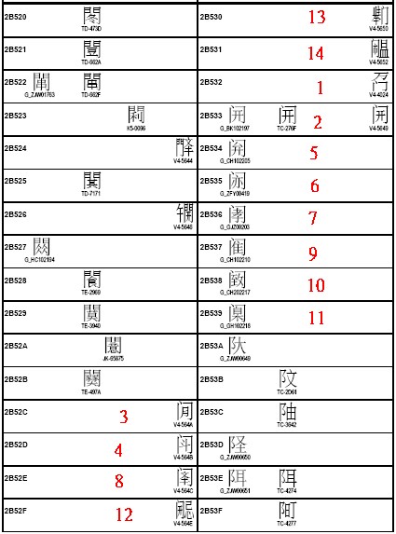

- Missing characters:
2 characters from TCA(TD-4421 and TD-4D2B) have been encoded in CJK_C V90 (2AC83 and 2AC87) were mistakenly removed due to a change of radical index from ‘moon’ to ‘meat’. Thus, IRG agreed to add them back to Ext. C as additional source.

