
ISO/IEC JTC 1/SC 2/WG 2 N3374
DATE: 2007-12-20

ISO/IEC JTC 1/SC 2/WG 2
Universal Multiple-Octet Coded Character Set (UCS) - ISO/IEC 10646

Secretariat: ANSI

DOC TYPE: | Ad-hoc meeting announcement
TITLE: | Tai Tham ad-hoc meeting 21-22 Jan 2008, Payap University, ChiangMai, Thailand
SOURCE: | Mike Ksar, Convener
PROJECT: | JTC 1.02.18 – ISO/IEC 10646
STATUS:
ACTION ID: | ACT – Please contact Mr Michael Leung (email: linginstPYU_MSEA@sil.org) to register for the Ad Hoc meeting or for the optional tutorial session, and for room reservations. Please contact Mr Martin Hosken (email: martin_hosken@sil.org) for all other details.
DUE DATE: | 2008-01-08
DISTRIBUTION: | SC2 National Member Bodies, Dr. Udom Warotamasikkhadit, Mr He Lifeng, Venerable Ananda Adittatthammo and U Hong Kham Noom
MEDIUM: | Electronic
NO. OF PAGES: | 2

At meeting 51 of ISO/IEC JTC1/SC2/WG2 17-21 Sep 2007, a resolution was made asking that the China national body meet with other interested parties to resolve any remaining issues in the proposed Tai Tham encoding. As a result an ad-hoc is to happen at Payap University, ChiangMai, Thailand between 21-22 January 2008, chaired by Mr Peter Constable. Recipients are invited to form a delegation to that meeting. The delegation should be no more than 5 people, consisting of a team leader, at least one person who is an expert in the script and its use and one person with expertise in the computational aspects of the script, including existing fonts, keyboarding and sorting.

Delegates should bring with them any samples of problematic characters and sequences, information on existing keyboard layouts, fonts and sort orders, including dictionaries or other documents showing those sort orders.

In addition to the ad-hoc, an introductory tutorial on Unicode and the Tai Tham proposal is being offered. If you would like to be involved with that, please contact Martin Hosken.

Timetable
17-18 Jan Tutorial on the current encoding of Tai Tham in Unicode (optional—please register in advance).
21-22 Jan Ad-hoc meeting

The ad-hoc meeting will start at 09:30 on 21/Jan/2007 at the International House of Payap University, Maekhao campus. The International House is located on the east side of the outer ring road in the next building after the Faculty of Law.
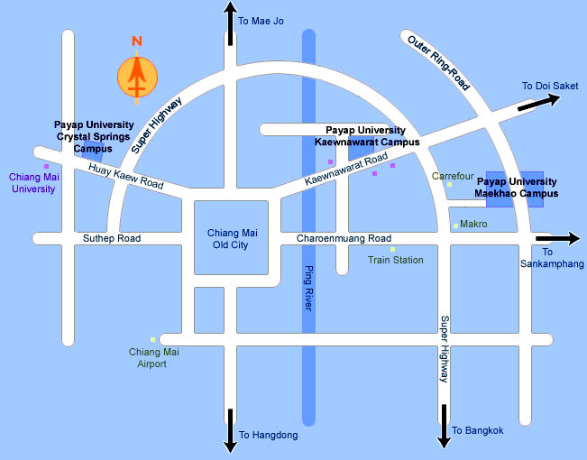

Accommodation
While you are welcome to arrange your own accommodation, there is accommodation available at the venue, including breakfast.

Standard: B880/night. single bed, bathroom
Twin Superior: B1100/night, 2 single beds, bathroom
Deluxe: B1540/night, double bed, bathroom, fridge, TV
Suite: B2420/night, two bedrooms: 1 double bed, 2 single beds, bathroom, fridge, TV

Catered lunch: B100 per person.

NB. The current exchange rate is approx B33=$1 US.

Please contact Mr Michael Leung (email: linginstPYU_MSEA@sil.org) for room reservations, and to indicate if you plan to have the catered lunch.

Visas
If you need an invitation from a Thai instution for visa purposes, please contact Martin Hosken.

Mike Ksar
ISO/IEC/JTC 1/SC 2/WG 2 Convener  22680 Alcalde Rd  Cupertino, CA 95014  U. S. A. | Phone: +1 408 255-1217  e-mail: mikeksar@10646.com

