JTC1/SC2/WG2 N3445

Date: 2008-04-15

Source/Contribution Identifier: | Hong Kong Special Administrative Region (HKSAR)
Meeting: | 52nd WG2 Meeting in Redmond, WA, U.S.A.
Title: | Six characters to be submitted for inclusion in the BMP
Status: | IRG Member Submission
(for the information of WG2)
Requested Action: | For WG2’s information, we will request IRG’s consideration to give HKSAR permission to include in the BMP the six characters, listed in Annex I, which are the newly included Hong Kong Supplementary Character Set (HKSCS) characters after the promulgation of the existing HKSCS-2004 standard.

Background:
The HKSAR Government has adopted the ISO 10646 coding standard and the HKSCS for its open and common Chinese language interface. The HKSCS specifies characters used by the HKSAR community. The first version of the HKSCS was published in 1999, and all the characters in the latest version, HKSCS-2004, have been included in the ISO/IEC 10646:2003 and its Amendment 1.

As an extension of the existing HKSCS-2004 standard, the Government of the HKSAR will publish a new version of the HKSCS (tentatively named HKSCS-2008) that includes 68 additional characters, six of which have not yet been included in the ISO/IEC 10646 standard.

The HKSAR will request IRG’s consideration to encode the six additional characters, proposed in Annex I to this document, in the BMP at the earliest possible opportunity. The HKSCS-2008 will provide a good reference for the community and should help foster the development of the information communication technology (ICT) industry in the HKSAR.
Annex I: Summary of the Six Newly Added HKSCS Characters

Serial No | Glyph | H-SOURCE | KangXi | KangXi Radical | No. of  Stroke | IDC | Evidence
1 |  | H-87C2 | 0102.291 | 人 | 6 | 亻争 | Located in page 73 of Zhonghua Zihai(《中華字海》) [please refer to Annex II]  .  Person’s name used in a travel document issued by the People’s Republic of China  Located in Extension D document: Page 13, CJK_D_V30, IRGN1401
2 |  | H-87D2 | 0365.211 | 彳 | 4 | 彳尺 | Chinese character used in the lyrics of Cantonese opera (粵曲曲譜字符). Sample is shown in Annex III.  Cantonese opera is regarded as a cultural heritage of the People’s Republic of China (seehttp://www.gov.cn/zwgk/2006-06/02/content_297946.htm).
3 |  | H-87D6 | 0365.211 | 彳 | 4 | 彳五 | - Ditto -
4 |  | H-87DA | 1036.401 | 艸 | 7 | 艹氵止 | Person’s name used in a birth certificate issued by the HKSAR Government.  This character cannot be unified with U+6DFD, which has the radical “water”.  Located in Extension D document: Page 344, CJK_D_V30, IRGN1401  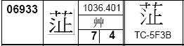
5 |  | H-87DC | 0660.271 | 水 | 16 | 氵頴 | Person’s name used in a birth certificate issued by the HKSAR Government.  This character cannot be unified with U+240E1.  Located in Extension C  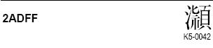
6 |  | H-87DF | 1125.151 | 衣 | 12 | 衤喜 | Person’s name used in an identity card issued by the HKSAR Government.  This character cannot be unified with U+79A7.  Located in Extension D document: Page 374, CJK_D_V30, IRGN1401  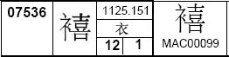
Annex II: Extract of Zhonghua Zihai(《中華字海》)
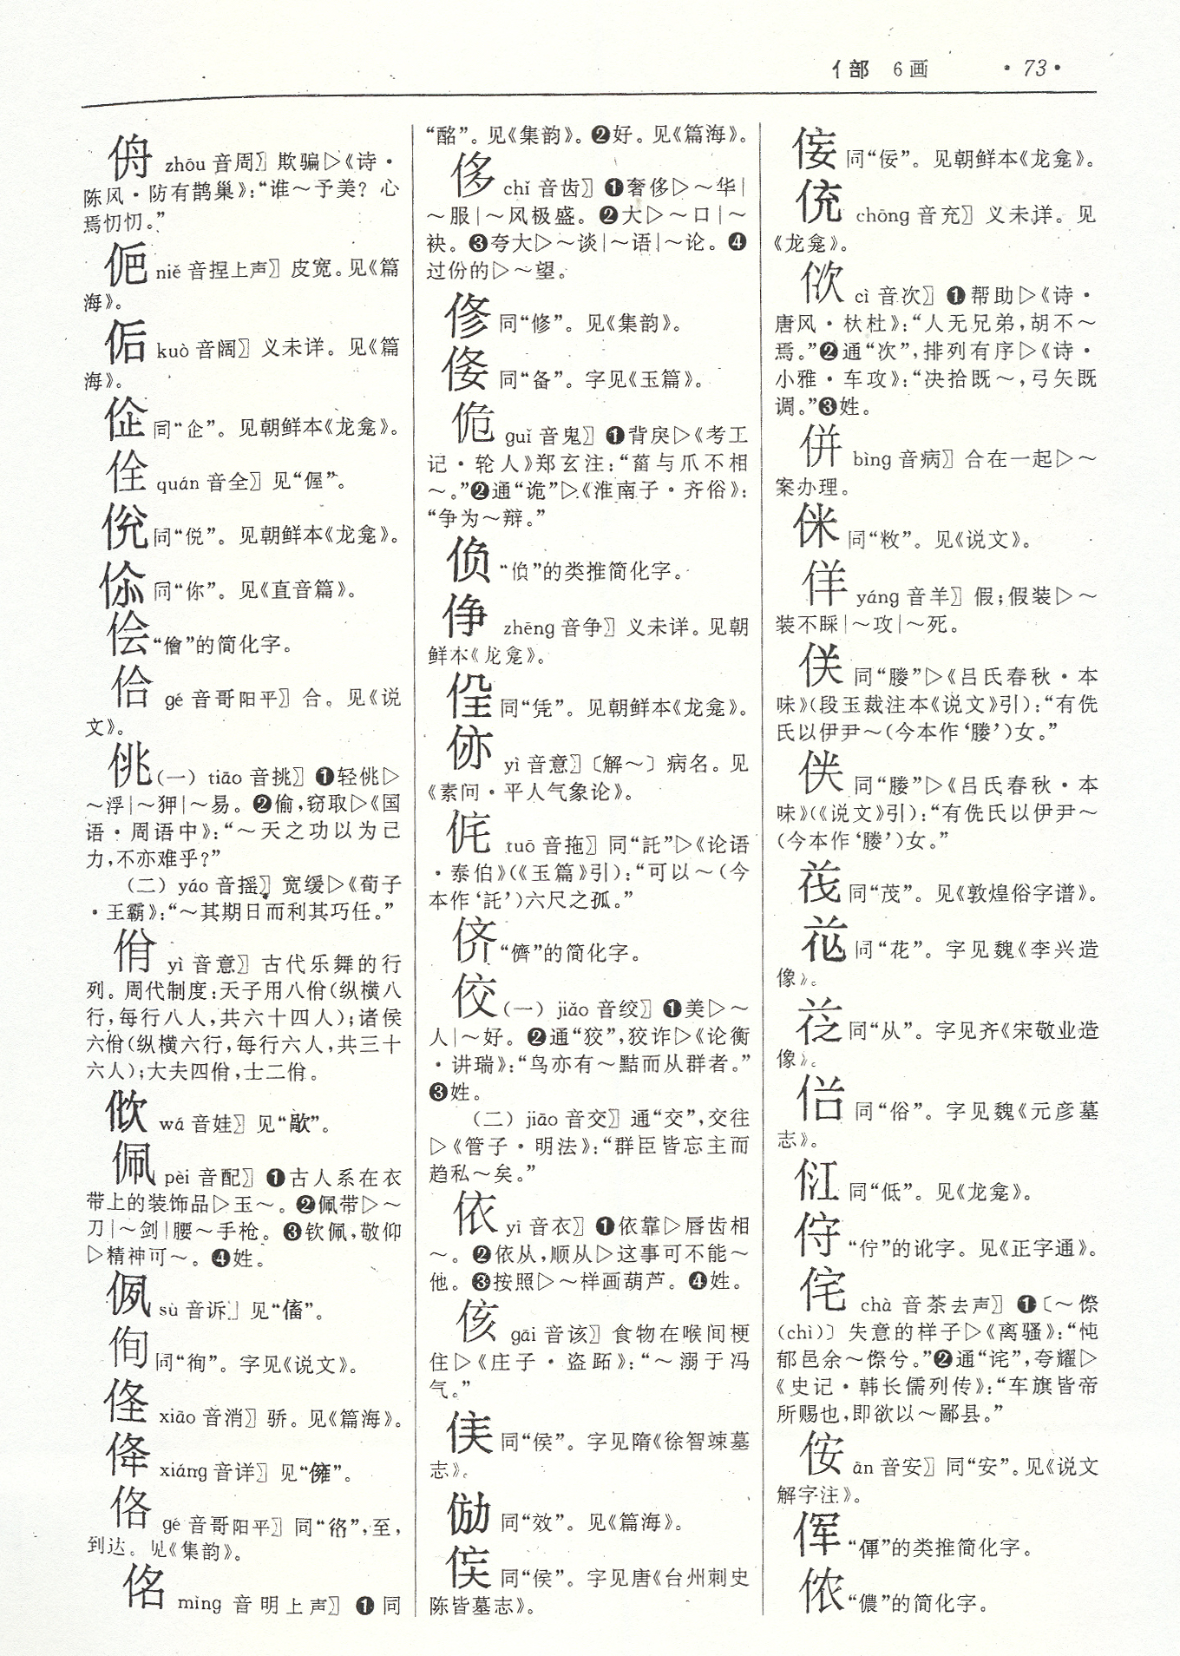
Annex III: Sample of Characters in Cantonese Opera Lyrics

