 | ISO/IEC JTC 1/SC 2/WG 2 N3499
DATE: 2008-09-10

ISO/IEC JTC 1/SC 2/WG 2
Universal Multiple-Octet Coded Character Set (UCS) - ISO/IEC 10646
Secretariat: ANSI

DOC TYPE: | Calling Notice Meeting 53
TITLE: | 2nd Call Meeting # 53 from 2008-10-13/17 at the Hong Kong Polytechnic University, Hung Hom, Hong Kong.
SOURCE: | Mike Ksar, Convener
PROJECT: | JTC 1.02.18 – ISO/IEC 10646
STATUS:
ACTION ID: | ACT – Make plans to attend and provide input on agenda items. Logistics details are included in this document. Notify convener if you plan to attend.
DUE DATE: | 2008-10-06
DISTRIBUTION: | SC2/WG2 members and Liaison organizations
MEDIUM: | Electronic
NO. OF PAGES: | 4

This is the 2nd call for WG2 meeting # 53 from 13-17 October 2008 in Hong Kong, HKSAR, China. An outline of the agenda is included in this document. The host organization is the Hong Kong Polytechnic University, Hung Hom, Hong Kong. Please notify the convener if you plan to attend.

The detailed logistics and contact information are given below. This call will be announced to the sc2wg2 alias and posted on the SC2WG2 web site.

Those of you who need a visa to enter Hong Kong, HKSAR, China can initiate the process of obtaining a visa.

WG2 will be meeting starting at 10:00 am Monday, 13 October 2008 and conclude on Friday 17 October 2008.

The objective of this meeting is to continue the WG2 program of work, with focus on Amendments 6 and reviewing other contributions, including ones that have been carried forward from meeting 52. The web site has not been updated since 9 May 2008 but several silent postings have been added to it. The document register itself will be updated shortly and uploaded as well.

Mike Ksar
ISO/IEC/JTC 1/SC 2/WG 2 Convener  22680 Alcalde Rd  Cupertino, CA 95014  U. S. A. | Phone: +1 408 255-1217  Fax: +1 408 255-1217  e-mail: mikeksar@10646.com
LOGISTICS DETAILS
ISO/IEC JTC1/SC2/WG2 Meeting #53
Hong Kong, 13-17 Oct. 2008

Meeting Place
Hong Kong Polytechnic University, Hung Hom, Hong Kong

Meeting room：Room PQ703, Mong Man Wai Building, the Hong Kong Polytechnic University, Hung Hom, Hong Kong (Marked in the attached campus map).

Facility: Wireless connection to internet will be provided in the meeting room during the meeting. Limited printing can be handled upon request.

Contact Person
Prof. LU Qin: csluqin@comp.polyu.edu.hk
Phone : (852) 2766 7247, (852) 9684 0623(mobile)
Fax : (852) 2774 0842

Host : Dept. Of Computing, Hong Kong Polytechnic University

Welcome Dinner:
6:30pm, Wed. 15 Oct., 2008 at 14/F, Li Ka Shing Tower (Block M), HK Polytechnic University. (See attached campus map for location) - (Confirmation is needed.)

Visa Application:

Passport holders of many countries do not need visa to HK. Please check HKSARG government Website to see if you need visa application at: http://www.immd.gov.hk/ehtml/hkvisas_4.htm

If you need invitation letter for visa application, please provide your personal particulars: name, travel document number, intended stay period in case you want longer stay. If there are additional requirement from your visa office, please send such request. Please note that the Hong Kong Polytechnic University is the inviting body and cannot serve as your guarantor.

General Description and Travel Info

The Hong Kong Polytechnic University is 5 min. from in Tsim Sha Tsui East, a very popular tourist district. It is also only 2 minutes away from the train station to ShenZhen (China), the subway system, and all the tunnel busses to Hong Kong Island. There are plenty of places to eat either on campus or off campus. Tourist information can be found in the Hong Kong Tourist Association Website in a number of different languages. Please follow the links to find more information (www.hkta.org or http://www.hkta.org/eng/index.jsp for English Site).

Hotels

Many countries provide good travel packages to HK. In fact, you can almost stay in any hotels in HK which would have good access to HK Polytechnic University by Train, MTR, or bus. Taxi is also plentiful.

Special arrangements are made to two hotels in walking distance to campus:

Hotel Harbour Plaza Metropolis(http://www.harbour-plaza.com/hpme), right next to the Hung Hom Train station, starting at rate HKD 1,650.

and Ramada Hotel Kowloon(http://www.ramadahongkong.com/), in TST area, at rate of HKD 1,080.

Please take the respective registration form and send directly to Hotel for reservations.

NOTE: October is a very busy trade show time in HK, so you are highly recommended to make your hotel bookings soonest possible.

HONG KONG POLYTECHNIC UNIV. INFORMATION

Univ. Website: http://www.polyu.edu.hk

Dept. Website: http://www.comp.polyu.edu.hk

Campus Map: http://www.polyu.edu.hk/fmo/facilities/images/Leaflet-Campus.gif

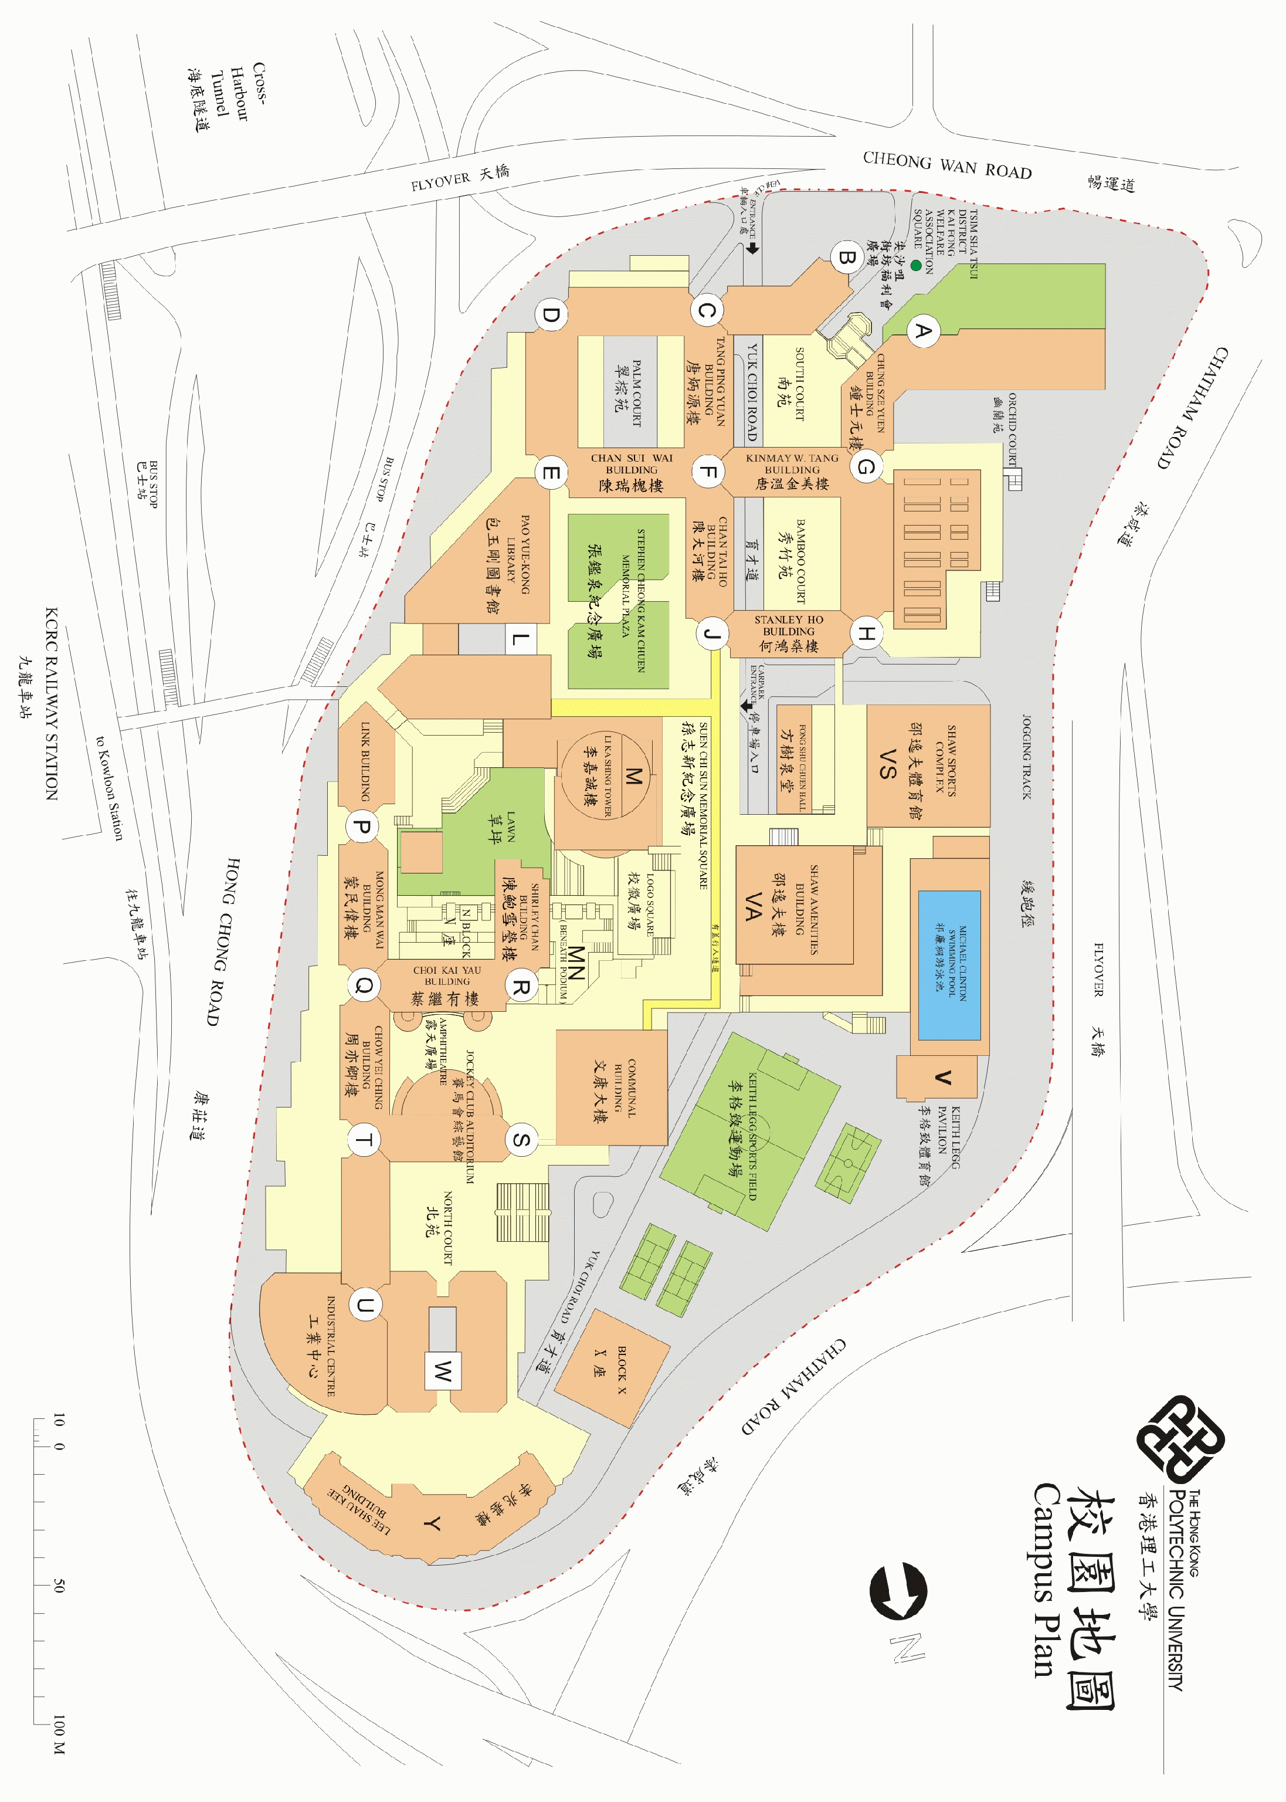
Banquet: 14/F, Li Ka Shing Tower(M), 6:30pm, Wed. 15 Oct., 2008.

Take elevator P to 7th floor, Meeting place: Room PQ703, Mong Man Wai Bldg.

Preliminary Agenda – Meeting # 53
Topic (Document No.) | Proposed Outcome

- Opening and roll call Update WG2Distribution List
- Approval of the agenda Approved agenda
- Approval of minutes of meeting 52 Approved Minutes
- Review action items from previous meeting Updated Action Item List
- JTC1 and ITTF matters: FYI

- SC2 matters: FYI
  - SC2 Program of Work FYI
  - Submittals to ITTF FYI
  - Ballot results FYI
- 10646: 2003

- Architecture issues

- Publication issues

- IRG status and reports
- Defect reports
- Liaison reports
  - Unicode Consortium
  - IETF
  - SC22
  - W3C
  - SEI
- Other business
  - Web Site Review
  - Future Meetings
    - Meeting 54 – 2009-04-20/24 Mountain View, CA, U.S. (pending confirmation);
Toronto, Canada (alternate)
    - Meeting 55 – 2009-10-26/30 with SC2 plenary, Tokushima, Japan
    - Meeting 56 – Spring 2010, CA, U.S. (pending confirmation)
    - Meeting 57 – Fall 2010, R.O. Korea (pending confirmation)
- Closing
  - Approval of Resolutions of Meeting 53
  - Adjournment

