 | ISO/IEC JTC 1/SC 2/WG 2 N3855
DATE: 2010-07-07

ISO/IEC JTC 1/SC 2/WG 2
Universal Multiple-Octet Coded Character Set (UCS) - ISO/IEC 10646
Secretariat: ANSI

DOC TYPE: | Calling Notice Meeting 57
TITLE: | 1st Call Meeting # 57 from 2010-10-04/08 hosted by the Korean Agency for Technology and Standards (KATS), the Korean National Body of ISO and IEC, in Busan, Korea
SOURCE: | Mike Ksar, Convener
PROJECT: | JTC 1.02.18 – ISO/IEC 10646
STATUS:
ACTION ID: | ACT – Those who need a visa to the Republic of Korea need to send a request answering all questions as described in the Korean National Body invitation letter below. Make plans to attend and provide input on agenda items. Logistics details are included in this document.  Meeting Coordinator is Ms. Eunsook Kim at KATS.  Visa Processing: See details below
DUE DATE: | 2010-09-24
DISTRIBUTION: | SC2/WG2 members and Liaison organizations
MEDIUM: | Electronic
NO. OF PAGES: | 12

This is the first call for WG2 meeting # 57 from 4-8 October 2010 in Busan, Korea. It is hosted by the Korean National Body at the Lotte Hotel Busan. An outline of the agenda is included in this document.

WG2 will be meeting starting at 10:00 am Monday, 4 October 2010 and conclude by noon time Friday 8 October 2010. Note: Internet access via wireless LAN is available in the meeting room area.

The objective of this meeting is to continue the WG2 program of work, with focus on the next edition of ISO/IEC 10646 FDIS as well as on the 3rd edition of ISO/IEC 10646. Contributions, including ones that have been carried forward from earlier meetings will be reviewed as well.

The detailed logistics and contact information are given below and will be posted in document N3855-L.

Mike Ksar
ISO/IEC/JTC 1/SC 2/WG 2 Convener  22680 Alcalde Rd  Cupertino, CA 95014  U. S. A. | Phone: +1 408 255-1217  e-mail: mikeksar@10646.com
Preliminary Agenda – Meeting # 57
Topic (Document No.) | Proposed Outcome

- Opening and roll call Update WG2Distribution List
- Approval of the agenda Approved agenda
- Approval of minutes of meeting 56 Approved Minutes
- Review action items from previous meeting Updated Action Item List
- JTC1 and ITTF matters: FYI
- SC2 matters: FYI
  - SC2 Program of Work FYI
  - Submittals to ITTF FYI
  - Ballot results FYI
- WG2 matters:
- IRG status and reports
- Script contributions related to ballots:
- Script contributions not related to ballots
- Ballots disposition of comments
  - FDIS for 2nd edition
  - CD for 3rd edition
- Architecture issues
- Publication issues
- Defect reports
- Liaison reports
  - Unicode Consortium
  - IETF
  - SC22
  - W3C
  - SEI
- Other business
  - Web Site Review
  - Future Meetings
    - Meeting 58 – 2011-06-06/11, Helsinki, Finland (along with SC2 plenary)
    - Meeting 59 - Fall 2011, Mountain View, CA, USA (pending confirmation),
Germany (as backup)
    - Meeting 60 – Spring 2012 – Looking for host
- Closing
  - Approval of Resolutions of Meeting 57
  - Adjournment
ISO/IEC JTC1/SC2/WG2 N3855-L
Updated 2010-07-07

Logistic information for
The 57th ISO/IEC JTC 1/SC 2/WG 2 Meeting
2010 Oct. 4(Mon) ~ 8(Fri), Busan, Republic of Korea

1. Meeting information

KATS would like to extend a warm welcome to all delegates and guests to the 57th ISO/IEC JTC 1/SC 2/WG 2 meeting in Busan, Korea.

1. Meeting Host
The 57th JTC 1/SC 2/WG 2 meeting will be hosted by Korean Agency for Technology and Standards (KATS), which is Korean National Body of ISO and IEC.

2. Meeting Schedule
Monday 4th to Friday 8th October 2010
 | 4(Mon) | 5(Tue) | 6(Wed) | 7(Thu) | 8(Fri)
9:00 ~ 12:00 | ✓ | ✓ | ✓ | ✓ | ✓
13:00 ~ 18:00 | ✓ | ✓ | ✓ | ✓ | ✓

During the meeting, coffee and cookie will be served twice a day (morning and afternoon).

3. Venue
Lotte Hotel Busan
503-15, Bujeon-dong, Busanjin-gu, Busan, Korea, 614-303
Tel: +82 51 810 1000, Fax: +82 51 810 5110
URL: http://www.lottehotelbusan.com

4. Host Contact
All the meeting arrangement will be coordinated by;

Ms. Eunsook Kim
International Standards Coordinator
Tel: +82-2-509-7263/4, Fax : +82-2-507-1924
Email: eunsook@kats.go.kr

5. Social Event
Delegates and accompanying person are kindly invited to attend the social events, free of charge

◈ Welcome Reception
- Date: October 4(Mon), 2010
- Time: 7:00-9:00 pm
(If you have any food restriction, please indicate it in the Annex I)

6. Registration
Delegates are kindly requested to complete the Registration Form (Annex I) and return it to the host contact no later than 10 September 2010.
A confirmation will be sent by e-mail to the participants by meeting coordinator.
- Registration Desk
Registration desk for the meeting will be located in Secretariat (Administration Office) and will be opened at 8:30AM. (from Monday 4 Oct. to Friday 8 Oct.)

- Badges
Delegates and accompanying persons will receive a badge showing their name and country represented.
All participants are requested to wear their badges during the meeting.

7. Secretariat (Administration office)
We will open the Secretariat (Administration office) to offer information and to respond to your request during the SC 2/WG 2 meeting.
All participants can use office equipment and etc. For copying, please come to Secretariat and use the copying machine for free by yourself.

8. Meeting room
To support electronic working methods, each meeting room will be equipped with power outlet, beam projector, screen and Internet.
- Computer Networking
Each meeting room will be equipped with wireless access (Wireless LAN, supporting IEEE802.11b, 2.4GHz band) to the Internet. And to make use of these facilities, you need to bring your own Wireless LAN Card.

9. Accommodation (Lotte hotel)
Special arrangements have been made with the Lotte Hotel Busan to accommodate delegates and their accompanying persons of JTC1/SC 2/WG 2 meeting.

ROOM RATE: 10% Tax and 10% service charge are included
ROOM TYPE | Special rate (KRW)
Double or Twin | 150,000 KRW
Double or Twin(including breakfast) | 170,000 KRW (1 breakfast)
※ Exchange rate(the basic date: June 28, 2010) USD 1 ≒ 1,220 KRW (Korean WON)
※ 20,000 KRW(tax, service charge included) for additional 1 breakfast

Please directly send the reservation form (Annex II) to Lotte Hotel Busan via the following fax or e-mail no later than 10 September 2010.

Mr. Choo Byung Kwan
Tel : +82 2 759 7060 , +82 10 2545 6900
Fax : +82 2 319 8709
E-mail: bkchoo@lotte.net

Please note that accommodation cannot be guaranteed as special rate for registration after 10 September 2010 on a first come, first served basis.

Guest Room reservation web page address:
http://www.lottehotel.com/Convention/ConventionReserv.asp?strSeqNO=2167292

Please make a room reservation at above page, and it will make you more easily to confirm the room reservation.

10) Additional Hotel Information
If a delegate would prefer to lodge at different hotels, the following is a listing of hotels near the meeting venue;
Hotel | Address/  Telephone number | website | Rate  (per night) | Notes
Toyoko INN | Busan Seo-Myeon  Tel: +82 -51-638-1045 | http://www.toyoko-inn.com/e_hotel/00221/index.html | Single 52,470KRW  Twin  72,270KRW | a 10 minute walk away From Meeting place  10% Tax and Breakfast all Included
Hotel Nongshim | 137-7 ONCHUN-DONG/  Tel: +82 -51-550-2412 | http://www.hotelnongshim.com/eng/index.asp | Single  139,150KRW | a 15-20 minute by car from Meeting place  Breakfast not Included

2. General information

1. Transportation (in Busan)
- A 10 minute's drive from Busan Station, 25 minute’s Gimhae International Airport.

By Airport Limousine bus from Gimhae Airport to LOTTE HOTEL BUSAN
- An Airport limousine bus serves the Hotel-Airport route every 40 minutes.
- It takes 25 minutes from Gimhae Airport to the LOTTE HOTEL BUSAN.

By subway (Metro) from Busan Station
- take Subway (Metro) Line 1 and get off at Seomyeon Station.

For detail information how to get to meeting venue (The LOTTE HOTEL BUSAN), please visit the website of The LOTTE HOTEL BUSAN and Subway system.

Subway system: http://english.busan.go.kr/04_transportation/04_01.jsp
Lotte hotel: http://www.lottehotelbusan.com

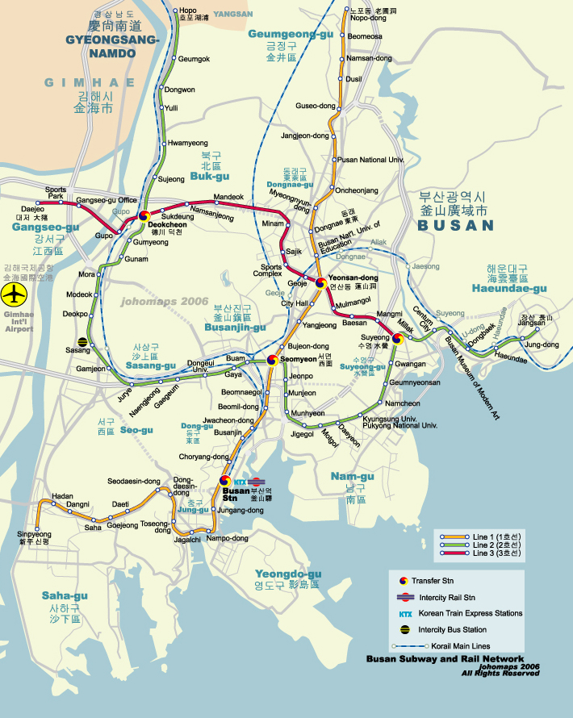

2. Meeting facilities
1) Office
A copy machine of medium speed, a personal computer and a printer adaptable to Windows XP with MS office will be installed at the Secretariat (Administration office) room.

2) Computer Networking
Each meeting room will be equipped with wireless access (Wireless LAN) to the Internet and to make use of these facilities, you need to bring your own Wireless LAN Card.

3. VISA
Delegates are advised to check with the local travel agent about regulations regarding VISA. In case of doubt, the information can be obtained from the nearest Korean Embassy or Consulate as well as the following website:
http://www.mofat.go.kr/

If you need an invitation letter for visa, please send the following information to Korea Host by e-mail (eunsook@kats.go.kr) with registration form.
※ Note that China and Taiwan delegates need to get an original invitation letter for visa.

-Name
-Sex: Male or Female
-Date of birth (dd-mm-yyyy)
-Passport No. & Date of Expiry (dd-mm-yyyy)
-Company / Organization
-Your Designation / Title
-Address
-Tel/Fax
-E-mail

4. Weather
Busan (Pusan) in October is an early fall weather. It is the best season for visiting Korea. October average temperature is 18~24°C

5. Currency and Credit Cards
The unit of Korean currency is Won. Coin denominations are 1 won, 5 won, 10 won, 50 won, 100 won, 500 won. Bank notes are 1,000 won, 5,000 won, 10,000 won, 50,000 won. Bank checks are circulated in denominations of 100,000 won and over.

Foreign currency and traveler’s check can be converted into Korean won at foreign exchange banks and other authorized money exchangers. The exchange rate is subject to market fluctuations. One U.S dollar was equivalent to about 1,220 KRW (Korean WON) as of June 28, 2010.

Credit cards, including VISA, American Express, Diner’s Club, Master Card and JCB, are accepted at major hotels, department stores, and restaurants.

6. Electricity
The standard voltage in the Korea is 220 volts AC, 60 Hz with a round two-pin plug (same as in Germany or France). Always check the power supply before using your equipment.

7. Sightseeing
Busan, a city where its mountains, rivers and the sea are in harmony, and exciting and abundant festivities, and diverse international functions are held all the year round.
You’ll experience all the splendours of big city and the beauty of nature in Busan

Useful Links
- Busan City tour and information: http://english.busan.go.kr/index.jsp
- Inchon International Airport : http://www.airport.or.kr/Eng/home.jsp
- KOREAN Air : http://www.koreanair.com/
- ASIANA Airline : http://us.flyasiana.com
ANNEX I

REGISTRATION FORM

JTC1/SC2/WG2 Meeting

4-8 October 2010 Busan, Republic of Korea

Delegates attending the meeting are requested to complete this form and to send it to the Host Contact at the following address by fax or e-mail no later than 10th Sept. 2010.

TO: Ms. Eunsook Kim

KATS (Fax +82-2-509-7068 / Email: eunsook@kats.go.kr)

Please fill out this form with BLOCK LETTERS
FIRST NAME |  |  |  |  |  |  |  |  |  | FAMILY NAME
Please indicate with an ”x”, the appropriate selection.
Prof. |  |  |  | Dr. |  |  |  |  | Mr. . |  |  |  |  | Ms.
ORGANIZATION:
OFFICE ADDRESS:
COUNTRY:
Tel: |  |  |  | Fax: |  |  |  | E-mail:
SOCIAL EVENT

Banquet : Participant Number (with accompanying person )

Do you have any “Food Restriction”? Yes : No :
(Korean traditional dishes will be served.)

INFORMATION - Accompanying person/guest
Mr. |  | Ms. | FIRST NAME |  |  |  |  |  |  |  |  | LAST NAME
Accommodation Information: Accommodation during your stay in Busan, Korea.
Hotel Name: |  |  | LOTTE HOTEL BUSAN Others:
Arrival Date: |  |  |  |  |  |  | Departure Date:

ANNEX II

HOTEL RESERVATION FORM

The 57th JTC1/SC 2/WG 2 Meeting

4 ~ 8 October 2010, Busan, Republic of Korea

The rate granted to all guests participating in the above mentioned event amounts to a below table per single room per night from 2 October until 10 October 2010.

PLEASE COMPLETE IN CAPITAL LETTERS
Personal Information
Mr | Mrs | Ms | First Name | Family Name
Address
Company |  | E-mail
Tel |  | Fax
Check in Date & Time |  | Check out Date & Time
Card Type |  | Card Hold's Name
Card No.
Exp. Date | (mm/yy)
Room Requirement
Standard room | Double Twin | 150,000KRW | * Service charge, tax is included / Breakfast KRW 20,000 will be added per person
Standard room  (including Breakfast) | Double Twin | 170,000KRW
Special Requests
Our check in time is 2 pm. Guests arriving before 2 pm will be accommodated as rooms become available. Check out time is 12 pm and our porters will arrange to hold luggage for those guests leaving the hotel later in the day. All reservations must be guaranteed by the individual delegates for late arrival by either credit card or one night room rate as a deposit. The rooms can be cancelled up to 48 hrs before arrival. After this time a cancellation charge added.
* Exchange rate : USD1 = KRW 1,220(As of June 2010)

If you wish to take advantage of this special rate,
Please return this page by September 10, 2010 to
: Fax +82 2 319 8709 E-Mail: bkchoo@lotte.net
(After that date, the Lotte Hotel Busan will not be able to guarantee availability,
and reservations will be made upon room and rate availability.

