JTC1/SC2/WG2 N3939

Date: 2010-10-05

Updated: 2011-02-19*

LOGISTIC Information

Logistic details for the ISO/IEC JTC1/SC2/WG2 Meeting 58 and SC2 plenary meeting in Helsinki, Finland, 2011-06-06/10.

Dates June 6th–10th, 2011

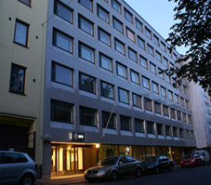
Host & Location

Finnish Standards Association (SFS)

http://www.sfs.fi

Malminkatu 34

FI-00100 Helsinki, Finland

Contact persons at SFS:

Ms. Hillevi Vuori

e-mail: hillevi.vuori@sfs.fi

tel. +358 40 356 8003

fax +358 9 146 4925

Ms. Sari Lamminaho

e-mail: sari.lamminaho@sfs.fi

tel. +358 9 1499 3466

fax +358 9 146 4925

The SFS premises are located in the Helsinki city centre. There is a wide range of hotels, restaurants and shops within walking distance.

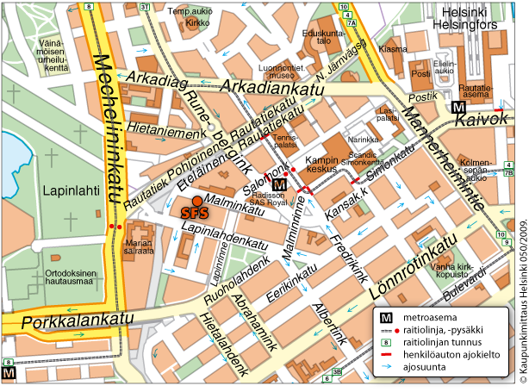

See also Google maps:http://maps.google.com/maps?q=Malminkatu+34,+00100+Helsinki,+Suomi&sll=37.0625,-95.677068&sspn=23.875,57.630033&ie=UTF8&hq=&hnear=Malminkatu+34,+00100+Helsinki,+Suomi&z=16

Registration

Please confirm your participation by May 18th by sending an e-mail to Ms. Toshiko Kimura (kimura@itscj.ipsj.or.jp) or a fax to +81 3 3431 6493. Please send a copy to the convener Mr. Mike Ksar (mikeksar@gmail.com) and SFS (it-info@sfs.fi or fax +358 9 146 4925).

Entry Visas

Visitors from a number of countries will be required to have a valid passport and a valid visa. The visas must be obtained before departure and the applications should be made to a Finnish Embassy or Consulate in your country of residence. For further information, see the internet site of Ministry of Foreign Affairs of Finland:

http://formin.finland.fi/Public/default.aspx?contentid=69601&nodeid=15716&contentlan=2&culture=en-US

If you need a letter of invitation, please contact Ms. Hillevi Vuori or Ms. Sari Lamminaho at SFS (details above).

*Hotels

SFS has made a block reservation at the Radisson Blu Royal hotel. Please make your hotel reservation directly at the hotel.

In order to have your room with the contracted rate, please quote the client code when making the reservation. Note hotel rate duration has been updated to start from Friday, 3 June rather than Sunday, 5 June.

Recommended hotel:

Radisson Blu Royal http://www.radissonblu.com/royalhotel-helsinki

Address: Runeberginkatu 2, 00100 Helsinki

- two minutes walk from SFS premises

Standard 154 € / night

The rates are valid June 3rd–10th when reserved by May 18th, 2011. Client code SC2. Please note that the number of rooms at this rate is limited.

The rates include a Super Breakfast buffet during normal opening hours (VAT 23%), service, room charge VAT (9%) and sauna. High-speed and/or wireless Internet access is free of charge for all guests throughout the hotel.

Payment: Cash or credit card

Reservations: Central Sales Services

Telephone: +358 20 1234 700 / individual room reservations

Telefax: +358 20 1234 740

E-mail: reservations.finland@RadissonBlu.com

Please quote the client code SC2 when making a booking.

Other hotels with special rates within walking distance:

Hotel Scandic Simonkenttä http://www.scandichotels.com/en/Hotels/Countries/Finland/Helsinki/Hotels/Scandic-Simonkentta/?redirected=true

- ten minutes walk from SFS premises

Client code D000006032
Please check the best daily rates (Corporate Saver) at: www.scandichotels.fi

by using the booking code “D000006032” or phone +358 (0)800 0 6969/Scandic reservations centre.

Sokos Hotel Presidentti http://www.sokoshotelpresidentti.fi/en/index.html

- ten minutes walk from SFS premises

Client code SFS

The rates for the year 2011 will be completed later.

Hotel Helka http://www.helka.fi/

- five minutes walk from SFS premises

Client code SFS

The rates for the year 2011 will be completed later.

Getting to the city centre from the Helsinki-Vantaa airport

Buses and taxis are reliable and safe to use in Finland.

Bus services from the Helsinki-Vantaa airport take you to Helsinki city centre and back comfortably and rapidly. The trip to Helsinki city centre by bus 615 or Finnair City Bus takes approximately 35 minutes and costs around 6 €. Both the lines run to Helsinki Central Railway Station, situated within 15 minutes walk from the SFS premises.

The taxi journey from the airport to the centre of Helsinki takes about 30 minutes and costs about 35-40 €. The taxi stations are located right outside the arrival areas of the terminals. There are also three taxi operators at the Helsinki-Vantaa airport that offer special taxi services, fixed fare shared taxis and tours and chartered drives. See the service map for details: http://www.helsinki-vantaa.fi/servicemap

Electricity The electric current in Finland is 220 V (230 V), 50 Hz. A two-pin plug system familiar throughout Europe is used.

Weather The average daytime temperature in Helsinki in the beginning of June is around +15 °C, but the temperature may vary between +10 °C and +20 °C.

You can check the Helsinki five day weather forecast at Finnish Meteorological Institute’s site:

http://www.fmi.fi/weather/local.html?Keywords=&station=2934&param=4&map=1&place=Helsinki

Currency & Credit Cards

The Finnish currency is the Euro (€), with 100 cents (c) = 1,00 €.

Most major credit cards are accepted in hotels, restaurants and shops. However, some shops may not accept payment by credit card.

Tourism For tourist attractions and leisure activities in Helsinki, please visit the Helsinki official tourism site:

http://www.visithelsinki.fi/In_English/Visitor/Helsinki/Welcome_to_Helsinki!.iw3

See also the Visit Finland site:

http://www.visitfinland.com/en/web/guest/finland-guide/home

