JTC1/SC2/WG2 N4139-R2

Date: 2012-01-29

LOGISTIC Information

Logistic details for the ISO/IEC JTC1/SC2/WG2 Meeting 59 in Mountain View, CA

Dates: Feb 13 - 17, 2011

Host & Location: The Unicode Consortium
Microsoft Silicon Valley Campus
1045 L'Avenida Street, Building 4
Mountain View, CA 94043 -- U.S.A.

Contact person: Note that the contact person for the upcoming meeting 59 in Mountain View, CA is not Magda Danish who has been replaced by Irina Shlyapnikova [irinaunicode@gmail.com]. We thank Magda for all the support that she gave us over the years and welcome Irina.

e-mail: irinaunicode@gmail.com

tel. +1.650.693.3690

fax +1.650.693.3010

Meeting Specifics:

The meeting will take place in the following conference rooms:

- Monday Feb 13: INFERNO Conference room—Building 4 – Complimentary breakfast will be served in the conference room
- Tuesday Feb 14: INFERNO Conference room—Building 4
- Wednesday Feb 15: INFERNO Conference room—Building 4
- Thursday Feb 16: FLAME Conference room—Building 4
- Friday Feb 17: INFERNO Conference room—Building 4

- Make sure you claim your badge at the Building’s reception desk everyday. It will allow you to move freely on campus.
- In case any problem arises, please have the receptionist contact Irina at extension 33690 or her cell phone at (650) 793-1840.
- Internet connection will be available to all meeting participants.
- Print will be on demand only.
- Lunch will be at the Microsoft cafeteria at participants’ expense
- Afternoon snacks will be served at the conference room
- Free hot and cold drinks will be available from the floor kitchen

Registration

Please confirm your participation by January 25, 2012 by sending an e-mail to Ms. Toshiko Kimura (kimura@itscj.ipsj.or.jp) or a fax to +81 3 3431 6493. Please send a copy to the convener Mr. Mike Ksar (mikeksar@gmail.com) and the Unicode office (irinaunicode@gmail.com).

Entry Visas

Visitors from a number of countries will be required to have a valid passport and a valid visa. The visas must be obtained before departure and the applications should be made to the American Embassy or Consulate in your country of residence.

If you need a letter of invitation, please contact Irina at the Unicode Consortium (details above).

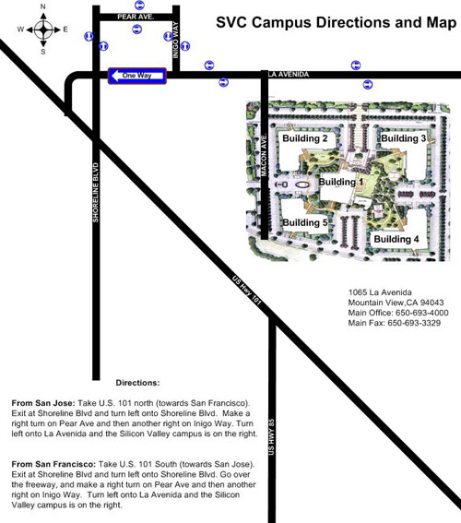

Location Map and Hotel Accomodations:

http://www.bing.com/maps/default.aspx?v=2&cp=37.413168~-122.0713&style=r&lvl=15&tilt=-90&dir=0&alt=-1000&scene=5859756&sp=Point.q71z7j4ttnk7_1065%20La%20Avenida%20St%2c%20Mountain%20View%2c%20CA%2094043-1421%2c%20United%20States___#JnE9Y2F0LjEzMzQ0JTdlc3N0LjAlN2VwZy4xJmJiPTM3LjQzMTI3MjYwNTU2MDQlN2UtMTIyLjA1MTM2NTgyMjYwMSU3ZTM3LjM5NTA1OTAxNzQyODglN2UtMTIyLjA5MTIzNDE3NzM5OQ==

Getting to Mountain View, CA from San Francisco Airport (SFO) or San Jose Airport (SJC):
All major rental companies have offices at SFO and SJC
Door to door shuttle buses are also available at both airports and cost $30/person from SFO to Mountain View and $25/person from SJC to Mountain View (companions pay $10 each). Taxis will run approximately $100 from SFO and $50 from San Jose.

