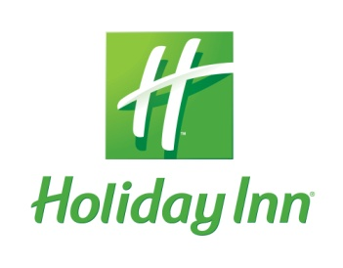 ISO/IEC JTC1/SC2/WG2 N4392-L

HOTEL RESERVATION FORM

For the delegates of the conference
ISO/IEC JTC1/ SC2 WG2
(10-14 of June, 2013, Vilnius, Lithuania)

Hotel HOLIDAY INN VILNIUS ****
Please submit this form to the hotel until 9th of May
fax: +370 5 210 30 01
e-mail: reservation@ibc.lt

Address: Seimyniskiu str.1, Vilnius LT-09312, Lithuania
www.holidayinnvilnius.lt

Mr. /Mrs.: _________

FAMILY NAME: __________________________________________________

FIRST NAME: __________________________________________________

ADDRESS: __________________________________________________

COUNTRY: __________________________________________________

TELEPHONE: __________________________________________________

E-MAIL: __________________________________________________

Room rate include: 21% VAT, buffet breakfast, Mini Gym, Sauna and Internet access.

ROOM TYPE: SINGLE (standard) EUR 105 DOUBLE (standard) EUR 117
SMOKING NON SMOKING

DATE OF ARRIVAL: __________________ 14:00 a.m. check in time

DATE OF DEPARTURE: __________________ 12:00 a.m. check out time

Name of accompanying person __________________________________________

Airport pick up EUR 21 Arrival flight number and time ________________
Airport drop off EUR 18 Departure flight number and time ______________

PAYMENT: Visa EC/MC AMEX Diners Club Cash
Please, guarantee your reservation by your Credit card No:
_________________________________________ Valid trough: ________
Reservation terms:
- Dead line for reservation is 9th of May.
- If your reservation will be made later than 9th of May you will be applied with the hotel standard rate on exact date on availability.
Cancelation terms:
- If your cancellation will be made in written form 3 days before arrival, no any cancellation penalties will be applied by the Hotel.
- If the room booking will be cancelled less than 3 days prior arrival, the hotel will charge 100% one room night price from your credit card.

Remarks ____________________________________________________________
Date: ________________________ Signature: _________________________

Please fax this form back to: 370 5 2103001, or e-mail to reservation@ibc.lt
Thank you.

