 | ISO/IEC JTC 1/SC 2/WG 2 N4392
DATE: 2013-01-30

ISO/IEC JTC 1/SC 2/WG 2
Universal Multiple-Octet Coded Character Set (UCS) - ISO/IEC 10646
Secretariat: ANSI

DOC TYPE: | Calling Notice Meeting 61
TITLE: | 1st Call Meeting # 61 hosted Lithuanian Standards Board (NB of Lithuania) in Vilnius, Lithuania from 10-14 June in Vilnius, Lithuania.
SOURCE: | Mike Ksar, Convener
PROJECT: | JTC 1.02.18 – ISO/IEC 10646
STATUS:
ACTION ID: | ACT – Those who need a visa to Lithuania need to contact Valteris Muzas of the Lithuanian Standards Board, Valteris.Muzas@lsd.lt. Make plans to attend and provide input on agenda items. Logistics details are in document N4392-L attached below. It includes logistics info and hotel reservation form for the Holiday Inn in Vilnius.  Visa Processing: Visitors from a number of countries will be required to have a valid passport and a valid visa. The visas must be obtained before departure and the applications should be made to the Lithuanian Embassy or Consulate in your country of residence. If you need a letter of invitation, please contact Mr. Valteris Muzas.
DUE DATE: | 2013-05-15
DISTRIBUTION: | SC2/WG2 members and Liaison organizations
MEDIUM: | Electronic
NO. OF PAGES: | 2

This is the first call for WG2 meeting # 61 from 10-14 June 2013 hosted by the Lithuanian Standards Board at the Holiday Inn in Vilnius, Lithuania. This call includes an agenda outline. The WG2 meeting starts at 10:00 am Monday, 10 June 2013 and concludes by noon time Friday 14 June 2013.

The objective of this meeting is to continue the WG2 program of work. Contributions, including ones that have been carried forward will be reviewed as well.

Mike Ksar
ISO/IEC/JTC 1/SC 2/WG 2 Convener  22680 Alcalde Rd  Cupertino, CA 95014 – U. S. A. | Phone: +1 408 255-1217  e-mail: mikeksar@10646.com  mikeksar@gmail.com
Agenda Outline – Meeting # 61
Topic (Document No.) | Proposed Outcome

- Opening and roll call Update WG2Distribution List
- Approval of the agenda Approved agenda
- Approval of minutes of meeting 60 Approved Minutes
- Review action items from previous meeting Updated Action Item List
- JTC1 and ITTF matters: FYI
- SC2 matters: FYI
  - SC2 Program of Work FYI
  - Submittals to ITTF FYI
  - Ballot results FYI
- WG2 matters:
- IRG status and reports
- Script contributions related to ballots:
- Script contributions not related to ballots
- Ballots disposition of comments
  - PDAM2
- Architecture issues
- Publication issues
- Defect reports
- Liaison reports
  - Unicode Consortium
  - IETF
  - SC22
  - W3C
  - SEI
- Other business
  - Web Site Review
  - Future Meetings
    - Meeting 62 – US NB in San Jose, CA 2014-02-24/28 San Jose, CA, U.S.A. - Location: Adobe campus
    - Meeting 63 2014-09 Sri Lanka (tentative); backup: China; co-located with SC2

- Closing
  - Approval of Resolutions of Meeting 61
  - Adjournment

ISO/IEC JTC1/SC2/WG2 N4392-L
Updated Map 2013-01-31

61st ISO/IEC/ JTC 1/SC 2/WG 2 meeting
Vilnius, Lithuania
10th to 14th June’2013

GENERAL INFORMATION

1. MEETING PLACE

The meeting will be held at the following address:

Hotel “Holiday Inn Vilnius”
Šeimyniškių Str. 1,
Vilnius LT-09312
TEL: +370 5 210 30 00
FAX: +370 5 210 30 01
e-mail: reservation@ibc.lt
Website: www.holidayinnvilnius.lt

2. ACCOMMODATION

May we draw your attention to the exceptional offer which we have managed to arrange with the Hotel “Holiday Inn Vilnius” (in which the meeting will take place) for 105/117 EUR/night (buffet breakfast and VAT included), if you book before the 10th May’2013.

If you choose “Holiday Inn Vilnius”, you are kindly requested to arrange your accommodation directly with the hotel. For booking to the hotel “Holiday Inn Vilnius” use the enclosed hotel registration form.

3. HOW TO GET TO THE HOTEL AND THE MEETING PLACE

Vilnius International Airport is situated approx. 10 km from the centre of Vilnius.

Getting from Vilnius Airport to the Hotel:
- Bus No. 2 goes to the city centre (journey time – 25 minutes, ticket price – 2,5 Litas). You have to debus at the stop “Žaliasis tiltas” (“Green bridge”) right after the river bridge, then walk 300 m straight ahead (see the map below).
- Taxi. Journey time – about 15 minutes, cost – about 40 Litas.

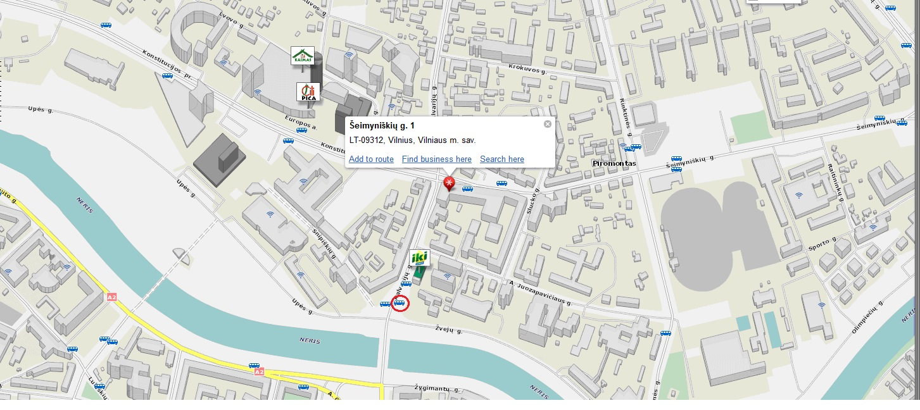

http://www.maps.lt/map/default.aspx?lang=en#q=Šeimyniškių%20Str.%201%20Vilnius
Bus No. 2 stop, walk from here 300 m right ahead to the hotel “Holiday Inn Vilnius” at Šeimyniškių g. 1.

4. SOCIAL EVENT

(To be updated)

5. OTHER INFORMATION

Public Transport
Find out more about public transport in Vilnius:
www.vilniustransport.lt

Useful information on Lithuania
http://english.wunderground.com/global/stations/26730.html
http://www.vilniushotels.lt/
http://www.vilnius.lt/
www.lithuania.lt/
www.travel-lithuania.com/

Currency: Litas (official exchange rate: 1 Euro = 3,4528 LTL).

Other official currencies exchange rate at http://www.lb.lt/en_index.htm

ISO/IEC JTC1/SC2/WG2 N4392-L

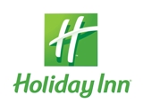 HOTEL RESERVATION FORM
For delegates of
ISO/IEC JTC 1/SC 2/WG 2 "Universal coded character set" meeting
June 10-14th, 2013 Vilnius

Hotel Holiday Inn Vilnius ****

Please submit this form to the hotel until May 10th 2013, if later the reservation will be confirmed upon availability
By e-mail: reservation@ibc.lt

Mr/Ms: _________

FAMILY NAME: __________________________________________________

FIRST NAME: __________________________________________________

ADDRESS: __________________________________________________

COUNTRY: __________________________________________________

TELEPHONE: __________________________________________________

FAX: __________________________________________________

E-MAIL: __________________________________________________

ROOM TYPE: standard SINGLE EUR 105 standard DOUBLE EUR 117

SMOKING NON SMOKING

Room rate include VAT, buffet breakfast. Mini Gym free of charge

DATE OF ARRIVAL: __________________ 14:00 a.m. check in time

DATE OF DEPARTURE: __________________ 12:00 a.m. check out time
Name of accompanying person __________________________________________

PAYMENT: Credit card: Visa□ EC/MC□ AMEX□ Cash□ Diners Club□

Please, guarantee your reservation by your Credit card No: _________________________________________ Valid trough:________
- Cancelation terms: if your cancellation will be made in written form till June 2nd, 2013 no cancellation penalties will be applied by the Hotel
- If room booking will be cancelled later than 24 h before arrival the hotel will charge 100% one room night price from your credit card.
Remarks ____________________________________________________________

Date: ________________________ Signature: _________________________

Please send this form back to: e-mail to reservation@ibc.lt
Thank you.

