 | ISO/IEC JTC 1/SC 2/WG 2 N4485
DATE: 2013-09-28

ISO/IEC JTC 1/SC 2/WG 2
Universal Multiple-Octet Coded Character Set (UCS) - ISO/IEC 10646
Secretariat: ANSI

DOC TYPE: | Calling Notice Meeting 62
TITLE: | 1st Call Meeting # 62 hosted by the U.S.(USNB) in San Jose, CA from 24-28 February 2014 on the campus of Adobe.
SOURCE: | Mike Ksar, Convener
PROJECT: | JTC 1.02.18 – ISO/IEC 10646
STATUS:
ACTION ID: | ACT – Those who need a visa to the U.S. need to contact Ellen Mastro, ellen@unicode.org of the Unicode Consortium. Make plans to attend and provide input on agenda items. Logistics details are in document N4483. It includes logistics info and recommended hotels near the meeting site at Adobe in San Jose, CA.
DUE DATE: | 2014-02-15
DISTRIBUTION: | SC2/WG2 members and Liaison organizations
MEDIUM: | Electronic
NO. OF PAGES: | 2

This is the first call for WG2 meeting # 62 from 24-28 February 2014 hosted by the USNB on the campus of Adobe in San Jose CA. This call includes an agenda outline. The WG2 meeting starts at 10:00 am Monday, 24 February 2014 and concludes by noon time Friday 14 June 2013.

The objective of this meeting is to continue the WG2 program of work. Contributions, including ones that have been carried forward will be reviewed as well.

Mike Ksar
ISO/IEC/JTC 1/SC 2/WG 2 Convener  22680 Alcalde Rd  Cupertino, CA 95014 – U. S. A. | Phone: +1 408 255-1217  e-mail: mikeksar@10646.com  mikeksar@gmail.com
Agenda Outline – Meeting # 62
Topic (Document No.) | Proposed Outcome

- Opening and roll call Update WG2Distribution List
- Approval of the agenda Approved agenda
- Approval of minutes of meeting 61 Approved Minutes
- Review action items from previous meeting Updated Action Item List
- JTC1 and ITTF matters: FYI
- SC2 matters: FYI
  - SC2 Program of Work FYI
  - Submittals to ITTF FYI
  - Ballot results FYI
- WG2 matters:
- IRG status and reports
- Script contributions related to ballots:
- Script contributions not related to ballots
- Ballots disposition of comments
  - PDAM 1 of ISO/IEC 10646 4th edition
- Architecture issues
- Publication issues
- Defect reports
- Liaison reports
  - Unicode Consortium
  - IETF
  - SC22
  - W3C
  - SEI
- Other business
  - Web Site Review
  - Future Meetings
    - Meeting 63 2014-09 Sri Lanka (tentative); backup: China; co-located with SC2
    - Meeting 64 – looking for host; backup: U.S.
- Closing
  - Approval of Resolutions of Meeting 62
  - Adjournment

ISO/IEC JTC1/SC2/WG2 N4483
LOGISTIC INFORMATION

Logistic details for the ISO/JTC1/SC2/WG2 Meeting 62 in San Jose, California

Dates: February 24-28, 2014

Host and Location: The Unicode Consortium
Adobe Systems Incorporated
345 Park Ave.
San Jose, CA 95110 USA

Contact person: For administrative issues please contact Ellen Mastros, Unicode Consortium Office Manager at 1-650-693-2793, ellen@unicode.org.
The on-site contact person at Adobe is:
Dr. Ken Lunde
Mailstop E09
345 Park Ave.
San Jose, CA 95110-2704 USA
Tel: 1-408-56-3866 office
1-408-515-2618 mobile
lunde@adobe.com

Meeting specifics:
The meeting will take place in the Albertus and Aldus conference rooms on the second floor of the Adobe West Tower. Telephone numbers are
Albertus 1-408-536-3041
Aldus 1-408-536-5013 and 1-408-536-4596 for polycom

For Wi-Fi access please send your email address to Ken Lunde (lunde@adobe.com) no later than February 14, 2014. Your email address will serve as your username for the duration of the meeting and your password will be sent to that email address at the time of pre-registration.

Lunch will be at the Adobe cafeteria at participants’ expense

Afternoon snacks will be provided

A dinner will be held on Wednesday, February 26, hosted by Unicode

Registration:
Please send your name, title and affiliation to Ken Lunde (lunde@adobe.com) and Mike Ksar (mikeksar@10646.com)

Entry Visas:
Visitors from a number of countries will be required to have a valid passport and a valid visa. The visas must be obtained before departure and the application should be made to the American Embassy or Consulate in your country of residence.

If you need a letter of invitation, please contact Ellen Mastros at the Unicode Consortium, details above.
Unicode will provide a letter upon receipt of the following information:

• Designation of ISO/JTC1/SC2/WG2 meeting #62
• Name (include male/female)
• Organization
• Date of birth
• Passport Number

Location Map and Hotel Accommodations:

All of these hotels are within walking distance from the meeting venue.

*Ask for the Adobe corporate rate.

The Fairmont Hotel*
170 South Market St.
San Jose, CA
408-998-1900
800-527-4727
www.fairmont.com/sanjose

The DeAnza Hotel*
233 West Santa Clara St.
San Jose, CA
800-843-3700
www.hoteldeanza.com

The Hilton and Towers*
Almaden Blvd.
San Jose, CA
408-287-2100
800-HILTONS
www.hilton.com

Hotel Montgomery*
211 South First St.
San Jose, CA
408-282-8800
www.hotelmontgomerysj.com

San Jose Marriott*
301 South Market St.
San Jose, CA
408-280-1300
408-280-0212
www.sanjosemarriott.com

The Sainte Claire, A Larkspur Hotel
302 South Market Street
San Jose, CA 95113
Main: 408-295-2000
www.TheSainteClaire.com

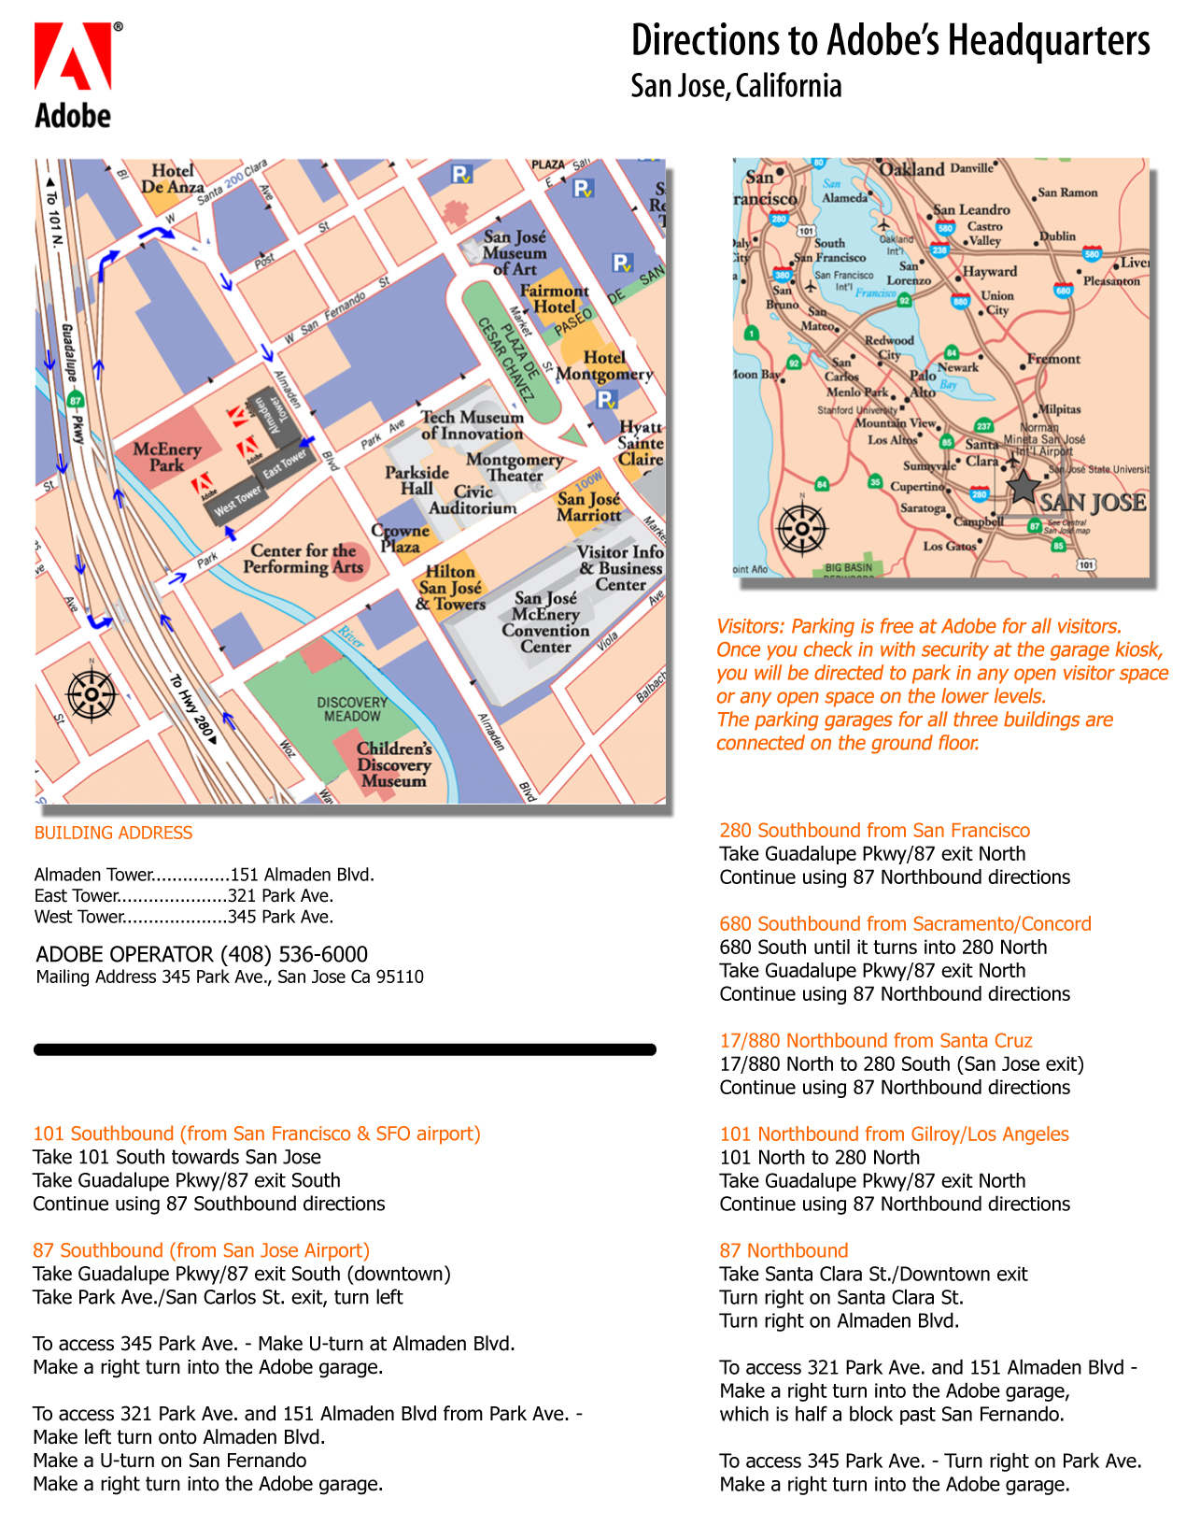
Getting to the Adobe campus from San Francisco Airport (SFO) or San Jose Airport (SJC):
All major rental companies have offices at SFO and SJC. SJC is the closest airport to Adobe and downtown San Jose. Cab fare is approximately $20 one way.

