JP |  | 2.2 and many others |  | ed | First character of “Clause” is capitalized. | Change to lower case character.
JP |  | 23.2 |  | te | In CJKsrc.txt file, UCS code point is described as the format of “U+hhhh” or “U+hhhhh”. This is not consistent with other UCS code point format “hhhh” or “hhhhh”, for example, in 22.4. | Change the format to “hhhh” or “hhhhh” in CJKsrc.txt.
JP |  | 31.3 | Code Chart for CJK Extension E | te | (This is to confirm the resolution IRG M41.2 from IRG meeting #41 in Tokyo.)  As described in IRG N1957, there are glyph errors in CJK Extension E code table as for U+2C0D1 and U+2C7D3. | Make sure to correct the glyphs shown as IRGN1977 with reflecting the feedback to this document if any.
JP |  | Annex A |  | ed | The title of A.6.12 is “312 Unicode 6.3”. | Change to “313 Unicode 6.3”
JP |  | Annex F |  | ed | “sub-clause” has a dash, although other “subclause” does not. | Keep them consistent.
JP |  | Annex S |  | te | (This is same comment as what JP commented at CD ballot of ISO/IEC 10646 4th edition.)  The following pair taken from S.3 is for a source separation caused by T source.  This figure should be taken from 2003 edition in order to preserve the original intention from the early days as follows.  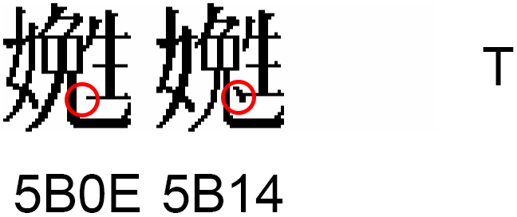  Here, a shape with a dot is on 5B14, and that without is on 5B0E. | Use the figure from 2003 edition.

