ISO/IEC JTC1/SC2/WG2 N4576-A
Updated Date: 2014-05-09
Logistics for JTC1/SC2/WG2 Meeting 63 in Colombo, Sri Lanka
29 September 2014 – 3 October 2014
Hosts | - Sri Lanka Standards Institution (SLSI)  17 Victoria Place, off Elvitigala Mawatha  Colombo 08, Sri Lanka  - Information and Communication Technology Agency of Sri Lanka (ICTA)  160/24, Kirimandala Mawatha, Colombo 05, Sri Lanka  www.icta.lk  +94 11 2369099, +94 11 2369100
Contact person | Ms. Chamali Perera  Information and Communication Technology Agency of Sri Lanka (ICTA)  chamalip@icta.lk  +94 11 2369099, +94 11 2369100 ext. 248.  Ms. Aruni Goonetilleke  aruni@icta.lk  +94 11 2369099, +94 11 2369100 ext. 298.  Ms. Rita Kern  rita@icta.lk +94 11 2369099, +94 11 2369100 ext. 287
Meeting location | Crystal Room – Lower,  Hotel Taj Samudra  No.25, Galle Face Center Road, Colombo, Sri Lanka  Phone: + 94 11 2 446622  http://www.taj-samudra-colombo-colombo-sri-lanka.ww.lk/index.html
Hotel | Hotel Ramada Colombo  30 Sir Mohamed Macan Markar Mawatha  Colombo 03, Sri Lanka,  Phone: +94 11 2422001  Email: info@ramadacolombo.com  Web: http://www.ramadacolombo.com/  Single/double with no breakfast: USD 121 nett  Single with breakfast: USD 131 nett  Double with breakfast: USD 141 nett  Please contact Charmaine when booking a room at the Ramada:  She’s the Banquet and Room Sales Coordinator.  Phone:  - Direct +94 11 4794307  - Mobile +94 773574801  - General +94 11 2422001  Email: charmaine@ramadacolombo.com  Please email Charmaine, rather than reserving through the Internet and state that it is for the ICTA event.  Map  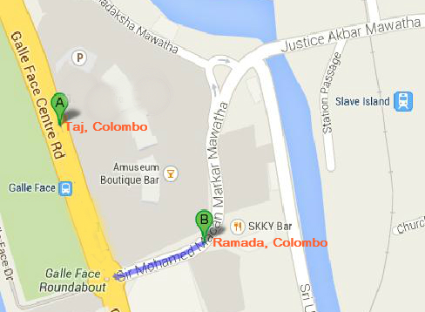
Entry visas | If you require a letter of invitation, please contact Rita. (rita@icta.lk )  Visa: The website address is: http://www.eta.gov.lk  Please use only the gov.lk site, not other sites.
Local weather  (forecast: for September/October) | 30º C
Currency | Approx. 1 USD = 130 LKR (2014-05-05 – Central Bank of Sri Lanka)
Electricity | 220 – 240 V, 50/60 Hz.
Airport pickup | The host will provide airport pickup.

