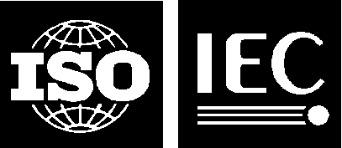 | ISO/IEC JTC 1/SC 2/WG 2 N4576
DATE: 2014-05-09

ISO/IEC JTC 1/SC 2/WG 2
Universal Multiple-Octet Coded Character Set (UCS) - ISO/IEC 10646
Secretariat: ANSI

DOC TYPE: | Calling Notice Meeting 63
TITLE: | 1st Call Meeting # 63 hosted by Sri Lanka Standards Institution (SLSI) and the Information and Communication Technology Agency of Sri Lanka (ICTA) in Colombo, Sri Lanka from 29 September 2014 through 3 October 2014.
SOURCE: | Mike Ksar, Convener
PROJECT: | JTC 1.02.18 – ISO/IEC 10646
STATUS:
ACTION ID: | ACT – Those who need a visa to Sri Lanka need to contact Ms. Chamali Perera, Information and Communication Technology Agency for Sri Lanka (ICTA), chamalip@icta.lk. Make plans to attend and provide input on agenda items. Logistics details are in document N4576-A, attached below. It includes logistics info and recommended hotels near the meeting site.
DUE DATE: | 2014-09-15
DISTRIBUTION: | SC2/WG2 members and Liaison organizations
MEDIUM: | Electronic
NO. OF PAGES: | 4

This is the first call for WG2 meeting # 63 from 29 September 2014 through 3 October 2014 hosted by by Sri Lanka Standards Institution (SLSI) and the Information and Communication Technology Agency of Sri Lanka (ICTA) in Colombo, Sri Lanka in Colombo, Sri Lanka. This call includes an agenda outline. The WG2 meeting starts at 10:00 am Monday, 29 September 2014 and concludes by noon time Friday 3 October 2014. It is followed by an SC2 Plenary in the afternoon of Friday, 3 October 2014. The call and agenda for the SC2 plenary will be issued by the SC2 Secretariat in Tokyo, Japan.

The objective of this meeting is to continue the WG2 program of work. Contributions, including ones that have been carried forward will be reviewed as well.

Mike Ksar
ISO/IEC/JTC 1/SC 2/WG 2 Convener  22680 Alcalde Rd  Cupertino, CA 95014 – U. S. A. | Phone: +1 408 255-1217  e-mail: mikeksar@10646.com
Agenda Outline – Meeting # 63
Topic (Document No.) | Proposed Outcome

- Opening and roll call Update WG2Distribution List
- Approval of the agenda Approved agenda
- Approval of minutes of meeting 62 Approved Minutes
- Review action items from previous meeting Updated Action Item List
- JTC1 and ITTF matters: FYI
- SC2 matters: FYI
  - SC2 Program of Work FYI
  - Submittals to ITTF FYI
  - Ballot results FYI
- WG2 matters:
- IRG status and reports
- Script contributions related to ballots:
- Script contributions not related to ballots
- Ballots disposition of comments
  - FDIS ISO/IEC 10646 4th edition
  - PDAM2 ISO/IEC 10646 4th edition
- Architecture issues
- Publication issues
- Defect reports
- Liaison reports
  - Unicode Consortium
  - IETF
  - SC22
  - W3C
  - SEI
- Other business
  - Web Site Review
  - Future Meetings
    - Meeting 64 – looking for host; backup: U.S.
    - Meeting 65 – looking for host; backup: U.S.
- Closing
  - Approval of Resolutions of Meeting 63
  - Adjournment

ISO/IEC JTC1/SC2/WG2 N4576-A
Updated Date: 2014-05-09
Logistics for JTC1/SC2/WG2 Meeting 63 in Colombo, Sri Lanka
29 September 2014 – 3 October 2014
Hosts | - Sri Lanka Standards Institution (SLSI)  17 Victoria Place, off Elvitigala Mawatha  Colombo 08, Sri Lanka  - Information and Communication Technology Agency of Sri Lanka (ICTA)  160/24, Kirimandala Mawatha, Colombo 05, Sri Lanka  www.icta.lk  +94 11 2369099, +94 11 2369100
Contact person | Ms. Chamali Perera  Information and Communication Technology Agency of Sri Lanka (ICTA)  chamalip@icta.lk  +94 11 2369099, +94 11 2369100 ext. 248.  Ms. Aruni Goonetilleke  aruni@icta.lk  +94 11 2369099, +94 11 2369100 ext. 298.  Ms. Rita Kern  rita@icta.lk +94 11 2369099, +94 11 2369100 ext. 287
Meeting location | Crystal Room – Lower,  Hotel Taj Samudra  No.25, Galle Face Center Road, Colombo, Sri Lanka  Phone: + 94 11 2 446622  http://www.taj-samudra-colombo-colombo-sri-lanka.ww.lk/index.html
Hotel | Hotel Ramada Colombo  30 Sir Mohamed Macan Markar Mawatha  Colombo 03, Sri Lanka,  Phone: +94 11 2422001  Email: info@ramadacolombo.com  Web: http://www.ramadacolombo.com/  Single/double with no breakfast: USD 121 nett  Single with breakfast: USD 131 nett  Double with breakfast: USD 141 nett  Please contact Charmaine when booking a room at the Ramada:  She’s the Banquet and Room Sales Coordinator.  Phone:  - Direct +94 11 4794307  - Mobile +94 773574801  - General +94 11 2422001  Email: charmaine@ramadacolombo.com  Please email Charmaine, rather than reserving through the Internet and state that it is for the ICTA event.  Map  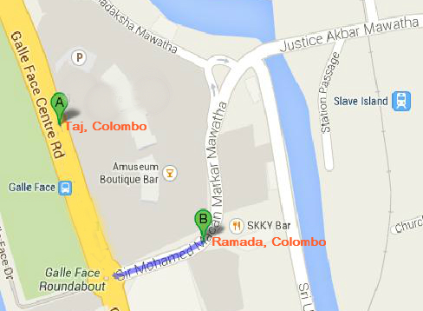
Entry visas | If you require a letter of invitation, please contact Rita. (rita@icta.lk )  Visa: The website address is: http://www.eta.gov.lk  Please use only the gov.lk site, not other sites.
Local weather  (forecast: for September/October) | 30º C
Currency | Approx. 1 USD = 130 LKR (2014-05-05 – Central Bank of Sri Lanka)
Electricity | 220 – 240 V, 50/60 Hz.
Airport pickup | The host will provide airport pickup.

