信息产业部归口的ISO/IEC文件投票表决意见审批表
文件编号 |  | N4340 |  | 要求完成日期 |  | 2014-8-31
专业室名称 |  | 信息技术研究中心 |  | 所收文时间 |  | 2014-7
技  术  归  口  单  位  意  见 | 文件中文名称 | ISO/IEC 10646 第四版第二补篇
技  术  归  口  单  位  意  见 | 文件内容概述 | ISO/IEC 10646《信息技术 通用编码字符集》对世界上所有文字统一编码，以解决多文种统一处理的问题。  本补篇对各国文字和古文字编码字符集进行了补充，包括我国提出的《通用规范汉字表》汉字和西夏字。
技  术  归  口  单  位  意  见 | 结论意见 | 同意但对西夏字字表和蒙古文字表提出意见。  经办人：陈壮 主管领导签字： 单位盖章： 年 月 日
技  术  归  口  单  位  意  见 | 科技发展部意见：  经办人： 年 月 日 |  | （副）总工程师批示：  签字： 年 月 日
部科技司批示  签字： 年 月 日 |  |  |  |  | ISO/IEC中国国家委员会秘书处审核意见：  签字： 年 月 日

China is in favor of SC2N4303 10646/NP Amd 2 with comments.

1. About 5 “BIRGA”s in Mongolian code chart
China does not agree to encode 5 “BIRGA”s (U+181A through U+181E). There are up to 14 “BIRGA”s (all are variants of U+1800 “MONGOLIAN BIRGA”) found in literatures, which means there is no enough space for them in Mongolian code chart. A proposal on usage of VARIATION SELECTORS for Mongolian, including that for “BIRGA”s will be submitted to SC2/WG2 soon.

2. About Tangut code charts.
1) The radical of should be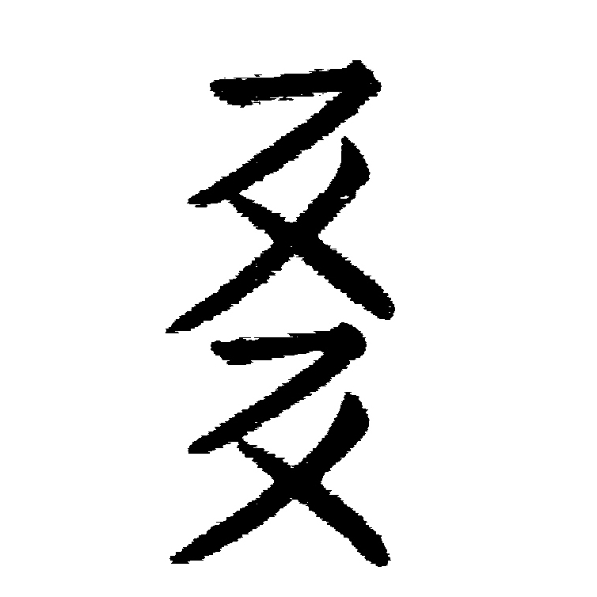.
2) There is no Tangut glyph like , it should be taken place by .
3) The glyph of is wrong, it should be taken place by .
4) The radical of should be 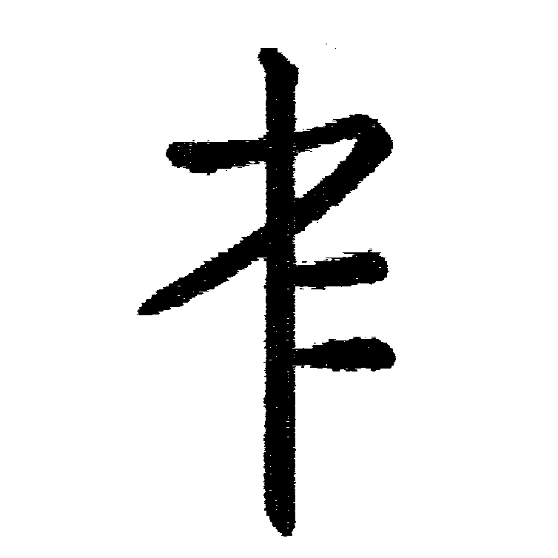.

MB/NC1 | Line number  (e.g. 17) | Clause/ Subclause  (e.g. 3.1) | Paragraph/ Figure/ Table/  (e.g. Table 1) | Type of comment2 | Comments | Proposed change | Observations of the secretariat
CN  01 |  |  | Mongolian | T | China does not agree to encode 5 “BIRGA”s (U+181A through U+181E). There are up to 14 “BIRGA”s (all are variants of U+1800 “MONGOLIAN BIRGA”) found in literatures, which means there is no enough space for them in Mongolian code chart. A proposal on usage of VARIATION SELECTORS for Mongolian, including that for “BIRGA”s will be submitted to SC2/WG2 soon.
CN  02 |  |  | Tangut | T |  | 1) The radical of should be.  2) There is no Tangut glyph like , it should be taken place by .  3) The glyph of is wrong, it should be taken place by .  4) The radical of should be .

