TOWARDS UNICODE STANDARD FOR URDU
Dr. Khaver ZIA
Director
Beaconhouse Informatics Computer Institute
Lahore. Pakistan
E-mail: kzia@informatics.edu.pk

ABSTRACT
This paper is an update on the progress made in standardization of Urdu in Pakistan. The compatibility of Standard character Set of Urdu with Unicode is analyzed. Inclusion of 25 Urdu Characters and ligatures in the Unicode standard is proposed.

KEYWORDS

Multilingual Processing, Standardization, Unicode, Urdu

- INTRODUCTION
Urdu language and its characteristics have been discussed in detail in earlier papers [1] [2]. The code table of Urdu referred to in these papers was approved by the Government of Pakistan in August 2000. In the current paper an analysis is done with a view to make the Urdu character set compatible with Unicode.
- ANALYSIS OF URDU CHARACTER CODES
The Unicode standard which is fully compatible with ISO/IEC 10646 specification encodes characters in a 16-bit code. This enables 65,535 unique characters to be encoded. The advantages of Unicode include uniform character width and ability to include all national standards. [3] [4].
On going through the encoding of characters in Unicode, it is found that Arabic and its associated languages have been allocated 1,200 code points. These code points range from 0600h to 06FFh (256 code points) and then from FB50h to FEFFh (944 code points). These code points comprise basic characters of the Arabic family of languages along with innumerable glyphs and ligatures.
An exercise was done to identify the Urdu characters in the Arabic block and draw up a table of comparison. The result is given in Table 1. After the exercise was completed it was found that 25 characters do not have a representation in Unicode. These have been listed in Table 2. Each character is given a proposed description and a symbol, where applicable. If these “missing characters” are given a place in Unicode standard, it would make Urdu compatible with Unicode and ISO/IEC 10646.
It should be noted that Unicode does not specify the collating sequence. In case of Urdu too, the collating sequence is defined through software. Unicode can serve as a source table for all the character and ligatures of Urdu, as it does for other languages of the world.
- CONCLUSION
ISO/IEC 10646 /Unicode is fast assuming a standard for representing national character codes. After analysis of Urdu character codes with Unicode standard, a table of missing Urdu characters is drawn up. It is proposed that these characters be included in the Unicode standard.
- REFERENCES
- ZIA, Khaver (1999),“Standard Code Table for Urdu”. 4th Symposium on Multilingual Information Processing (MLIT-4). Yangon. Myanmar. Organized by CICC Japan. October.
- ZIA, Khaver (1999), “A Survey of Standardization in Urdu.” 4th Symposium on Multilingual Information Processing (MLIT-4). Yangon. Myanmar. Organized by CICC Japan. October.
- LUA Kim Teng (1989), “Standardization for Multilingual Computing”. Keynote Address. Proc. of 3rd AFSIT Symposium held at Singapore. Organized by CICC. Japan. December.
- SHIBANO Koji (1993), “ISO/IEC 10646-1 in Japan”. Technical Report. Proc. of 7th AFSIT held in Tokyo. Japan. Organized by CICC Japan. October.
- ACKNOWLEDGEMENTS
The author thanks the management of Beaconhouse Informatics Pakistan, for its support in the preparation of this paper. The author gratefully acknowledges the provision of scanned bit-images of Urdu characters and ligatures by Mr. Humayun Qureshi, formerly of IBM, Pakistan.

TABLE 1

Standard Urdu Codes mapped to ISO/IEC 10646 /Unicode

Serial No. | Code Point (hex) | Symbol | Unicode | Unicode Description (where applicable) or Proposed Description
1-32 | 00-1F |  |  | CONTROL AREA (Lower Block)
33 | 20 |  | 0020 | SPACE
34 | 21 | ! | 0021 | EXCLAMATION MARK
35 | 22 | " | 0022 | QUOTATION MARK
36 | 23 | # | 0023 | NUMBER SIGN
37 | 24 | Cr | 00A4 | CURRENCY SIGN
38 | 25 | % | 0025 | PERCENTAGE SIGN
39 | 26 | & | 0026 | AMPERSAND
40 | 27 | ، |  | ARABIC-URDU INVERTED PESH SIGN Urdu
41 | 28 | ( | 0028 | LEFT PARENTHESIS
42 | 29 | ) | 0029 | RIGHT PARENTHESIS
43 | 2A | * | 002A | ASTERISK
44 | 2B | + | 002B | PLUS SIGN
45 | 2C | ، | 060C | ARABIC COMMA
46 | 2D | - | 002D | HYPHEN-MINUS
47 | 2E | 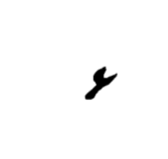 |  | ARABIC-URDU DECIMAL SIGN Urdu
48 | 2F | ÷ | 00F7 | DIVISION SIGN

Serial No. | Code Point (hex) | Symbol | Unicode | Unicode Description (where applicable) or Proposed Description
49 | 30 | 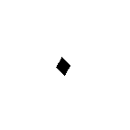 | 06F0 | EASTERN ARABIC-INDIC DIGIT ZERO
50 | 31 | 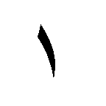 | 06F1 | EASTERN ARABIC-INDIC DIGIT ONE
51 | 32 | 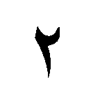 | 06F2 | EASTERN ARABIC-INDIC DIGIT TWO
52 | 33 | 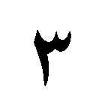 | 06F3 | EASTERN ARABIC-INDIC DIGIT THREE
53 | 34 | 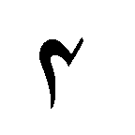 | 06F4 | EASTERN ARABIC-INDIC DIGIT FOUR
54 | 35 | 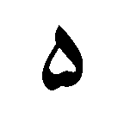 | 06F5 | EASTERN ARABIC-INDIC DIGIT FIVE
55 | 36 | 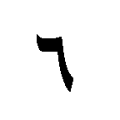 | 06F6 | EASTERN ARABIC-INDIC DIGIT SIX
56 | 37 | 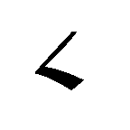 | 06F7 | EASTERN ARABIC-INDIC DIGIT SEVEN
57 | 38 | 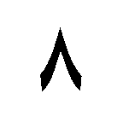 | 06F8 | EASTERN ARABIC-INDIC DIGIT EIGHT
58 | 39 | 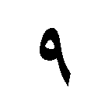 | 06F9 | EASTERN ARABIC-INDIC DIGIT NINE
59 | 3A | 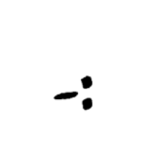 |  | ARABIC-URDU COLON SIGN Urdu
60 | 3B | ؛ | 061B | ARABIC SEMI-COLON
61 | 3C | < | 003C | LESS-THAN SIGN
62 | 3D | = | 003D | EQUALS SIGN
63 | 3E | > | 003E | GREATER-THAN SIGN
64 | 3F | 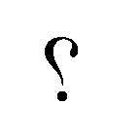 | 061F | ARABIC QUESTION MARK
65 | 40 | @ | 0040 | COMMERCIAL AT
66 | 41 |  |  | ARABIC-URDU HARD SPACE Urdu
67 | 42 | 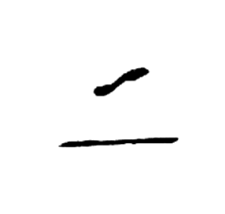 |  | ARABIC-URDU HAMZA E IZAFAT Urdu
68 | 43 | 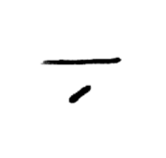 |  | ARABIC-URDU KASRA E IZAFAT Urdu

Serial No. | Code Point (hex) | Symbol | Unicode | Unicode Description (where applicable) or Proposed Description
69 | 44 | 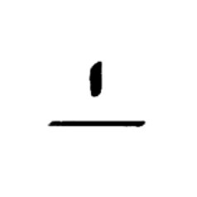 | 0670 | ARABIC ALEF ABOVE
70 | 45 | 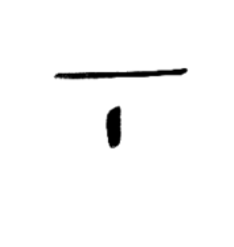 |  | ARABIC-URDU ALEF BELOW Urdu
71 | 46 | 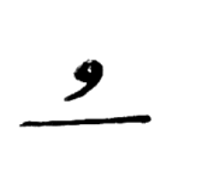 |  | ARABIC-URDU PESH ABOVE Urdu
72 | 47 | 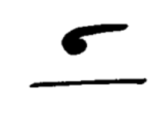 |  | ARABIC-URDU SPECIAL INVERTED PESH Urdu
73 | 48 | 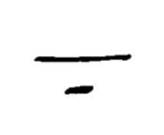 |  | ARABIC-URDU ZARE BELOW Urdu
74 | 49 | 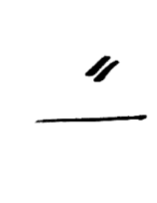 | 064B | ARABIC SPACING FATHATAN
75 | 4A | 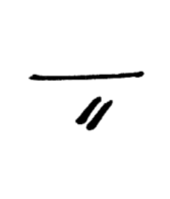 | 064D | ARABIC SPACING KASRATAN
76 | 4B | 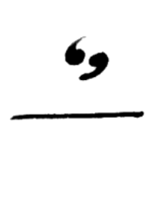 | 064C | ARABIC SPACING DAMMATAN
77 | 4C | 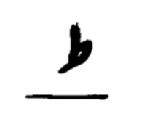 |  | ARABIC-URDU SMALL TAH Urdu
78 | 4D | 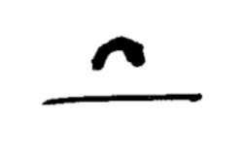 |  | ARABIC-URDU SAKOON Urdu
79 | 4E | 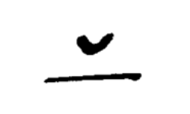 |  | ARABIC-URDU REVERSE SAKOON Urdu
80 | 4F | 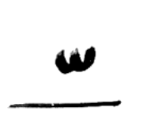 | 0651 | ARABIC SHADDAH
81 | 50 | 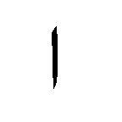 | 0627 | ARABIC LETTER ALEF
82 | 51 | 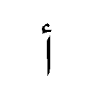 | 0623 | ARABIC LETTER HAMZAH ON ALEF
83 | 52 | 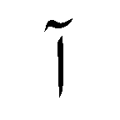 | 0622 | ARABIC LETTER MADDAH ON ALEF
84 | 53 | 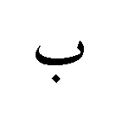 | 0628 | ARABIC LETTER BAA
85 | 54 | 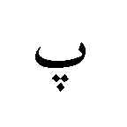 | 067E | ARABIC LETTER TAA WITH THREE DOTS BELOW = peh
86 | 55 | 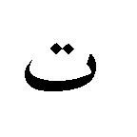 | 062A | ARABIC LETTER TAA
87 | 56 | 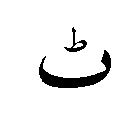 | 0679 | ARABIC LETTER TAA WITH SMALL TAH
88 | 57 | 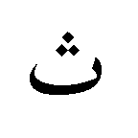 | 062B | ARABIC LETTER THAA

Serial No. | Code Point (hex) | Symbol | Unicode | Unicode Description (where applicable) or Proposed Description
89 | 58 | 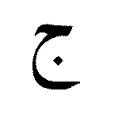 | 062C | ARABIC LETTER JEEM
90 | 59 | 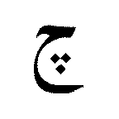 | 0686 | ARABIC LETTER HAA WITH MIDDLE THREE DOTS DOWNWARD = tcheh
91 | 5A | 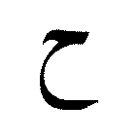 | 062D | ARABIC LETTER HAA
92 | 5B | 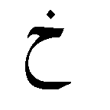 | 062E | ARABIC LETTER KHAA
93 | 5C | 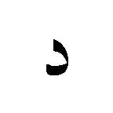 | 062F | ARABIC LETTER DAL
94 | 5D | 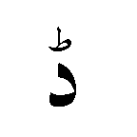 | 0688 | ARABIC LETTER DAL WITH SMALL TAH
95 | 5E | 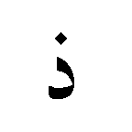 | 0630 | ARABIC LETTER THAL
96 | 5F | 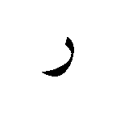 | 0631 | ARABIC LETTER RA
97 | 60 | 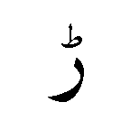 | 0691 | ARABIC LETTER RA WITH SMALL TAH
98 | 61 | 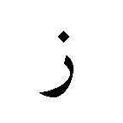 | 0632 | ARABIC LETTER ZAIN
99 | 62 | 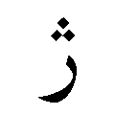 | 0698 | ARABIC LETTER RA WITH THREE DOTS ABOVE = jeh
100 | 63 | 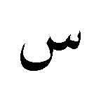 | 0633 | ARABIC LETTER SEEN
101 | 64 | 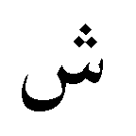 | 0634 | ARABIC LETTER SHEEN
102 | 65 | 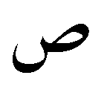 | 0635 | ARABIC LETTER SAD
103 | 66 | 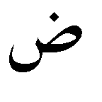 | 0636 | ARABIC LETTER DAD
104 | 67 | 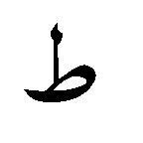 | 0637 | ARABIC LETTER TAH
105 | 68 | 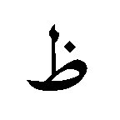 | 0638 | ARABIC LETTER DHAH
106 | 69 | 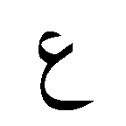 | 0639 | ARABIC LETTER AIN
107 | 6A | 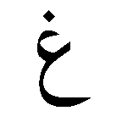 | 063A | ARABIC LETTER GHAIN
108 | 6B | 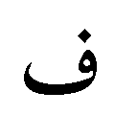 | 0641 | ARABIC LETTER FA

Serial No. | Code Point (hex) | Symbol | Unicode | Unicode Description (where applicable) or Proposed Description
109 | 6C | 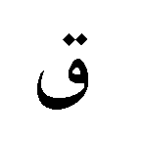 | 0642 | ARABIC LETTER QAF
110 | 6D | 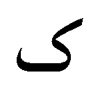 | 06A9 | ARABIC LETTER OPEN CAF
111 | 6E | 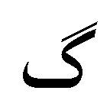 | 06AF | ARABIC LETTER GAF
112 | 6F | 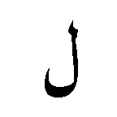 | 0644 | ARABIC LETTER LAM
113 | 70 | 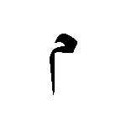 | 0645 | ARABIC LETTER MEEM
114 | 71 | 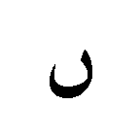 | 06BA | ARABIC LETTER DOTLESS NOON
115 | 72 | 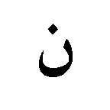 | 0646 | ARABIC LETTER NOON
116 | 73 | 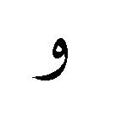 | 0648 | ARABIC LETTER WAW
117 | 74 | 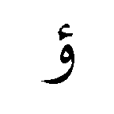 | 0624 | ARABIC LETTER HAMZAH ON WAW
118 | 75 | 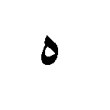 | 0647 | ARABIC LETTER HA
119 | 76 | 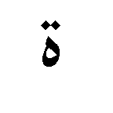 | 0629 | ARABIC LETTER TAA MARBUTAH
120 | 77 | 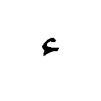 | 0621 | ARABIC LETTER HAMZAH
121 | 78 | 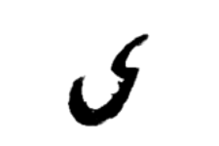 | 0649 | ARABIC LETTER ALEF MAQSURAH
122 | 79 | 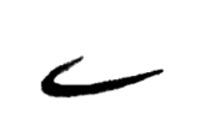 | 06D2 | ARABIC LETTER YA BARREE
123 | 7A | 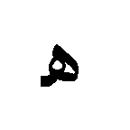 | 06BE | ARABIC LETTER KNOTTED HA
124 | 7B |  |  | ARABIC-URDU NO-DICRITIC SIGN Urdu
125 | 7C | 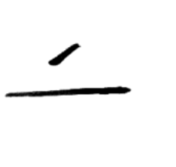 | 064E | ARABIC FATHAH
126 | 7D | 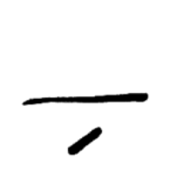 | 0650 | ARABIC KASRAH
127 | 7E |  | 064F | ARABIC DAMMAH
128 | 7F |  |  | NOT USED

Serial No. | Code Point (hex) | Symbol | Unicode | Unicode Description (where applicable) or Proposed Description
129-  160 | 80-9F |  |  | CONTROL AREA (Upper Block)
161 | A0 | 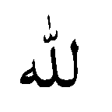 | FDF2 | ARABIC LIGATURE ALLAH ISOLATED FORM
162 | A1 | 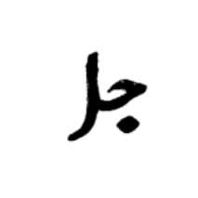 | FDFB | ARABIC LIGATURE JALLA JALALOUHOU
163 | A2 | 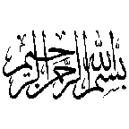 |  | ARABIC-URDU LIGATURE BISMILLAH Urdu
164 | A3 |  | FDFA | ARABIC LIGATURE SALLALLAHOU ALAYHE WASALLAM
165 | A4 | 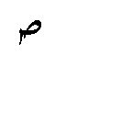 | FDF9 | ARABIC LIGATURE SALLA ISOLATED FORM
166 | A5 | 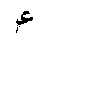 |  | ARABIC-URDU LIGATURE ALAYHE AS SALAM Urdu
167 | A6 | 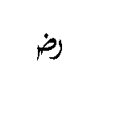 |  | ARABIC-URDU LIGATURE RADIALLAH Urdu
168 | A7 | 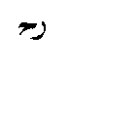 |  | ARABIC-URDU LIGATURE REHMATULLAH Urdu
169 | A8 | 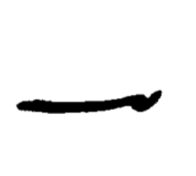 |  | ARABIC-URDU TAKHALLUS SIGN (Poetry) Urdu
170 | A9 | 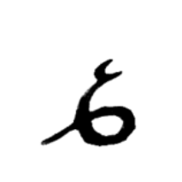 |  | ARABIC-URDU MISRA SIGN (Poetry) Urdu
171 | AA | 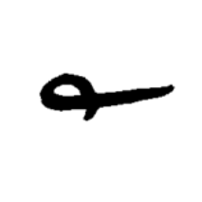 |  | ARABIC-URDU FOOTNOTE SIGN Urdu
172 | AB | 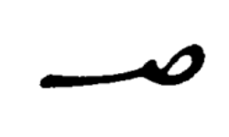 |  | ARABIC-URDU SAFAH SIGN Urdu
173 | AC | 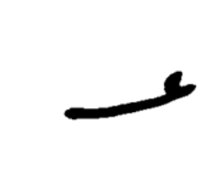 |  | ARABIC-URDU NUMBER SIGN Urdu
174 | AD | 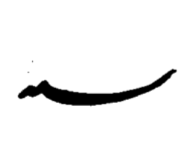 |  | ARABIC-URDU SANAH SIGN Urdu
175 | AE | 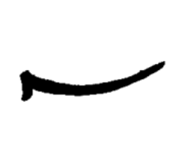 |  | ARABIC-URDU LONG MADD Urdu
176 | AF | 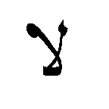 | FEFB | ARABIC LAAM ALEF ISOLATED
177 | B0 | ס |  | ARABIC-URDU END OF SECTION SIGN Urdu
178- 192 | B1-BF |  |  | RESERVED AREA

SerialNo. | Code Point (hex) | Symbol | Unicode | Unicode Description (where applicable) or Proposed Description
193 | C0 | [ | 005B | LEFT SQUARE BRACKET
194 | C1 | \ | 005C | REVERSE SOLIDUS (BACKSLASH)
195 | C2 | ] | 005D | RIGHT SQUARE BRACKET
196 | C3 | _ | 005F | LOW LINE (UNDERSCORE)
197 | C4 | { | 007B | LEFT CURLY BRACKET
198 | C5 | : | 003A | COLON
199 | C6 | } | 007D | RIGHT CURLY BRACKET
200 | C7 | 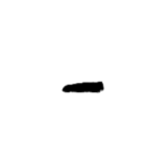 | 06D4 | ARABIC PERIOD (DASH)
201-  208 | C8-CF |  |  | RESERVED AREA
209- 254 | D0- FD |  |  | VENDOR AREA
255 | FE |  |  | LANGUAGE TOGGLE
256 | FF |  |  | NOT USED

TABLE 2

Characters and Ligatures from Standard Urdu Code Page
proposed for inclusion in ISO/IEC 10646 / Unicode

Serial No. | Code Point (hex) | Symbol | Unicode | Proposed Description
1 | 2E |  |  | ARABIC-URDU DECIMAL SIGN Urdu
2 | 3A |  |  | ARABIC-URDU COLON SIGN Urdu
3 | 41 |  |  | ARABIC-URDU HARD SPACE Urdu
4 | 42 |  |  | ARABIC-URDU HAMZA E IZAFAT Urdu
5 | 43 |  |  | ARABIC-URDU KASRA E IZAFAT Urdu
6 | 45 |  |  | ARABIC-URDU ALEF BELOW Urdu
l7 | 46 |  |  | ARABIC-URDU PESH ABOVE Urdu
8 | 47 |  |  | ARABIC-URDU SPECIAL INVERTED PESH Urdu
9 | 48 |  |  | ARABIC-URDU ZARE BELOW Urdu
10 | 4C |  |  | ARABIC-URDU SMALL TAH Urdu
11 | 4D |  |  | ARABIC-URDU SAKOON Urdu
12 | 4E |  |  | ARABIC-URDU REVERSE SAKOON Urdu
13 | 7B |  |  | ARABIC-URDU NO-DICRITIC SIGN Urdu
14 | A2 |  |  | ARABIC-URDU LIGATURE BISMILLAH Urdu
15 | A5 |  |  | ARABIC-URDU LIGATURE ALAYHE AS SALAM Urdu
16 | A6 |  |  | ARABIC-URDU LIGATURE RADIALLAH Urdu

Serial No. | Code Point (hex) | Symbol | Unicode | Proposed Description
17 | A7 |  |  | ARABIC-URDU LIGATURE REHMATULLAH Urdu
18 | A8 |  |  | ARABIC-URDU TAKHALLUS SIGN (Poetry) Urdu
19 | A9 |  |  | ARABIC-URDU MISRA SIGN (Poetry) Urdu
20 | AA |  |  | ARABIC-URDU FOOTNOTE SIGN Urdu
21 | AB |  |  | ARABIC-URDU SAFAH SIGN Urdu
22 | AC |  |  | ARABIC-URDU NUMBER SIGN Urdu
23 | AD |  |  | ARABIC-URDU SANAH SIGN Urdu
24 | AE |  |  | ARABIC-URDU LONG MADD Urdu
25 | B0 | ס |  | ARABIC-URDU END OF SECTION SIGN Urdu

