ISO
INTERNATIONAL ORGANIZATION FOR SANDARDIZATION
ORGANISATION INTERNATIONLE DE NORMALISATION
ISO/IEC JTC1/SC2/WG2
Universal Multiple - Octet Coded Character Set
( UCS )
ISO/IEC JTC1/SC2/WG2 N1814
Date: 1998-07-26

Title: Revised Proposal for Yi Characters and Yi Radicals
Source: China
Action:

Distribution: WG2 members

Introduction:

At WG2 meeting 33, China’s proposals N1608---Yi Characters and N1611---Yi Radicals were accepted by WG2 according to its RESOLUTION M33.18 ( Yi Script and Yi radicals), " WG 2 accepts 1165 characters, their shapes and names in document N 1608 for the Yi script, and their assignment to code positions in the range A000 to A48C in the BMP, and 57 characters (Note: 18 more than in resolution M32.8), their shapes and names in document N 1611 for the Yi radicals, and their assignment to code positions in the range A490 to A4C8 in the BMP.", they were also accepted by SC2 according to its resolution M07.11 of the 7th SC2 meeting.

Since some foreign experts and Chinese Yi experts noticed that there are some errors in the proposals mentioned above, China votes “NO” on PDAM 14---Yi syllables and Yi radicals with this revised proposal. In this paper, Chinese Yi experts corrected some characters’ names, removed duplicated character and changed their order in accordance with the habitual usage of Yi script.

The total number of Yi characters is 1165 and of Yi radicals is 57 as before. For details of coding and naming convention, please refer to the attachment.

The table below gives some of the correction.

Previous position and name | Current position and name | Change
A147 HAP |  | REMOVED (duplicated with that in A109)
A3D2 HXE | A17C HXE | MOVED
A1E5 LURP |  | REMOVED
 | A1E6 LUT
A1E8 LURT |  | REMOVED
 | A1EC LYT
A207 MURX | A20B MYRX | NAME CORRECTED
A208 MUR | A20C MYR | NAME CORRECTED
 | A230 NAP
A2A3 NZEX | A2A8 NREX | NAME CORRECTED
A3D0 VO |  | REMOVED
 | A3D3 VE
A43F ZZIT | A43F ZZITT | NAME CORRECTED
A48C WU | A43F W | NAME CORRECTED
A49F JY | A49F JYP | NAME CORRECTED
A4A6 PYT | A4A6 OTR | NAME CORRECTED
A4B0 CY | A4B0 XI | NAME CORRECTED
A4B3 LAVE | A4B3 LAV | NAME CORRECTED
A4B7 X | A4B7 FUZZ | NAME CORRECTED
A4BD VU | A4BD NGOT | NAME CORRECTED
A4C1 CISSEP | A4C1 CISS | NAME CORRECTED
A4C2 YRRT | A4C2 VRRT | NAME CORRECTED
A4C3 VRRT | A4C3 YRRT | NAME COORECTED
A4C5 HXOT | A4C5 TAT | NAME CORRECTED
A4C7 OB | A4C7 O | NAME CORRECTED

For details, see attachment please.
This page is intentionally left blank
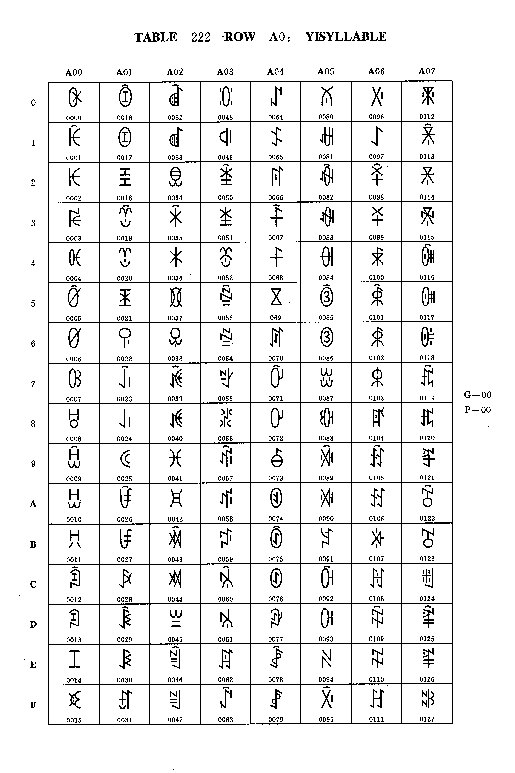
Table 222 - Row A0: YI SYLLABLES

G=00

P=00
Table 222 - Row A0: YI SYLLABLES

dec | hex | Name
000  001  002  003  004  005  006  007  008  009  010  011  012  013  014  015  016  017  018  019  020  021  022  023  024  025  026  027  028  029  030  031  032  033  034  035  036  037  038  039  040  041  042  043  044  045  046  047  048  049  050  051  052  053  054  055  056  057  058  059  060  061  062  063 | 00  01  02  03  04  05  06  07  08  09  0A  0B  0C  0D  0E  0F  10  11  12  13  14  15  16  17  18  19  1A  1B  1C  1D  1E  1F  20  21  22  23  24  25  26  27  28  29  2A  2B  2C  2D  2E  2F  30  31  32  33  34  35  36  37  38  39  3A  3B  3C  3D  3E  3F | YI SYLLABLE BIT  YI SYLLABLE BIX  YI SYLLABLE BI  YI SYLLABLE BIP  YI SYLLABLE BIET  YI SYLLABLE BIEX  YI SYLLABLE BIE  YI SYLLABLE BIEP  YI SYLLABLE BAT  YI SYLLABLE BAX  YI SYLLABLE BA  YI SYLLABLE BAP  YI SYLLABLE BUOX  YI SYLLABLE BUO  YI SYLLABLE BUOP  YI SYLLABLE BOT  YI SYLLABLE BOX  YI SYLLABLE BO  YI SYLLABLE BOP  YI SYLLABLE BEX  YI SYLLABLE BE  YI SYLLABLE BEP  YI SYLLABLE BUT  YI SYLLABLE BUX  YI SYLLABLE BU  YI SYLLABLE BUP  YI SYLLABLE BURX  YI SYLLABLE BUR  YI SYLLABLE BYT  YI SYLLABLE BYX  YI SYLLABLE BY  YI SYLLABLE BYP  YI SYLLABLE BYRX  YI SYLLABLE BYR  YI SYLLABLE BBIT  YI SYLLABLE BBIX  YI SYLLABLE BBI  YI SYLLABLE BBIP  YI SYLLABLE BBIET  YI SYLLABLE BBIEX  YI SYLLABLE BBIE  YI SYLLABLE BBIEP  YI SYLLABLE BBAT  YI SYLLABLE BBAX  YI SYLLABLE BBA  YI SYLLABLE BBAP  YI SYLLABLE BBUOX  YI SYLLABLE BBUO  YI SYLLABLE BBUOP  YI SYLLABLE BBOT  YI SYLLABLE BBOX  YI SYLLABLE BBO  YI SYLLABLE BBOP  YI SYLLABLE BBEX  YI SYLLABLE BBE  YI SYLLABLE BBEP  YI SYLLABLE BBUT  YI SYLLABLE BBUX  YI SYLLABLE BBU  YI SYLLABLE BBUP  YI SYLLABLE BBURX  YI SYLLABLE BBUR  YI SYLLABLE BBYT  YI SYLLABLE BBYX

dec | hex | Name
064  065  066  067  068  069  070  071  072  073  074  075  076  077  078  079  080  081  082  083  084  085  086  087  088  089  090  091  092  093  094  095  096  097  098  099  100  101  102  103  104  105  106  107  108  109  110  111  112  113  114  115  116  117  118  119  120  121  122  123  124  125  126  127 | 40  41  42  43  44  45  46  47  48  49  4A  4B  4C  4D  4E  4F  50  51  52  53  54  55  56  57  58  59  5A  5B  5C  5D  5E  5F  60  61  62  63  64  65  66  67  68  69  6A  6B  6C  6D  6E  6F  70  71  72  73  74  75  76  77  78  79  7A  7B  7C  7D  7E  7F | YI SYLLABLE BBY  YI SYLLABLE BBYP  YI SYLLABLE CIT  YI SYLLABLE CIX  YI SYLLABLE CI  YI SYLLABLE CIP  YI SYLLABLE CIET  YI SYLLABLE CIEX  YI SYLLABLE CIE  YI SYLLABLE CIEP  YI SYLLABLE CAT  YI SYLLABLE CAX  YI SYLLABLE CA  YI SYLLABLE CAP  YI SYLLABLE CUOX  YI SYLLABLE CUO  YI SYLLABLE CUOP  YI SYLLABLE COT  YI SYLLABLE COX  YI SYLLABLE CO  YI SYLLABLE COP  YI SYLLABLE CEX  YI SYLLABLE CE  YI SYLLABLE CEP  YI SYLLABLE CUT  YI SYLLABLE CUX  YI SYLLABLE CU  YI SYLLABLE CUP  YI SYLLABLE CURX  YI SYLLABLE CUR  YI SYLLABLE CYT  YI SYLLABLE CYX  YI SYLLABLE CY  YI SYLLABLE CYP  YI SYLLABLE CYRX  YI SYLLABLE CYR  YI SYLLABLE CHAT  YI SYLLABLE CHAX  YI SYLLABLE CHA  YI SYLLABLE CHAP  YI SYLLABLE CHUOT  YI SYLLABLE CHUOX  YI SYLLABLE CHUO  YI SYLLABLE CHUOP  YI SYLLABLE CHOT  YI SYLLABLE CHOX  YI SYLLABLE CHO  YI SYLLABLE CHOP  YI SYLLABLE CHET  YI SYLLABLE CHEX  YI SYLLABLE CHE  YI SYLLABLE CHEP  YI SYLLABLE CHUX  YI SYLLABLE CHU  YI SYLLABLE CHUP  YI SYLLABLE CHURX  YI SYLLABLE CHUR  YI SYLLABLE CHYT  YI SYLLABLE CHYX  YI SYLLABLE CHY  YI SYLLABLE CHYP  YI SYLLABLE CHYRX  YI SYLLABLE CHYR  YI SYLLABLE DIT

Group 00 Plane 00 Row A0
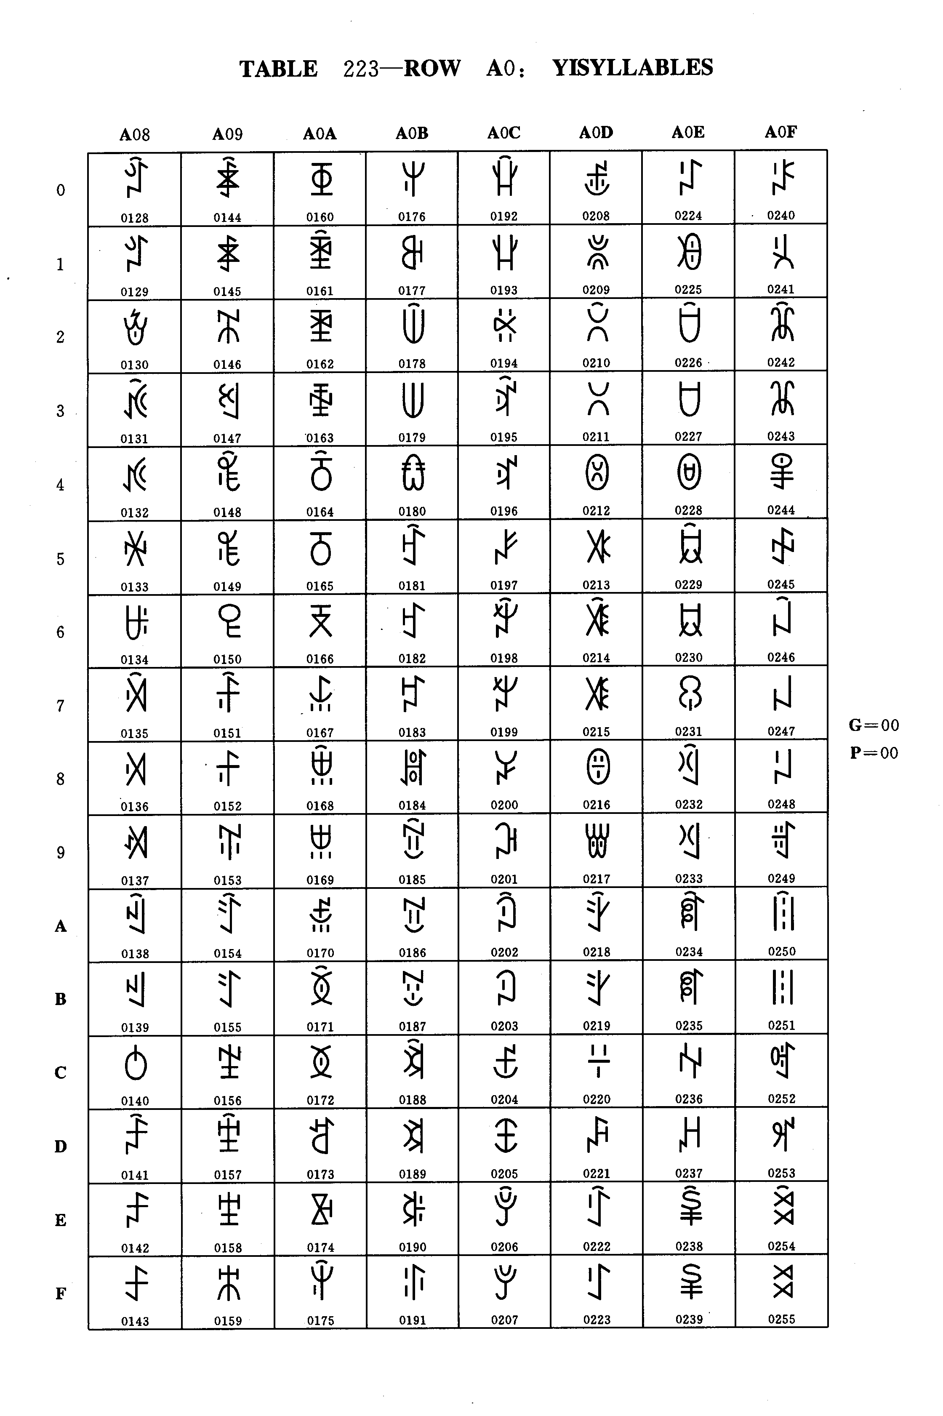
Table 223 - Row A0: YI SYLLABLES

TABLE 223 - Row A0: YI SYLLABLES
G = 00
P = 00

dec | hex | Name
128  129  130  131  132  133  134  135  136  137  138  139  140  141  142  143  144  145  146  147  148  149  150  151  152  153  154  155  156  157  158  159  160  161  162  163  164  165  166  167  168  169  170  171  172  173  174  175  176  177  178  179  180  181  182  183  184  185  186  187  188  189  190  191 | 80  81  82  83  84  85  86  87  88  89  8A  8B  8C  8D  8E  8F  90  91  92  93  94  95  96  97  98  99  9A  9B  9C  9D  9E  9F  A0  A1  A2  A3  A4  A5  A6  A7  A8  A9  AA  AB  AC  AD  AE  AF  B0  B1  B2  B3  B4  B5  B6  B7  B8  B9  BA  BB  BC  BD  BE  BF | YI SYLLABLE DIX  YI SYLLABLE DI  YI SYLLABLE DIP  YI SYLLABLE DIEX  YI SYLLABLE DIE  YI SYLLABLE DIEP  YI SYLLABLE DAT  YI SYLLABLE DAX  YI SYLLABLE DA  YI SYLLABLE DAP  YI SYLLABLE DUOX  YI SYLLABLE DUO  YI SYLLABLE DOT  YI SYLLABLE DOX  YI SYLLABLE DO  YI SYLLABLE DOP  YI SYLLABLE DEX  YI SYLLABLE DE  YI SYLLABLE DEP  YI SYLLABLE DUT  YI SYLLABLE DUX  YI SYLLABLE DU  YI SYLLABLE DUP  YI SYLLABLE DURX  YI SYLLABLE DUR  YI SYLLABLE DDIT  YI SYLLABLE DDIX  YI SYLLABLE DDI  YI SYLLABLE DDIP  YI SYLLABLE DDIEX  YI SYLLABLE DDIE  YI SYLLABLE DDIEP  YI SYLLABLE DDAT  YI SYLLABLE DDAX  YI SYLLABLE DDA  YI SYLLABLE DDAP  YI SYLLABLE DDUOX  YI SYLLABLE DDUO  YI SYLLABLE DDUOP  YI SYLLABLE DDOT  YI SYLLABLE DDOX  YI SYLLABLE DDO  YI SYLLABLE DDOP  YI SYLLABLE DDEX  YI SYLLABLE DDE  YI SYLLABLE DDEP  YI SYLLABLE DDUT  YI SYLLABLE DDUX  YI SYLLABLE DDU  YI SYLLABLE DDUP  YI SYLLABLE DDURX  YI SYLLABLE DDUR  YI SYLLABLE FIT  YI SYLLABLE FIX  YI SYLLABLE FI  YI SYLLABLE FIP  YI SYLLABLE FAT  YI SYLLABLE FAX  YI SYLLABLE FA  YI SYLLABLE FAP  YI SYLLABLE FOX  YI SYLLABLE FO  YI SYLLABLE FOP  YI SYLLABLE FUT

dec | hex | Name
192  193  194  195  196  197  198  199  200  201  202  203  204  205  206  207  208  209  210  211  212  213  214  215  216  217  218  219  220  221  222  223  224  225  226  227  228  229  230  231  232  233  234  235  236  237  238  239  240  241  242  243  244  245  246  247  248  249  250  251  252  253  254  255. | C0  C1  C2  C3  C4  C5  C6  C7  C8  C9  CA  CB  CC  CD  CE  CF  D0  D1  D2  D3  D4  D5  D6  D7  D8  D9  DA  DB  DC  DD  DE  DF  E0  E1  E2  E3  E4  E5  E6  E7  E8  E9  EA  EB  EC  ED  EE  EF  F0  F1  F2  F3  F4  F5  F6  F7  F8  F9  FA  FB  FC  FD  FE  FF | YI SYLLABLE FUX  YI SYLLABLE FU  YI SYLLABLE FUP  YI SYLLABLE FURX  YI SYLLABLE FUR  YI SYLLABLE FYT  YI SYLLABLE FYX  YI SYLLABLE FY  YI SYLLABLE FYP  YI SYLLABLE GIT  YI SYLLABLE GIX  YI SYLLABLE GI  YI SYLLABLE GIP  YI SYLLABLE GIET  YI SYLLABLE GIEX  YI SYLLABLE GIE  YI SYLLABLE GIEP  YI SYLLABLE GAT  YI SYLLABLE GAX  YI SYLLABLE GA  YI SYLLABLE GAP  YI SYLLABLE GUOT  YI SYLLABLE GUOX  YI SYLLABLE GUO  YI SYLLABLE GUOP  YI SYLLABLE GOT  YI SYLLABLE GOX  YI SYLLABLE GO  YI SYLLABLE GOP  YI SYLLABLE GET  YI SYLLABLE GEX  YI SYLLABLE GE  YI SYLLABLE GEP  YI SYLLABLE GUT  YI SYLLABLE GUX  YI SYLLABLE GU  YI SYLLABLE GUP  YI SYLLABLE GURX  YI SYLLABLE GUR  YI SYLLABLE GGIT  YI SYLLABLE GGIX  YI SYLLABLE GGI  YI SYLLABLE GGIEX  YI SYLLABLE GGIE  YI SYLLABLE GGIEP  YI SYLLABLE GGAT  YI SYLLABLE GGAX  YI SYLLABLE GGA  YI SYLLABLE GGAP  YI SYLLABLE GGUOT  YI SYLLABLE GGUOX  YI SYLLABLE GGUO  YI SYLLABLE GGUOP  YI SYLLABLE GGOT  YI SYLLABLE GGOX  YI SYLLABLE GGO  YI SYLLABLE GGOP  YI SYLLABLE GGET  YI SYLLABLE GGEX  YI SYLLABLE GGE  YI SYLLABLE GGEP  YI SYLLABLE GGUT  YI SYLLABLE GGUX  YI SYLLABLE GGU

Group 00 Plane 00 Row A0

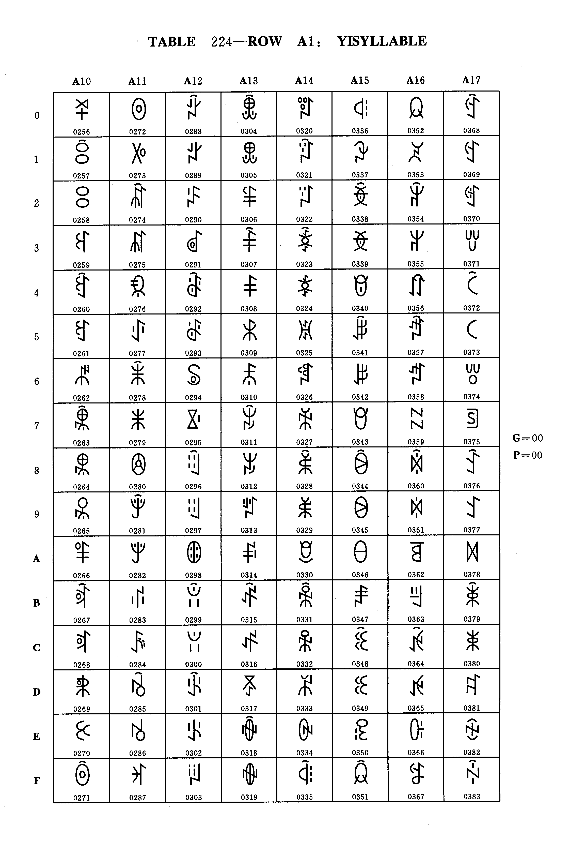
Table 224 - Row A1: YI SYLLABLES

Table 224 - Row A1: YI SYLLABLES
G = 00
P = 00

dec | hex | Name
000  001  002  003  004  005  006  007  008  009  010  011  012  013  014  015  016  017  018  019  020  021  022  023  024  025  026  027  028  029  030  031  032  033  034  035  036  037  038  039  040  041  042  043  044  045  046  047  048  049  050  051  052  053  054  055  056  057  058  059  060  061  062  063 | 00  01  02  03  04  05  06  07  08  09  0A  0B  0C  0D  0E  0F  10  11  12  13  14  15  16  17  18  19  1A  1B  1C  1D  1E  1F  20  21  22  23  24  25  26  27  28  29  2A  2B  2C  2D  2E  2F  30  31  32  33  34  35  36  37  38  39  3A  3B  3C  3D  3E  3F | YI SYLLABLE GGUP  YI SYLLABLE GGURX  YI SYLLABLE GGUR  YI SYLLABLE HIT  YI SYLLABLE HIEX  YI SYLLABLE HIE  YI SYLLABLE HAT  YI SYLLABLE HAX  YI SYLLABLE HA  YI SYLLABLE HAP  YI SYLLABLE HUOT  YI SYLLABLE HUOX  YI SYLLABLE HUO  YI SYLLABLE HUOP  YI SYLLABLE HOT  YI SYLLABLE HOX  YI SYLLABLE HO  YI SYLLABLE HOP  YI SYLLABLE HEX  YI SYLLABLE HE  YI SYLLABLE HEP  YI SYLLABLE HMIT  YI SYLLABLE HMIX  YI SYLLABLE HMI  YI SYLLABLE HMIP  YI SYLLABLE HMIEX  YI SYLLABLE HMIE  YI SYLLABLE HMIEP  YI SYLLABLE HMAT  YI SYLLABLE HMAX  YI SYLLABLE HMA  YI SYLLABLE HMAP  YI SYLLABLE HMUOX  YI SYLLABLE HMUO  YI SYLLABLE HMUOP  YI SYLLABLE HMOT  YI SYLLABLE HMOX  YI SYLLABLE HMO  YI SYLLABLE HMOP  YI SYLLABLE HMUT  YI SYLLABLE HMUX  YI SYLLABLE HMU  YI SYLLABLE HMUP  YI SYLLABLE HMURX  YI SYLLABLE HMUR  YI SYLLABLE HMYX  YI SYLLABLE HMY  YI SYLLABLE HMYP  YI SYLLABLE HMYRX  YI SYLLABLE HMYR  YI SYLLABLE HNIT  YI SYLLABLE HNIX  YI SYLLABLE HNI  YI SYLLABLE HNIP  YI SYLLABLE HNIET  YI SYLLABLE HNIEX  YI SYLLABLE HNIE  YI SYLLABLE HNIEP  YI SYLLABLE HNAT  YI SYLLABLE HNAX  YI SYLLABLE HNA  YI SYLLABLE HNAP  YI SYLLABLE HNUOX  YI SYLLABLE HNUO

dec | hex | Name
064  065  066  067  068  069  070  071  072  073  074  075  076  077  078  079  080  081  082  083  084  085  086  087  088  089  090  091  092  093  094  095  096  097  098  099  100  101  102  103  104  105  106  107  108  109  110  111  112  113  114  115  116  117  118  119  120  121  122  123  124  125  126  127 | 40  41  42  43  44  45  46  47  48  49  4A  4B  4C  4D  4E  4F  50  51  52  53  54  55  56  57  58  59  5A  5B  5C  5D  5E  5F  60  61  62  63  64  65  66  67  68  69  6A  6B  6C  6D  6E  6F  70  71  72  73  74  75  76  77  78  79  7A  7B  7C  7D  7E  7F | YI SYLLABLE HNOT  YI SYLLABLE HNOX  YI SYLLABLE HNOP  YI SYLLABLE HNEX  YI SYLLABLE HNE  YI SYLLABLE HNEP  YI SYLLABLE HNUT  YI SYLLABLE HLIT  YI SYLLABLE HLIX  YI SYLLABLE HLI  YI SYLLABLE HLIP  YI SYLLABLE HLIEX  YI SYLLABLE HLIE  YI SYLLABLE HLIEP  YI SYLLABLE HLAT  YI SYLLABLE HLAX  YI SYLLABLE HLA  YI SYLLABLE HLAP  YI SYLLABLE HLUOX  YI SYLLABLE HLUO  YI SYLLABLE HLUOP  YI SYLLABLE HLOX  YI SYLLABLE HLO  YI SYLLABLE HLOP  YI SYLLABLE HLEX  YI SYLLABLE HLE  YI SYLLABLE HLEP  YI SYLLABLE HLUT  YI SYLLABLE HLUX  YI SYLLABLE HLU  YI SYLLABLE HLUP  YI SYLLABLE HLURX  YI SYLLABLE HLUR  YI SYLLABLE HLYT  YI SYLLABLE HLYX  YI SYLLABLE HLY  YI SYLLABLE HLYP  YI SYLLABLE HLYRX  YI SYLLABLE HLYR  YI SYLLABLE HXIT  YI SYLLABLE HXIX  YI SYLLABLE HXI  YI SYLLABLE HXIP  YI SYLLABLE HXIET  YI SYLLABLE HXIEX  YI SYLLABLE HXIE  YI SYLLABLE HXIEP  YI SYLLABLE HXAT  YI SYLLABLE HXAX  YI SYLLABLE HXA  YI SYLLABLE HXAP  YI SYLLABLE HXUOT  YI SYLLABLE HXUOX  YI SYLLABLE HXUO  YI SYLLABLE HXUOP  YI SYLLABLE HXOT  YI SYLLABLE HXOX  YI SYLLABLE HXO  YI SYLLABLE HXOP  YI SYLLABLE HXEX  YI SYLLABLE HXE  YI SYLLABLE HXEP  YI SYLLABLE JIT  YI SYLLABLE JIX

Group 00 Plane 00 Row A1
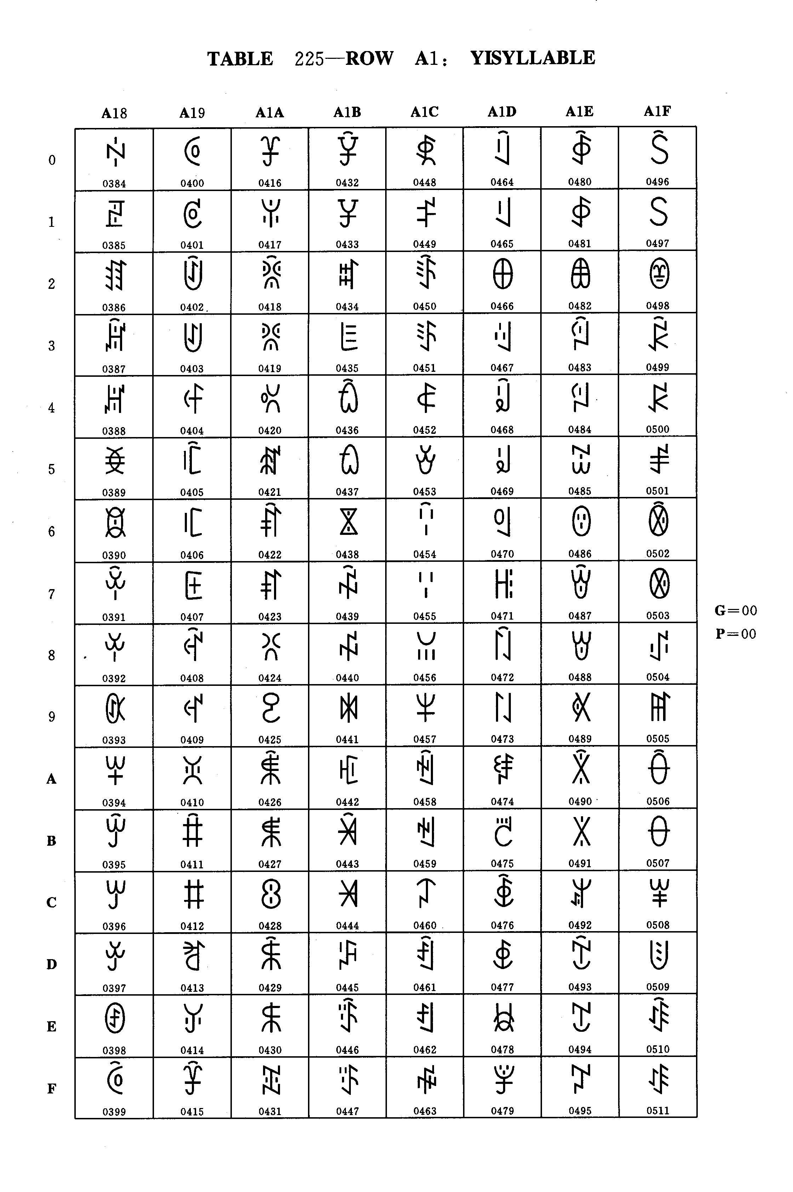
Table 225 - Row A1: YI SYLLABLES

TABLE 225 - Row A1: YI SYLLABLES
G = 00
P = 00

dec | hex | Name
128  129  130  131  132  133  134  135  136  137  138  139  140  141  142  143  144  145  146  147  148  149  150  151  152  153  154  155  156  157  158  159  160  161  162  163  164  165  166  167  168  169  170  171  172  173  174  175  176  177  178  179  180  181  182  183  184  185  186  187  188  189  190  191 | 80  81  82  83  84  85  86  87  88  89  8A  8B  8C  8D  8E  8F  90  91  92  93  94  95  96  97  98  99  9A  9B  9C  9D  9E  9F  A0  A1  A2  A3  A4  A5  A6  A7  A8  A9  AA  AB  AC  AD  AE  AF  B0  B1  B2  B3  B4  B5  B6  B7  B8  B9  BA  BB  BC  BD  BE  BF | YI SYLLABLE JI  YI SYLLABLE JIP  YI SYLLABLE JIET  YI SYLLABLE JIEX  YI SYLLABLE JIE  YI SYLLABLE JIEP  YI SYLLABLE JUOT  YI SYLLABLE JUOX  YI SYLLABLE JUO  YI SYLLABLE JUOP  YI SYLLABLE JOT  YI SYLLABLE JOX  YI SYLLABLE JO  YI SYLLABLE JOP  YI SYLLABLE JUT  YI SYLLABLE JUX  YI SYLLABLE JU  YI SYLLABLE JUP  YI SYLLABLE JURX  YI SYLLABLE JUR  YI SYLLABLE JYT  YI SYLLABLE JYX  YI SYLLABLE JY  YI SYLLABLE JYP  YI SYLLABLE JYRX  YI SYLLABLE JYR  YI SYLLABLE JJIT  YI SYLLABLE JJIX  YI SYLLABLE JJI  YI SYLLABLE JJIP  YI SYLLABLE JJIET  YI SYLLABLE JJIEX  YI SYLLABLE JJIE  YI SYLLABLE JJIEP  YI SYLLABLE JJUOX  YI SYLLABLE JJUO  YI SYLLABLE JJUOP  YI SYLLABLE JJOT  YI SYLLABLE JJOX  YI SYLLABLE JJO  YI SYLLABLE JJOP  YI SYLLABLE JJUT  YI SYLLABLE JJUX  YI SYLLABLE JJU  YI SYLLABLE JJUP  YI SYLLABLE JJURX  YI SYLLABLE JJUR  YI SYLLABLE JJYT  YI SYLLABLE JJYX  YI SYLLABLE JJY  YI SYLLABLE JJYP  YI SYLLABLE KIT  YI SYLLABLE KIX  YI SYLLABLE KI  YI SYLLABLE KIP  YI SYLLABLE KIEX  YI SYLLABLE KIE  YI SYLLABLE KIEP  YI SYLLABLE KAT  YI SYLLABLE KAX  YI SYLLABLE KA  YI SYLLABLE KAP  YI SYLLABLE KUOX  YI SYLLABLE KUO

dec | hex | Name
192  193  194  195  196  197  198  199  200  201  202  203  204  205  206  207  208  209  210  211  212  213  214  215  216  217  218  219  220  221  222  223  224  225  226  227  228  229  230  231  232  233  234  235  236  237  238  239  240  241  242  243  244  245  246  247  248  249  250  251  252  253  254  255. | C0  C1  C2  C3  C4  C5  C6  C7  C8  C9  CA  CB  CC  CD  CE  CF  D0  D1  D2  D3  D4  D5  D6  D7  D8  D9  DA  DB  DC  DD  DE  DF  E0  E1  E2  E3  E4  E5  E6  E7  E8  E9  EA  EB  EC  ED  EE  EF  F0  F1  F2  F3  F4  F5  F6  F7  F8  F9  FA  FB  FC  FD  FE  FF | YI SYLLABLE KUOP  YI SYLLABLE KOT  YI SYLLABLE KOX  YI SYLLABLE KO  YI SYLLABLE KOP  YI SYLLABLE KET  YI SYLLABLE KEX  YI SYLLABLE KE  YI SYLLABLE KEP  YI SYLLABLE KUT  YI SYLLABLE KUX  YI SYLLABLE KU  YI SYLLABLE KUP  YI SYLLABLE KURX  YI SYLLABLE KUR  YI SYLLABLE LIT  YI SYLLABLE LIX  YI SYLLABLE LI  YI SYLLABLE LIP  YI SYLLABLE LIET  YI SYLLABLE LIEX  YI SYLLABLE LIE  YI SYLLABLE LIEP  YI SYLLABLE LAT  YI SYLLABLE LAX  YI SYLLABLE LA  YI SYLLABLE LAP  YI SYLLABLE LUOT  YI SYLLABLE LUOX  YI SYLLABLE LUO  YI SYLLABLE LUOP  YI SYLLABLE LOT  YI SYLLABLE LOX  YI SYLLABLE LO  YI SYLLABLE LOP  YI SYLLABLE LEX  YI SYLLABLE LE  YI SYLLABLE LEP  YI SYLLABLE LUT  YI SYLLABLE LUX  YI SYLLABLE LU  YI SYLLABLE LUP  YI SYLLABLE LURX  YI SYLLABLE LUR  YI SYLLABLE LYT  YI SYLLABLE LYX  YI SYLLABLE LY  YI SYLLABLE LYP  YI SYLLABLE LYRX  YI SYLLABLE LYR  YI SYLLABLE MIT  YI SYLLABLE MIX  YI SYLLABLE MI  YI SYLLABLE MIP  YI SYLLABLE MIEX  YI SYLLABLE MIE  YI SYLLABLE MIEP  YI SYLLABLE MAT  YI SYLLABLE MAX  YI SYLLABLE MA  YI SYLLABLE MAP  YI SYLLABLE MUOT  YI SYLLABLE MUOX  YI SYLLABLE MUO

Group 00 Plane 00 Row A1

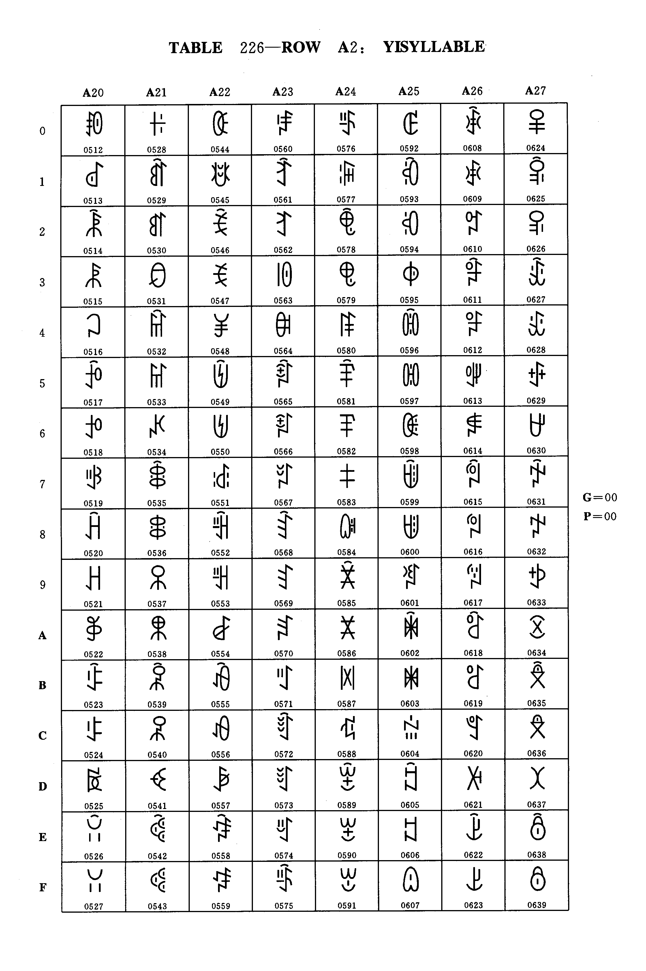
Table 226 - Row A2: YI SYLLABLES

Table 226 - Row A2: YI SYLLABLES
G = 00
P = 00

dec | hex | Name
000  001  002  003  004  005  006  007  008  009  010  011  012  013  014  015  016  017  018  019  020  021  022  023  024  025  026  027  028  029  030  031  032  033  034  035  036  037  038  039  040  041  042  043  044  045  046  047  048  049  050  051  052  053  054  055  056  057  058  059  060  061  062  063 | 00  01  02  03  04  05  06  07  08  09  0A  0B  0C  0D  0E  0F  10  11  12  13  14  15  16  17  18  19  1A  1B  1C  1D  1E  1F  20  21  22  23  24  25  26  27  28  29  2A  2B  2C  2D  2E  2F  30  31  32  33  34  35  36  37  38  39  3A  3B  3C  3D  3E  3F | YI SYLLABLE MUOP  YI SYLLABLE MOT  YI SYLLABLE MOX  YI SYLLABLE MO  YI SYLLABLE MOP  YI SYLLABLE MEX  YI SYLLABLE ME  YI SYLLABLE MUT  YI SYLLABLE MUX  YI SYLLABLE MU  YI SYLLABLE MUP  YI SYLLABLE MYRX  YI SYLLABLE MYR  YI SYLLABLE MYT  YI SYLLABLE MYX  YI SYLLABLE MY  YI SYLLABLE MYP  YI SYLLABLE MGIEX  YI SYLLABLE MGIE  YI SYLLABLE MGAT  YI SYLLABLE MGAX  YI SYLLABLE MGA  YI SYLLABLE MGAP  YI SYLLABLE MGUOX  YI SYLLABLE MGUO  YI SYLLABLE MGUOP  YI SYLLABLE MGOT  YI SYLLABLE MGOX  YI SYLLABLE MGO  YI SYLLABLE MGOP  YI SYLLABLE MGEX  YI SYLLABLE MGE  YI SYLLABLE MGEP  YI SYLLABLE MGUT  YI SYLLABLE MGUX  YI SYLLABLE MGU  YI SYLLABLE MGUP  YI SYLLABLE MGURX  YI SYLLABLE MGUR  YI SYLLABLE NIT  YI SYLLABLE NIX  YI SYLLABLE NI  YI SYLLABLE NIP  YI SYLLABLE NIEX  YI SYLLABLE NIE  YI SYLLABLE NIEP  YI SYLLABLE NAX  YI SYLLABLE NA  YI SYLLABLE NAP  YI SYLLABLE NUOX  YI SYLLABLE NUO  YI SYLLABLE NUOP  YI SYLLABLE NOT  YI SYLLABLE NOX  YI SYLLABLE NO  YI SYLLABLE NOP  YI SYLLABLE NEX  YI SYLLABLE NE  YI SYLLABLE NEP  YI SYLLABLE NUT  YI SYLLABLE NUX  YI SYLLABLE NU  YI SYLLABLE NUP  YI SYLLABLE NURX

dec | hex | Name
064  065  066  067  068  069  070  071  072  073  074  075  076  077  078  079  080  081  082  083  084  085  086  087  088  089  090  091  092  093  094  095  096  097  098  099  100  101  102  103  104  105  106  107  108  109  110  111  112  113  114  115  116  117  118  119  120  121  122  123  124  125  126  127 | 40  41  42  43  44  45  46  47  48  49  4A  4B  4C  4D  4E  4F  50  51  52  53  54  55  56  57  58  59  5A  5B  5C  5D  5E  5F  60  61  62  63  64  65  66  67  68  69  6A  6B  6C  6D  6E  6F  70  71  72  73  74  75  76  77  78  79  7A  7B  7C  7D  7E  7F | YI SYLLABLE NUR  YI SYLLABLE NBIT  YI SYLLABLE NBIX  YI SYLLABLE NBI  YI SYLLABLE NBIP  YI SYLLABLE NBIEX  YI SYLLABLE NBIE  YI SYLLABLE NBIEP  YI SYLLABLE NBAT  YI SYLLABLE NBAX  YI SYLLABLE NBA  YI SYLLABLE NBAP  YI SYLLABLE NBOT  YI SYLLABLE NBOX  YI SYLLABLE NBO  YI SYLLABLE NBOP  YI SYLLABLE NBUT  YI SYLLABLE NBUX  YI SYLLABLE NBU  YI SYLLABLE NBUP  YI SYLLABLE NBURX  YI SYLLABLE NBUR  YI SYLLABLE NBYT  YI SYLLABLE NBYX  YI SYLLABLE NBY  YI SYLLABLE NBYP  YI SYLLABLE NBYRX  YI SYLLABLE NBYR  YI SYLLABLE NDIT  YI SYLLABLE NDIX  YI SYLLABLE NDI  YI SYLLABLE NDIP  YI SYLLABLE NDIEX  YI SYLLABLE NDIE  YI SYLLABLE NDAT  YI SYLLABLE NDAX  YI SYLLABLE NDA  YI SYLLABLE NDAP  YI SYLLABLE NDOT  YI SYLLABLE NDOX  YI SYLLABLE NDO  YI SYLLABLE NDOP  YI SYLLABLE NDEX  YI SYLLABLE NDE  YI SYLLABLE NDEP  YI SYLLABLE NDUT  YI SYLLABLE NDUX  YI SYLLABLE NDU  YI SYLLABLE NDUP  YI SYLLABLE NDURX  YI SYLLABLE NDUR  YI SYLLABLE NGIEX  YI SYLLABLE NGIE  YI SYLLABLE NGIEP  YI SYLLABLE NGAT  YI SYLLABLE NGAX  YI SYLLABLE NGA  YI SYLLABLE NGAP  YI SYLLABLE NGUOT  YI SYLLABLE NGUOX  YI SYLLABLE NGUO  YI SYLLABLE NGOT  YI SYLLABLE NGOX  YI SYLLABLE NGO

Group 00 Plane 00 Row A2
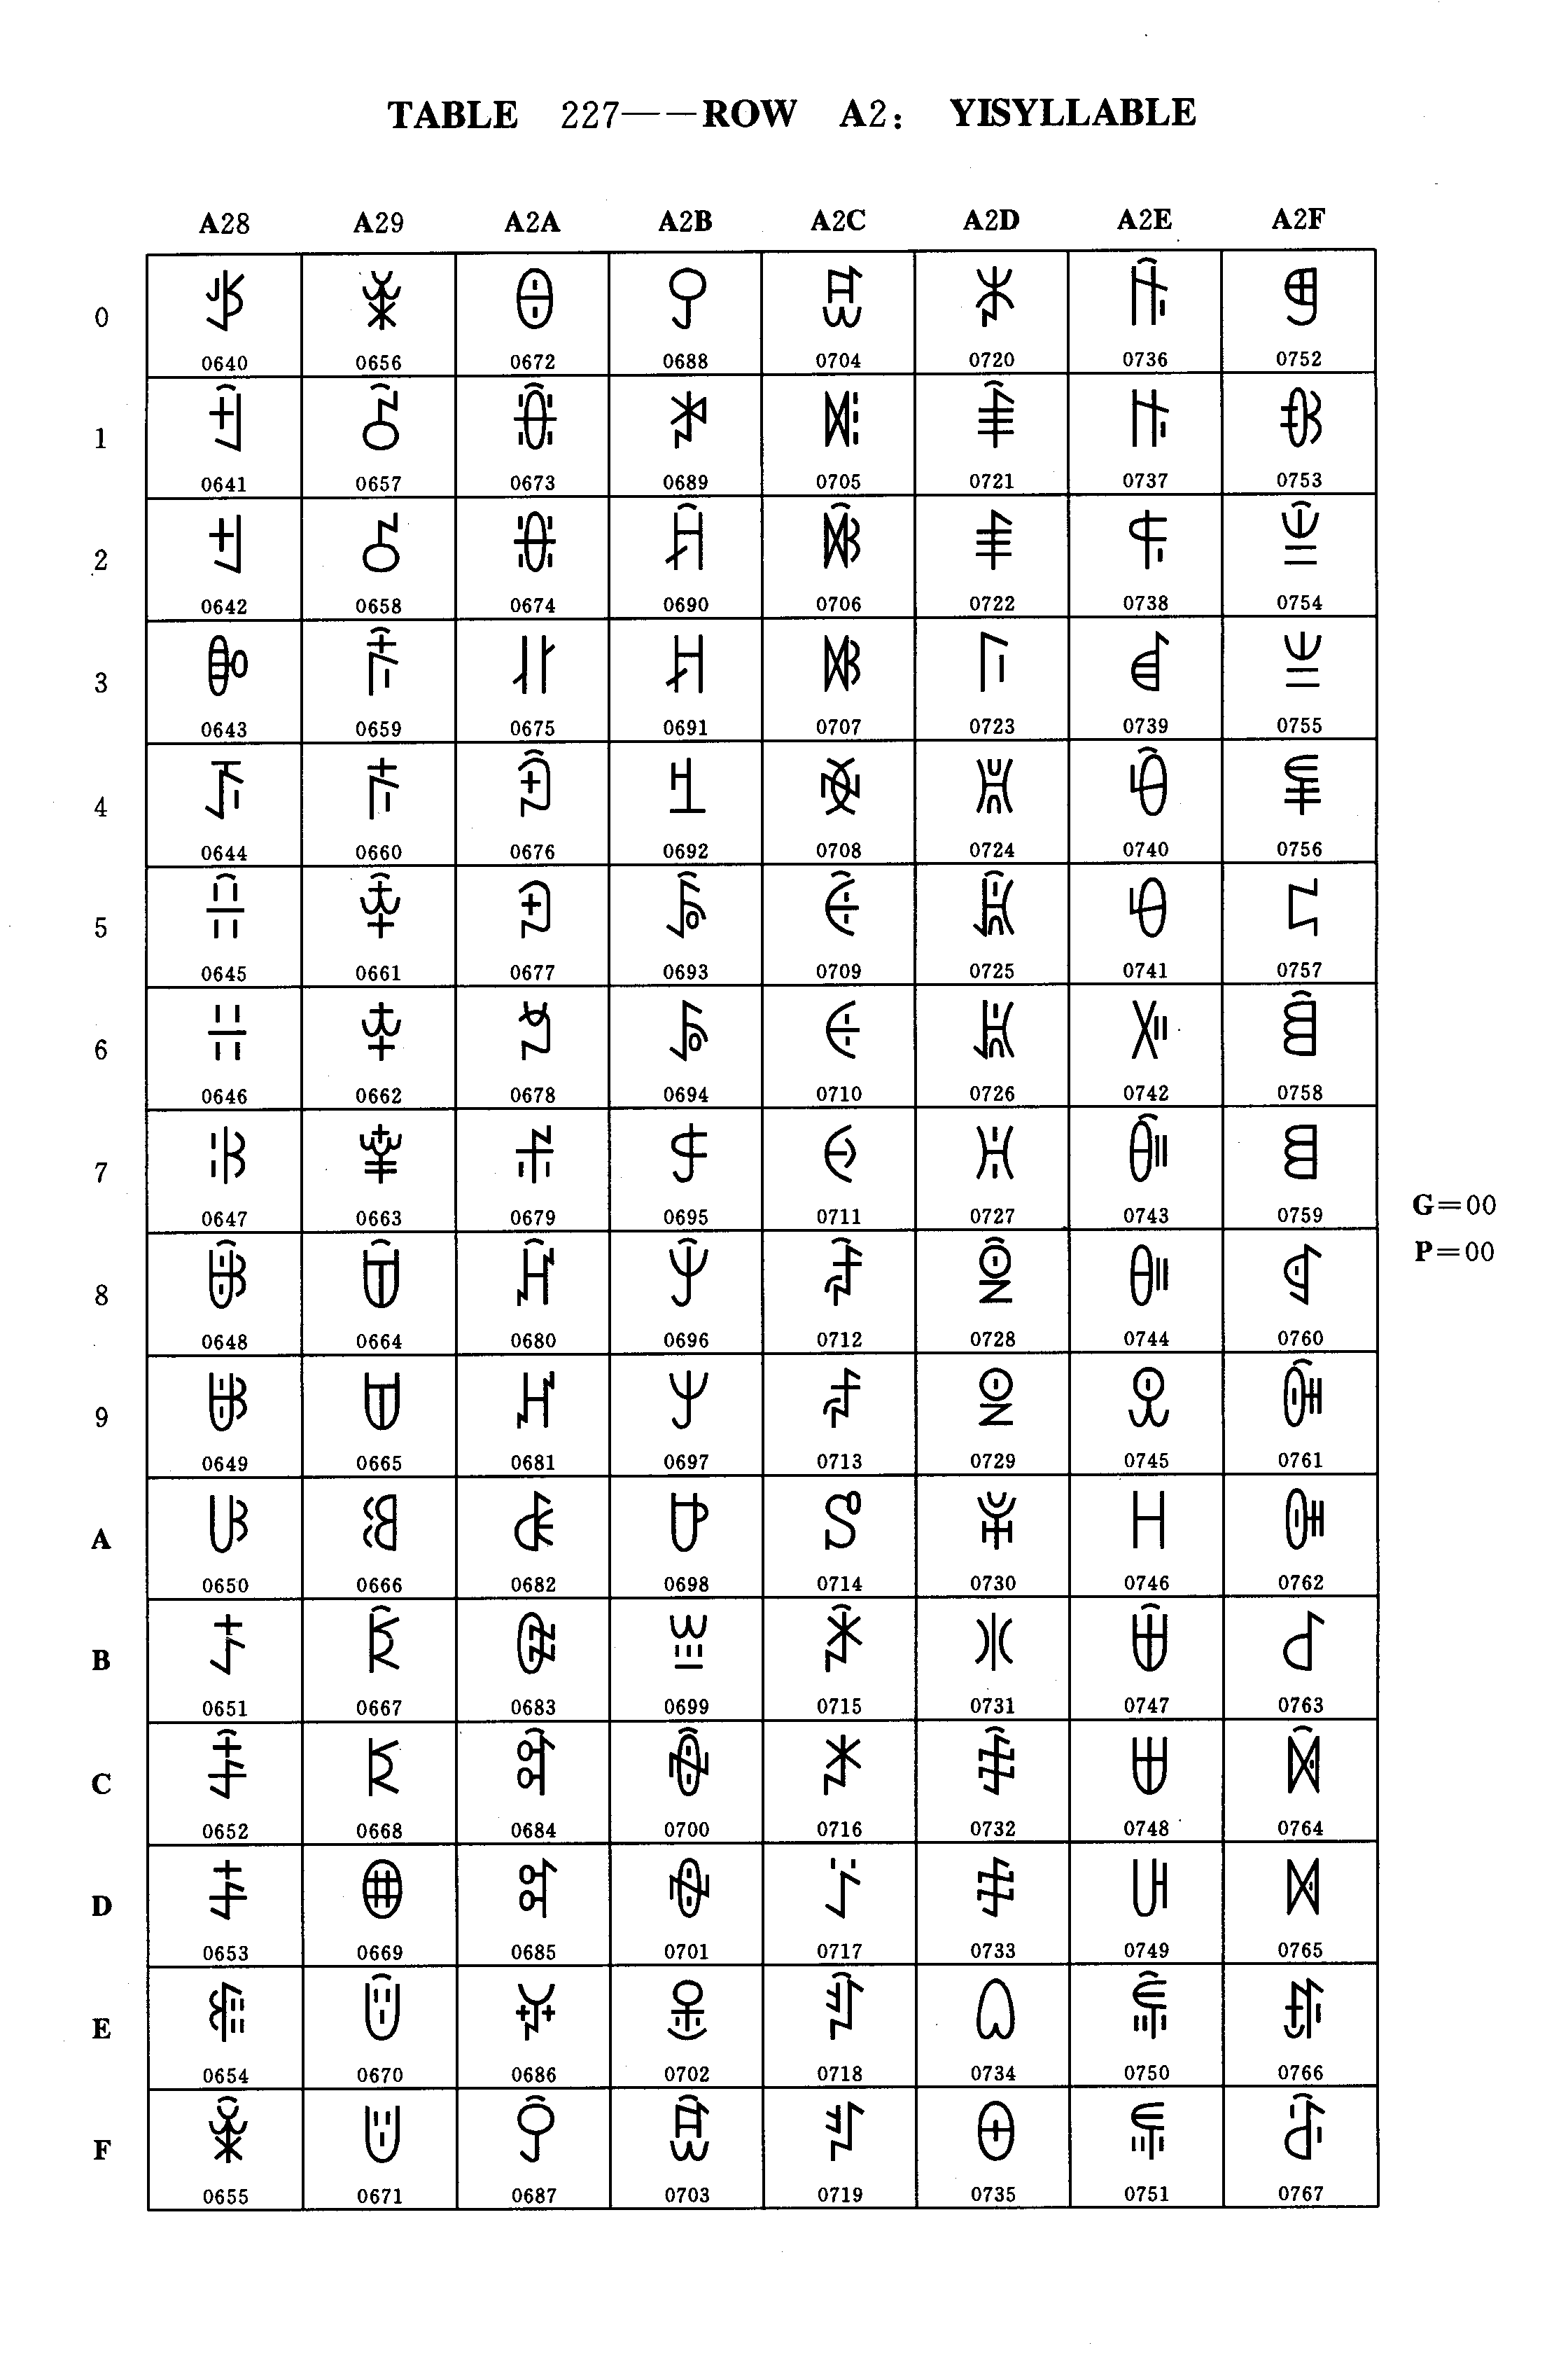

Table 227 - Row A2: YI SYLLABLES

TABLE 227 - Row A2: YI SYLLABLES
G = 00
P = 00

dec | hex | Name
128  129  130  131  132  133  134  135  136  137  138  139  140  141  142  143  144  145  146  147  148  149  150  151  152  153  154  155  156  157  158  159  160  161  162  163  164  165  166  167  168  169  170  171  172  173  174  175  176  177  178  179  180  181  182  183  184  185  186  187  188  189  190  191 | 80  81  82  83  84  85  86  87  88  89  8A  8B  8C  8D  8E  8F  90  91  92  93  94  95  96  97  98  99  9A  9B  9C  9D  9E  9F  A0  A1  A2  A3  A4  A5  A6  A7  A8  A9  AA  AB  AC  AD  AE  AF  B0  B1  B2  B3  B4  B5  B6  B7  B8  B9  BA  BB  BC  BD  BE  BF | YI SYLLABLE NGOP  YI SYLLABLE NGEX  YI SYLLABLE NGE  YI SYLLABLE NGEP  YI SYLLABLE NZIT  YI SYLLABLE NZIX  YI SYLLABLE NZI  YI SYLLABLE NZIP  YI SYLLABLE NZIEX  YI SYLLABLE NZIE  YI SYLLABLE NZIEP  YI SYLLABLE NZAT  YI SYLLABLE NZAX  YI SYLLABLE NZA  YI SYLLABLE NZAP  YI SYLLABLE NZUOX  YI SYLLABLE NZUO  YI SYLLABLE NZOX  YI SYLLABLE NZOP  YI SYLLABLE NZEX  YI SYLLABLE NZE  YI SYLLABLE NZUX  YI SYLLABLE NZU  YI SYLLABLE NZUP  YI SYLLABLE NZURX  YI SYLLABLE NZUR  YI SYLLABLE NZYT  YI SYLLABLE NZYX  YI SYLLABLE NZY  YI SYLLABLE NZYP  YI SYLLABLE NZYRX  YI SYLLABLE NZYR  YI SYLLABLE NRAT  YI SYLLABLE NRAX  YI SYLLABLE NRA  YI SYLLABLE NRAP  YI SYLLABLE NROX  YI SYLLABLE NRO  YI SYLLABLE NROP  YI SYLLABLE NRET  YI SYLLABLE NREX  YI SYLLABLE NRE  YI SYLLABLE NREP  YI SYLLABLE NRUT  YI SYLLABLE NRUX  YI SYLLABLE NRU  YI SYLLABLE NRUP  YI SYLLABLE NRURX  YI SYLLABLE NRUR  YI SYLLABLE NRYT  YI SYLLABLE NRYX  YI SYLLABLE NRY  YI SYLLABLE NRYP  YI SYLLABLE NRYRX  YI SYLLABLE NRYR  YI SYLLABLE NJIT  YI SYLLABLE NJIX  YI SYLLABLE NJI  YI SYLLABLE NJIP  YI SYLLABLE NJIET  YI SYLLABLE NJIEX  YI SYLLABLE NJIE  YI SYLLABLE NJIEP  YI SYLLABLE NJUOX

dec | hex | Name
192  193  194  195  196  197  198  199  200  201  202  203  204  205  206  207  208  209  210  211  212  213  214  215  216  217  218  219  220  221  222  223  224  225  226  227  228  229  230  231  232  233  234  235  236  237  238  239  240  241  242  243  244  245  246  247  248  249  250  251  252  253  254  255. | C0  C1  C2  C3  C4  C5  C6  C7  C8  C9  CA  CB  CC  CD  CE  CF  D0  D1  D2  D3  D4  D5  D6  D7  D8  D9  DA  DB  DC  DD  DE  DF  E0  E1  E2  E3  E4  E5  E6  E7  E8  E9  EA  EB  EC  ED  EE  EF  F0  F1  F2  F3  F4  F5  F6  F7  F8  F9  FA  FB  FC  FD  FE  FF | YI SYLLABLE NJUO  YI SYLLABLE NJOT  YI SYLLABLE NJOX  YI SYLLABLE NJO  YI SYLLABLE NJOP  YI SYLLABLE NJUX  YI SYLLABLE NJU  YI SYLLABLE NJUP  YI SYLLABLE NJURX  YI SYLLABLE NJUR  YI SYLLABLE NJYT  YI SYLLABLE NJYX  YI SYLLABLE NJY  YI SYLLABLE NJYP  YI SYLLABLE NJYRX  YI SYLLABLE NJYR  YI SYLLABLE NYIT  YI SYLLABLE NYIX  YI SYLLABLE NYI  YI SYLLABLE NYIP  YI SYLLABLE NYIET  YI SYLLABLE NYIEX  YI SYLLABLE NYIE  YI SYLLABLE NYIEP  YI SYLLABLE NYUOX  YI SYLLABLE NYUO  YI SYLLABLE NYUOP  YI SYLLABLE NYOT  YI SYLLABLE NYOX  YI SYLLABLE NYO  YI SYLLABLE NYOP  YI SYLLABLE NYUT  YI SYLLABLE NYUX  YI SYLLABLE NYU  YI SYLLABLE NYUP  YI SYLLABLE PIT  YI SYLLABLE PIX  YI SYLLABLE PI  YI SYLLABLE PIP  YI SYLLABLE PIEX  YI SYLLABLE PIE  YI SYLLABLE PIEP  YI SYLLABLE PAT  YI SYLLABLE PAX  YI SYLLABLE PA  YI SYLLABLE PAP  YI SYLLABLE PUOX  YI SYLLABLE PUO  YI SYLLABLE PUOP  YI SYLLABLE POT  YI SYLLABLE POX  YI SYLLABLE PO  YI SYLLABLE POP  YI SYLLABLE PUT  YI SYLLABLE PUX  YI SYLLABLE PU  YI SYLLABLE PUP  YI SYLLABLE PURX  YI SYLLABLE PUR  YI SYLLABLE PYT  YI SYLLABLE PYX  YI SYLLABLE PY  YI SYLLABLE PYP  YI SYLLABLE PYRX

Group 00 Plane 00 Row A2

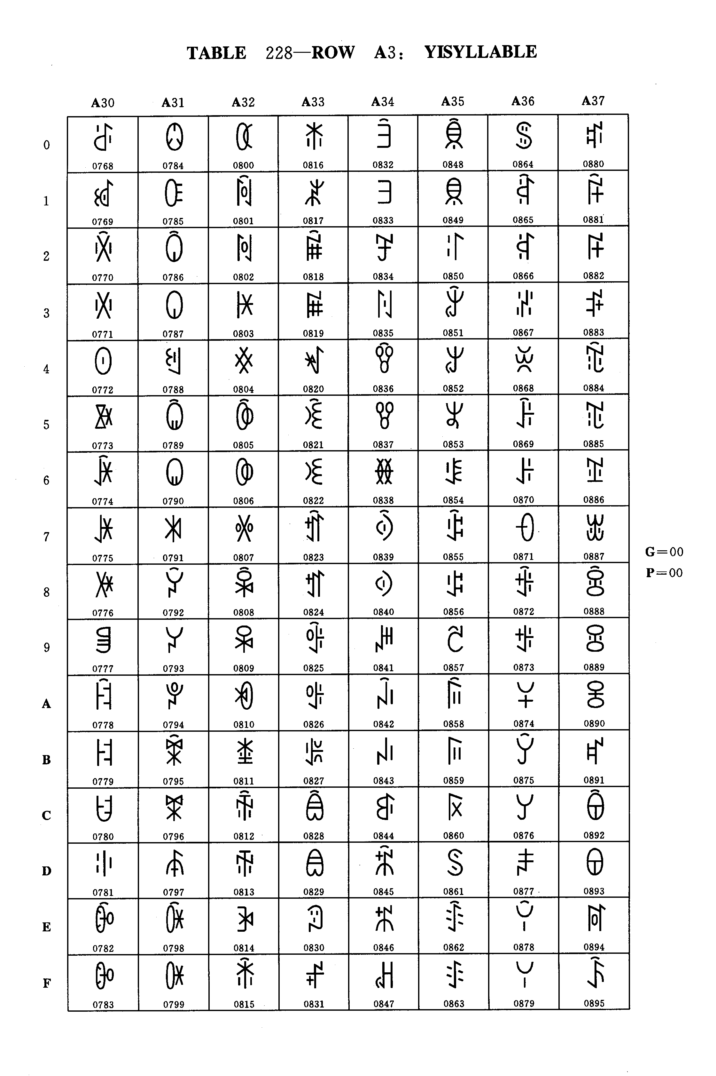
Table 228 - Row A3: YI SYLLABLES
Table 228 - Row A3: YI SYLLABLES
G = 00
P = 00

dec | hex | Name
000  001  002  003  004  005  006  007  008  009  010  011  012  013  014  015  016  017  018  019  020  021  022  023  024  025  026  027  028  029  030  031  032  033  034  035  036  037  038  039  040  041  042  043  044  045  046  047  048  049  050  051  052  053  054  055  056  057  058  059  060  061  062  063 | 00  01  02  03  04  05  06  07  08  09  0A  0B  0C  0D  0E  0F  10  11  12  13  14  15  16  17  18  19  1A  1B  1C  1D  1E  1F  20  21  22  23  24  25  26  27  28  29  2A  2B  2C  2D  2E  2F  30  31  32  33  34  35  36  37  38  39  3A  3B  3C  3D  3E  3F | YI SYLLABLE PYR  YI SYLLABLE QIT  YI SYLLABLE QIX  YI SYLLABLE QI  YI SYLLABLE QIP  YI SYLLABLE QIET  YI SYLLABLE QIEX  YI SYLLABLE QIE  YI SYLLABLE QIEP  YI SYLLABLE QUOT  YI SYLLABLE QUOX  YI SYLLABLE QUO  YI SYLLABLE QUOP  YI SYLLABLE QOT  YI SYLLABLE QOX  YI SYLLABLE QO  YI SYLLABLE QOP  YI SYLLABLE QUT  YI SYLLABLE QUX  YI SYLLABLE QU  YI SYLLABLE QUP  YI SYLLABLE QURX  YI SYLLABLE QUR  YI SYLLABLE QYT  YI SYLLABLE QYX  YI SYLLABLE QY  YI SYLLABLE QYP  YI SYLLABLE QYRX  YI SYLLABLE QYR  YI SYLLABLE RAT  YI SYLLABLE RAX  YI SYLLABLE RA  YI SYLLABLE RAP  YI SYLLABLE RUOX  YI SYLLABLE RUO  YI SYLLABLE RUOP  YI SYLLABLE ROT  YI SYLLABLE ROX  YI SYLLABLE RO  YI SYLLABLE ROP  YI SYLLABLE REX  YI SYLLABLE RE  YI SYLLABLE REP  YI SYLLABLE RUT  YI SYLLABLE RUX  YI SYLLABLE RU  YI SYLLABLE RUP  YI SYLLABLE RURX  YI SYLLABLE RUR  YI SYLLABLE RYT  YI SYLLABLE RYX  YI SYLLABLE RY  YI SYLLABLE RYP  YI SYLLABLE RYRX  YI SYLLABLE RYR  YI SYLLABLE RRAX  YI SYLLABLE RRA  YI SYLLABLE RRUOX  YI SYLLABLE RRUO  YI SYLLABLE RROT  YI SYLLABLE RROX  YI SYLLABLE RRO  YI SYLLABLE RROP  YI SYLLABLE RRET

dec | hex | Name
064  065  066  067  068  069  070  071  072  073  074  075  076  077  078  079  080  081  082  083  084  085  086  087  088  089  090  091  092  093  094  095  096  097  098  099  100  101  102  103  104  105  106  107  108  109  110  111  112  113  114  115  116  117  118  119  120  121  122  123  124  125  126  127 | 40  41  42  43  44  45  46  47  48  49  4A  4B  4C  4D  4E  4F  50  51  52  53  54  55  56  57  58  59  5A  5B  5C  5D  5E  5F  60  61  62  63  64  65  66  67  68  69  6A  6B  6C  6D  6E  6F  70  71  72  73  74  75  76  77  78  79  7A  7B  7C  7D  7E  7F | YI SYLLABLE RREX  YI SYLLABLE RRE  YI SYLLABLE RREP  YI SYLLABLE RRUT  YI SYLLABLE RRUX  YI SYLLABLE RRU  YI SYLLABLE RRUP  YI SYLLABLE RRURX  YI SYLLABLE RRUR  YI SYLLABLE RRYT  YI SYLLABLE RRYX  YI SYLLABLE RRY  YI SYLLABLE RRYP  YI SYLLABLE RRYRX  YI SYLLABLE RRYR  YI SYLLABLE SIT  YI SYLLABLE SIX  YI SYLLABLE SI  YI SYLLABLE SIP  YI SYLLABLE SIEX  YI SYLLABLE SIE  YI SYLLABLE SIEP  YI SYLLABLE SAT  YI SYLLABLE SAX  YI SYLLABLE SA  YI SYLLABLE SAP  YI SYLLABLE SUOX  YI SYLLABLE SUO  YI SYLLABLE SUOP  YI SYLLABLE SOT  YI SYLLABLE SOX  YI SYLLABLE SO  YI SYLLABLE SOP  YI SYLLABLE SEX  YI SYLLABLE SE  YI SYLLABLE SEP  YI SYLLABLE SUT  YI SYLLABLE SUX  YI SYLLABLE SU  YI SYLLABLE SUP  YI SYLLABLE SURX  YI SYLLABLE SUR  YI SYLLABLE SYT  YI SYLLABLE SYX  YI SYLLABLE SY  YI SYLLABLE SYP  YI SYLLABLE SYRX  YI SYLLABLE SYR  YI SYLLABLE SSIT  YI SYLLABLE SSIX  YI SYLLABLE SSI  YI SYLLABLE SSIP  YI SYLLABLE SSIEX  YI SYLLABLE SSIE  YI SYLLABLE SSIEP  YI SYLLABLE SSAT  YI SYLLABLE SSAX  YI SYLLABLE SSA  YI SYLLABLE SSAP  YI SYLLABLE SSOT  YI SYLLABLE SSOX  YI SYLLABLE SSO  YI SYLLABLE SSOP  YI SYLLABLE SSEX

Group 00 Plane 00 Row A3
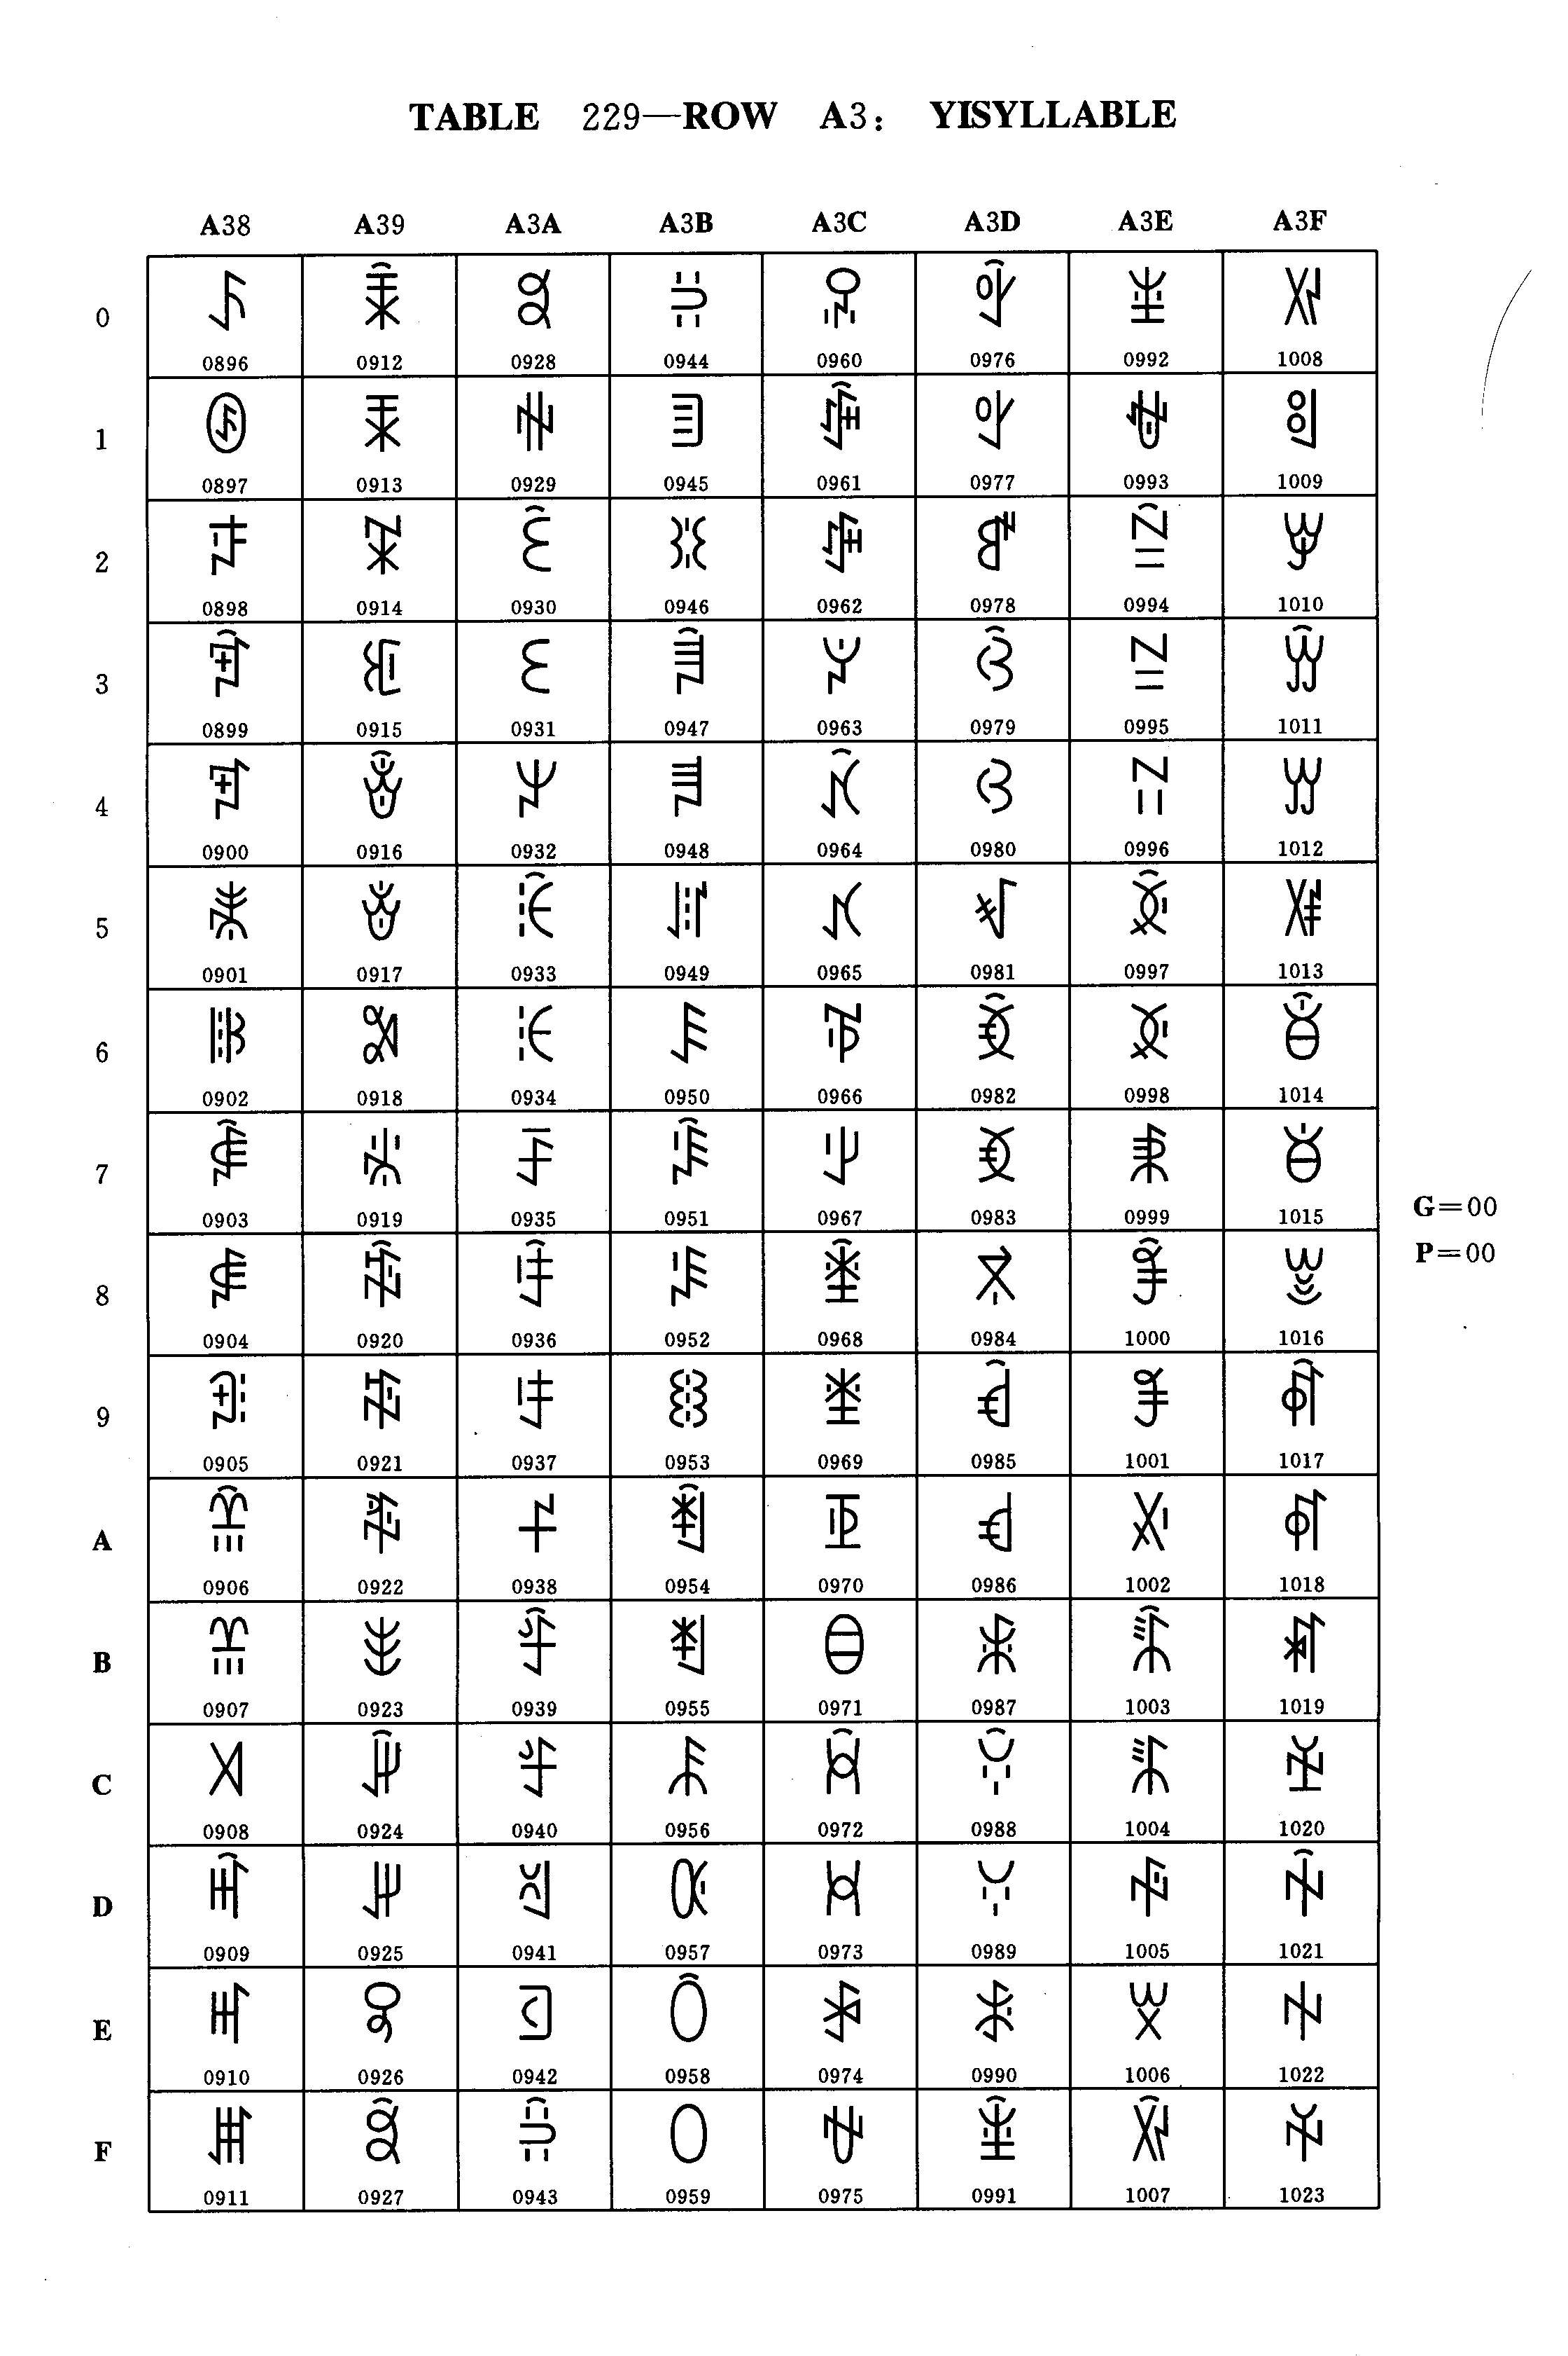
Table 229 - Row A3: YI SYLLABLES

TABLE 229 - Row A3: YI SYLLABLES

G = 00
P = 00

dec | hex | Name
128  129  130  131  132  133  134  135  136  137  138  139  140  141  142  143  144  145  146  147  148  149  150  151  152  153  154  155  156  157  158  159  160  161  162  163  164  165  166  167  168  169  170  171  172  173  174  175  176  177  178  179  180  181  182  183  184  185  186  187  188  189  190  191 | 80  81  82  83  84  85  86  87  88  89  8A  8B  8C  8D  8E  8F  90  91  92  93  94  95  96  97  98  99  9A  9B  9C  9D  9E  9F  A0  A1  A2  A3  A4  A5  A6  A7  A8  A9  AA  AB  AC  AD  AE  AF  B0  B1  B2  B3  B4  B5  B6  B7  B8  B9  BA  BB  BC  BD  BE  BF | YI SYLLABLE SSE  YI SYLLABLE SSEP  YI SYLLABLE SSUT  YI SYLLABLE SSUX  YI SYLLABLE SSU  YI SYLLABLE SSUP  YI SYLLABLE SSYT  YI SYLLABLE SSYX  YI SYLLABLE SSY  YI SYLLABLE SSYP  YI SYLLABLE SSYRX  YI SYLLABLE SSYR  YI SYLLABLE SHAT  YI SYLLABLE SHAX  YI SYLLABLE SHA  YI SYLLABLE SHAP  YI SYLLABLE SHUOX  YI SYLLABLE SHUO  YI SYLLABLE SHUOP  YI SYLLABLE SHOT  YI SYLLABLE SHOX  YI SYLLABLE SHO  YI SYLLABLE SHOP  YI SYLLABLE SHET  YI SYLLABLE SHEX  YI SYLLABLE SHE  YI SYLLABLE SHEP  YI SYLLABLE SHUT  YI SYLLABLE SHUX  YI SYLLABLE SHU  YI SYLLABLE SHUP  YI SYLLABLE SHURX  YI SYLLABLE SHUR  YI SYLLABLE SHYT  YI SYLLABLE SHYX  YI SYLLABLE SHY  YI SYLLABLE SHYP  YI SYLLABLE SHYRX  YI SYLLABLE SHYR  YI SYLLABLE TIT  YI SYLLABLE TIX  YI SYLLABLE TI  YI SYLLABLE TIP  YI SYLLABLE TIEX  YI SYLLABLE TIE  YI SYLLABLE TIEP  YI SYLLABLE TAT  YI SYLLABLE TAX  YI SYLLABLE TA  YI SYLLABLE TAP  YI SYLLABLE TUOT  YI SYLLABLE TUOX  YI SYLLABLE TUO  YI SYLLABLE TUOP  YI SYLLABLE TOT  YI SYLLABLE TOX  YI SYLLABLE TO  YI SYLLABLE TOP  YI SYLLABLE TEX  YI SYLLABLE TE  YI SYLLABLE TEP  YI SYLLABLE TUT  YI SYLLABLE TUX  YI SYLLABLE TU

dec | hex | Name
192  193  194  195  196  197  198  199  200  201  202  203  204  205  206  207  208  209  210  211  212  213  214  215  216  217  218  219  220  221  222  223  224  225  226  227  228  229  230  231  232  233  234  235  236  237  238  239  240  241  242  243  244  245  246  247  248  249  250  251  252  253  254  255. | C0  C1  C2  C3  C4  C5  C6  C7  C8  C9  CA  CB  CC  CD  CE  CF  D0  D1  D2  D3  D4  D5  D6  D7  D8  D9  DA  DB  DC  DD  DE  DF  E0  E1  E2  E3  E4  E5  E6  E7  E8  E9  EA  EB  EC  ED  EE  EF  F0  F1  F2  F3  F4  F5  F6  F7  F8  F9  FA  FB  FC  FD  FE  FF | YI SYLLABLE TUP  YI SYLLABLE TURX  YI SYLLABLE TUR  YI SYLLABLE VIT  YI SYLLABLE VIX  YI SYLLABLE VI  YI SYLLABLE VIP  YI SYLLABLE VIET  YI SYLLABLE VIEX  YI SYLLABLE VIE  YI SYLLABLE VIEP  YI SYLLABLE VAT  YI SYLLABLE VAX  YI SYLLABLE VA  YI SYLLABLE VAP  YI SYLLABLE VOT  YI SYLLABLE VOX  YI SYLLABLE VOP  YI SYLLABLE VEX  YI SYLLABLE VE  YI SYLLABLE VEP  YI SYLLABLE VUT  YI SYLLABLE VUX  YI SYLLABLE VU  YI SYLLABLE VUP  YI SYLLABLE VURX  YI SYLLABLE VUR  YI SYLLABLE VYT  YI SYLLABLE VYX  YI SYLLABLE VY  YI SYLLABLE VYP  YI SYLLABLE VYRX  YI SYLLABLE VYR  YI SYLLABLE WAT  YI SYLLABLE WAX  YI SYLLABLE WA  YI SYLLABLE WAP  YI SYLLABLE WUOX  YI SYLLABLE WUO  YI SYLLABLE WUOP  YI SYLLABLE WOX  YI SYLLABLE WO  YI SYLLABLE WOP  YI SYLLABLE WEX  YI SYLLABLE WE  YI SYLLABLE WEP  YI SYLLABLE XIT  YI SYLLABLE XIX  YI SYLLABLE XI  YI SYLLABLE XIP  YI SYLLABLE XIET  YI SYLLABLE XIEX  YI SYLLABLE XIE  YI SYLLABLE XIEP  YI SYLLABLE XUOX  YI SYLLABLE XUO  YI SYLLABLE XOT  YI SYLLABLE XOX  YI SYLLABLE XO  YI SYLLABLE XOP  YI SYLLABLE XYT  YI SYLLABLE XYX  YI SYLLABLE XY  YI SYLLABLE XYP

Group 00 Plane 00 Row A3

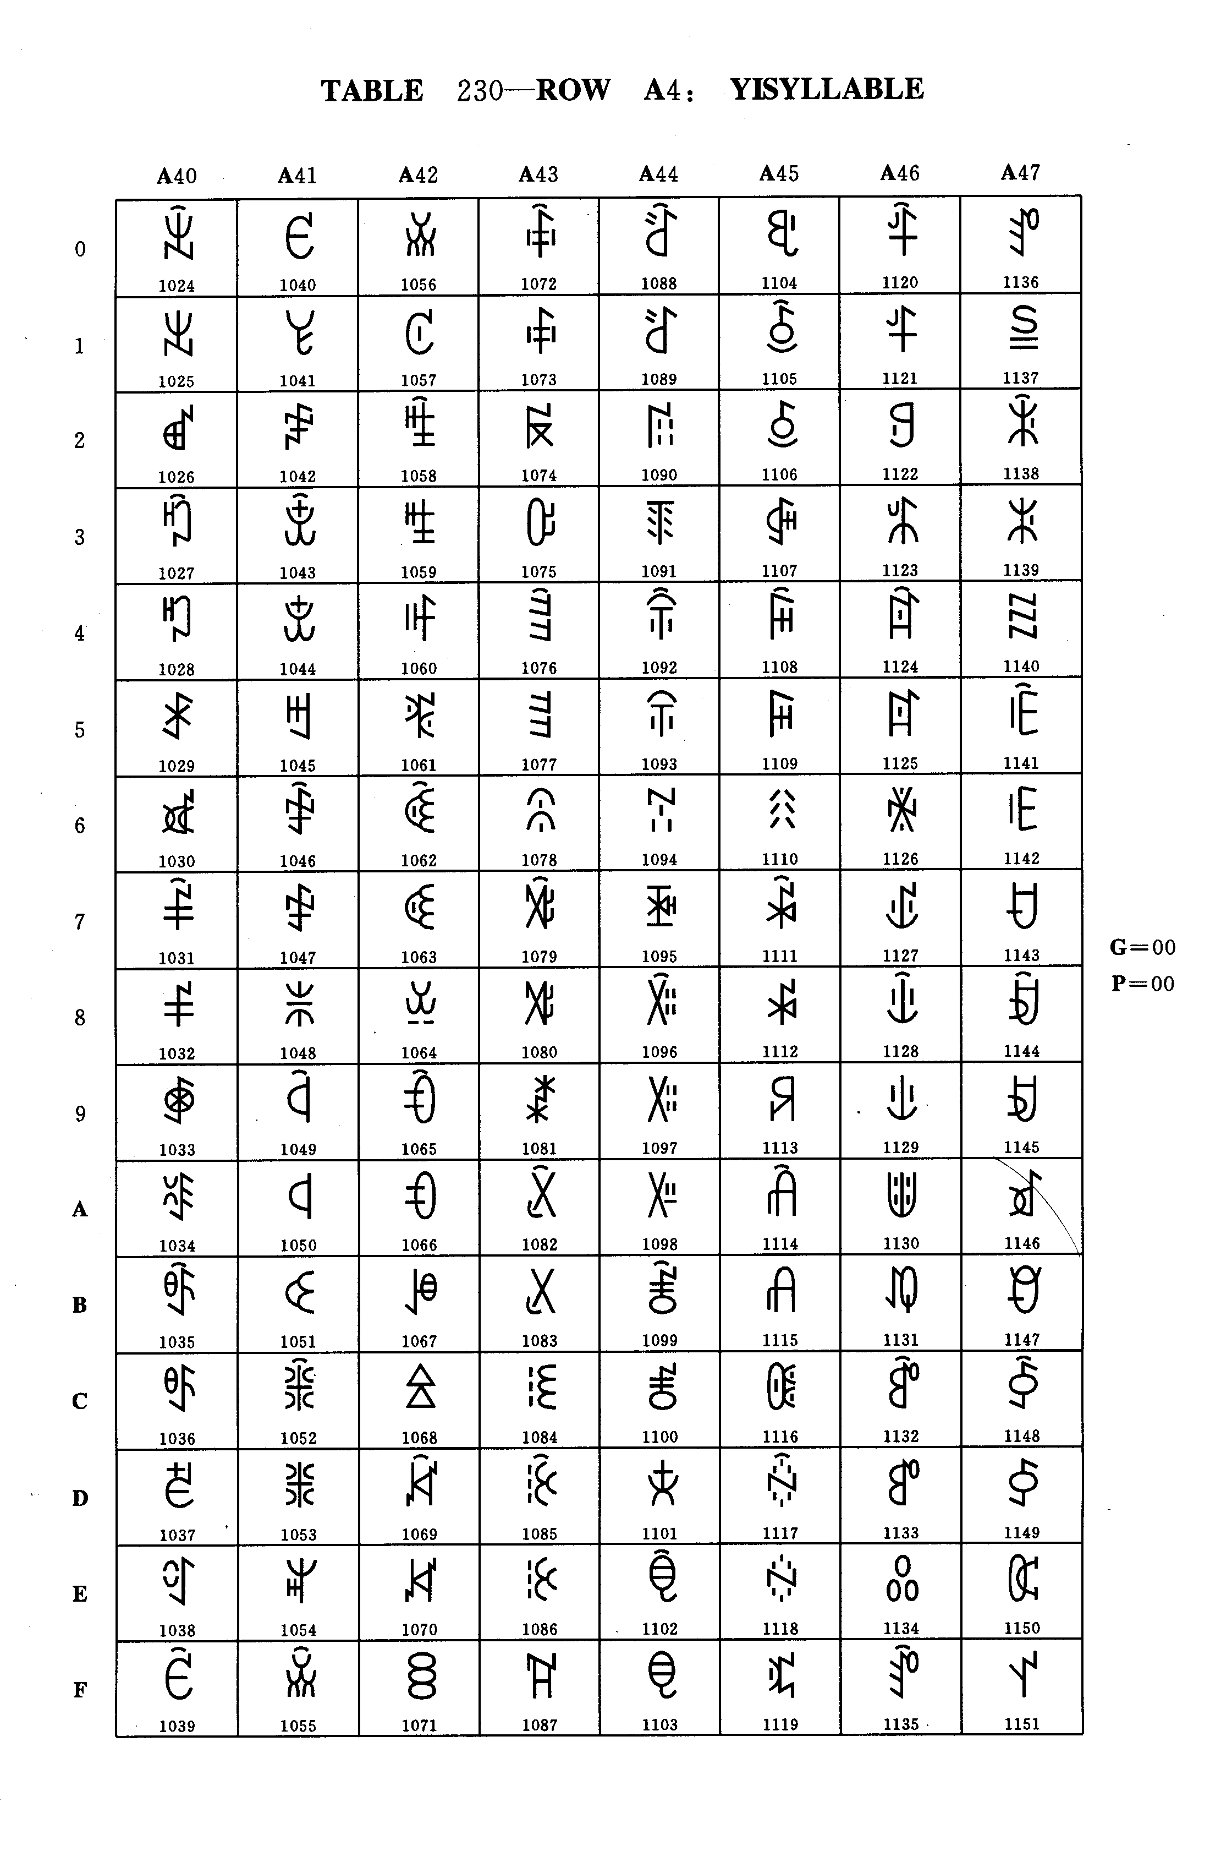
Table 230 - Row A4: YI SYLLABLES
Table 230 - Row A4: YI SYLLABLES
G = 00
P = 00

dec | hex | Name
000  001  002  003  004  005  006  007  008  009  010  011  012  013  014  015  016  017  018  019  020  021  022  023  024  025  026  027  028  029  030  031  032  033  034  035  036  037  038  039  040  041  042  043  044  045  046  047  048  049  050  051  052  053  054  055  056  057  058  059  060  061  062  063 | 00  01  02  03  04  05  06  07  08  09  0A  0B  0C  0D  0E  0F  10  11  12  13  14  15  16  17  18  19  1A  1B  1C  1D  1E  1F  20  21  22  23  24  25  26  27  28  29  2A  2B  2C  2D  2E  2F  30  31  32  33  34  35  36  37  38  39  3A  3B  3C  3D  3E  3F | YI SYLLABLE XYRX  YI SYLLABLE XYR  YI SYLLABLE YIT  YI SYLLABLE YIX  YI SYLLABLE YI  YI SYLLABLE YIP  YI SYLLABLE YIET  YI SYLLABLE YIEX  YI SYLLABLE YIE  YI SYLLABLE YIEP  YI SYLLABLE YUOT  YI SYLLABLE YUOX  YI SYLLABLE YUO  YI SYLLABLE YUOP  YI SYLLABLE YOT  YI SYLLABLE YOX  YI SYLLABLE YO  YI SYLLABLE YOP  YI SYLLABLE YUT  YI SYLLABLE YUX  YI SYLLABLE YU  YI SYLLABLE YUP  YI SYLLABLE YURX  YI SYLLABLE YUR  YI SYLLABLE YYT  YI SYLLABLE YYX  YI SYLLABLE YY  YI SYLLABLE YYP  YI SYLLABLE YYRX  YI SYLLABLE YYR  YI SYLLABLE ZIT  YI SYLLABLE ZIX  YI SYLLABLE ZI  YI SYLLABLE ZIP  YI SYLLABLE ZIEX  YI SYLLABLE ZIE  YI SYLLABLE ZIEP  YI SYLLABLE ZAT  YI SYLLABLE ZAX  YI SYLLABLE ZA  YI SYLLABLE ZAP  YI SYLLABLE ZUOX  YI SYLLABLE ZUO  YI SYLLABLE ZUOP  YI SYLLABLE ZOT  YI SYLLABLE ZOX  YI SYLLABLE ZO  YI SYLLABLE ZOP  YI SYLLABLE ZEX  YI SYLLABLE ZE  YI SYLLABLE ZEP  YI SYLLABLE ZUT  YI SYLLABLE ZUX  YI SYLLABLE ZU  YI SYLLABLE ZUP  YI SYLLABLE ZURX  YI SYLLABLE ZUR  YI SYLLABLE ZYT  YI SYLLABLE ZYX  YI SYLLABLE ZY  YI SYLLABLE ZYP  YI SYLLABLE ZYRX  YI SYLLABLE ZYR  YI SYLLABLE ZZITT

dec | hex | Name
064  065  066  067  068  069  070  071  072  073  074  075  076  077  078  079  080  081  082  083  084  085  086  087  088  089  090  091  092  093  094  095  096  097  098  099  100  101  102  103  104  105  106  107  108  109  110  111  112  113  114  115  116  117  118  119  120  121  122  123  124  125  126  127 | 40  41  42  43  44  45  46  47  48  49  4A  4B  4C  4D  4E  4F  50  51  52  53  54  55  56  57  58  59  5A  5B  5C  5D  5E  5F  60  61  62  63  64  65  66  67  68  69  6A  6B  6C  6D  6E  6F  70  71  72  73  74  75  76  77  78  79  7A  7B  7C  7D  7E  7F | YI SYLLABLE ZZIX  YI SYLLABLE ZZI  YI SYLLABLE ZZIP  YI SYLLABLE ZZIET  YI SYLLABLE ZZIEX  YI SYLLABLE ZZIE  YI SYLLABLE ZZIEP  YI SYLLABLE ZZAT  YI SYLLABLE ZZAX  YI SYLLABLE ZZA  YI SYLLABLE ZZAP  YI SYLLABLE ZZOX  YI SYLLABLE ZZO  YI SYLLABLE ZZOP  YI SYLLABLE ZZEX  YI SYLLABLE ZZE  YI SYLLABLE ZZEP  YI SYLLABLE ZZUX  YI SYLLABLE ZZU  YI SYLLABLE ZZUP  YI SYLLABLE ZZURX  YI SYLLABLE ZZUR  YI SYLLABLE ZZYT  YI SYLLABLE ZZYX  YI SYLLABLE ZZY  YI SYLLABLE ZZYP  YI SYLLABLE ZZYRX  YI SYLLABLE ZZYR  YI SYLLABLE ZHAT  YI SYLLABLE ZHAX  YI SYLLABLE ZHA  YI SYLLABLE ZHAP  YI SYLLABLE ZHUOX  YI SYLLABLE ZHUO  YI SYLLABLE ZHUOP  YI SYLLABLE ZHOT  YI SYLLABLE ZHOX  YI SYLLABLE ZHO  YI SYLLABLE ZHOP  YI SYLLABLE ZHET  YI SYLLABLE ZHEX  YI SYLLABLE ZHE  YI SYLLABLE ZHEP  YI SYLLABLE ZHUT  YI SYLLABLE ZHUX  YI SYLLABLE ZHU  YI SYLLABLE ZHUP  YI SYLLABLE ZHURX  YI SYLLABLE ZHUR  YI SYLLABLE ZHYT  YI SYLLABLE ZHYX  YI SYLLABLE ZHY  YI SYLLABLE ZHYP  YI SYLLABLE ZHYRX  YI SYLLABLE ZHYR  YI SYLLABLE IT  YI SYLLABLE IX  YI SYLLABLE I  YI SYLLABLE IP  YI SYLLABLE IET  YI SYLLABLE IEX  YI SYLLABLE IE  YI SYLLABLE IEP  YI SYLLABLE AT

Group 00 Plane 00 Row A4
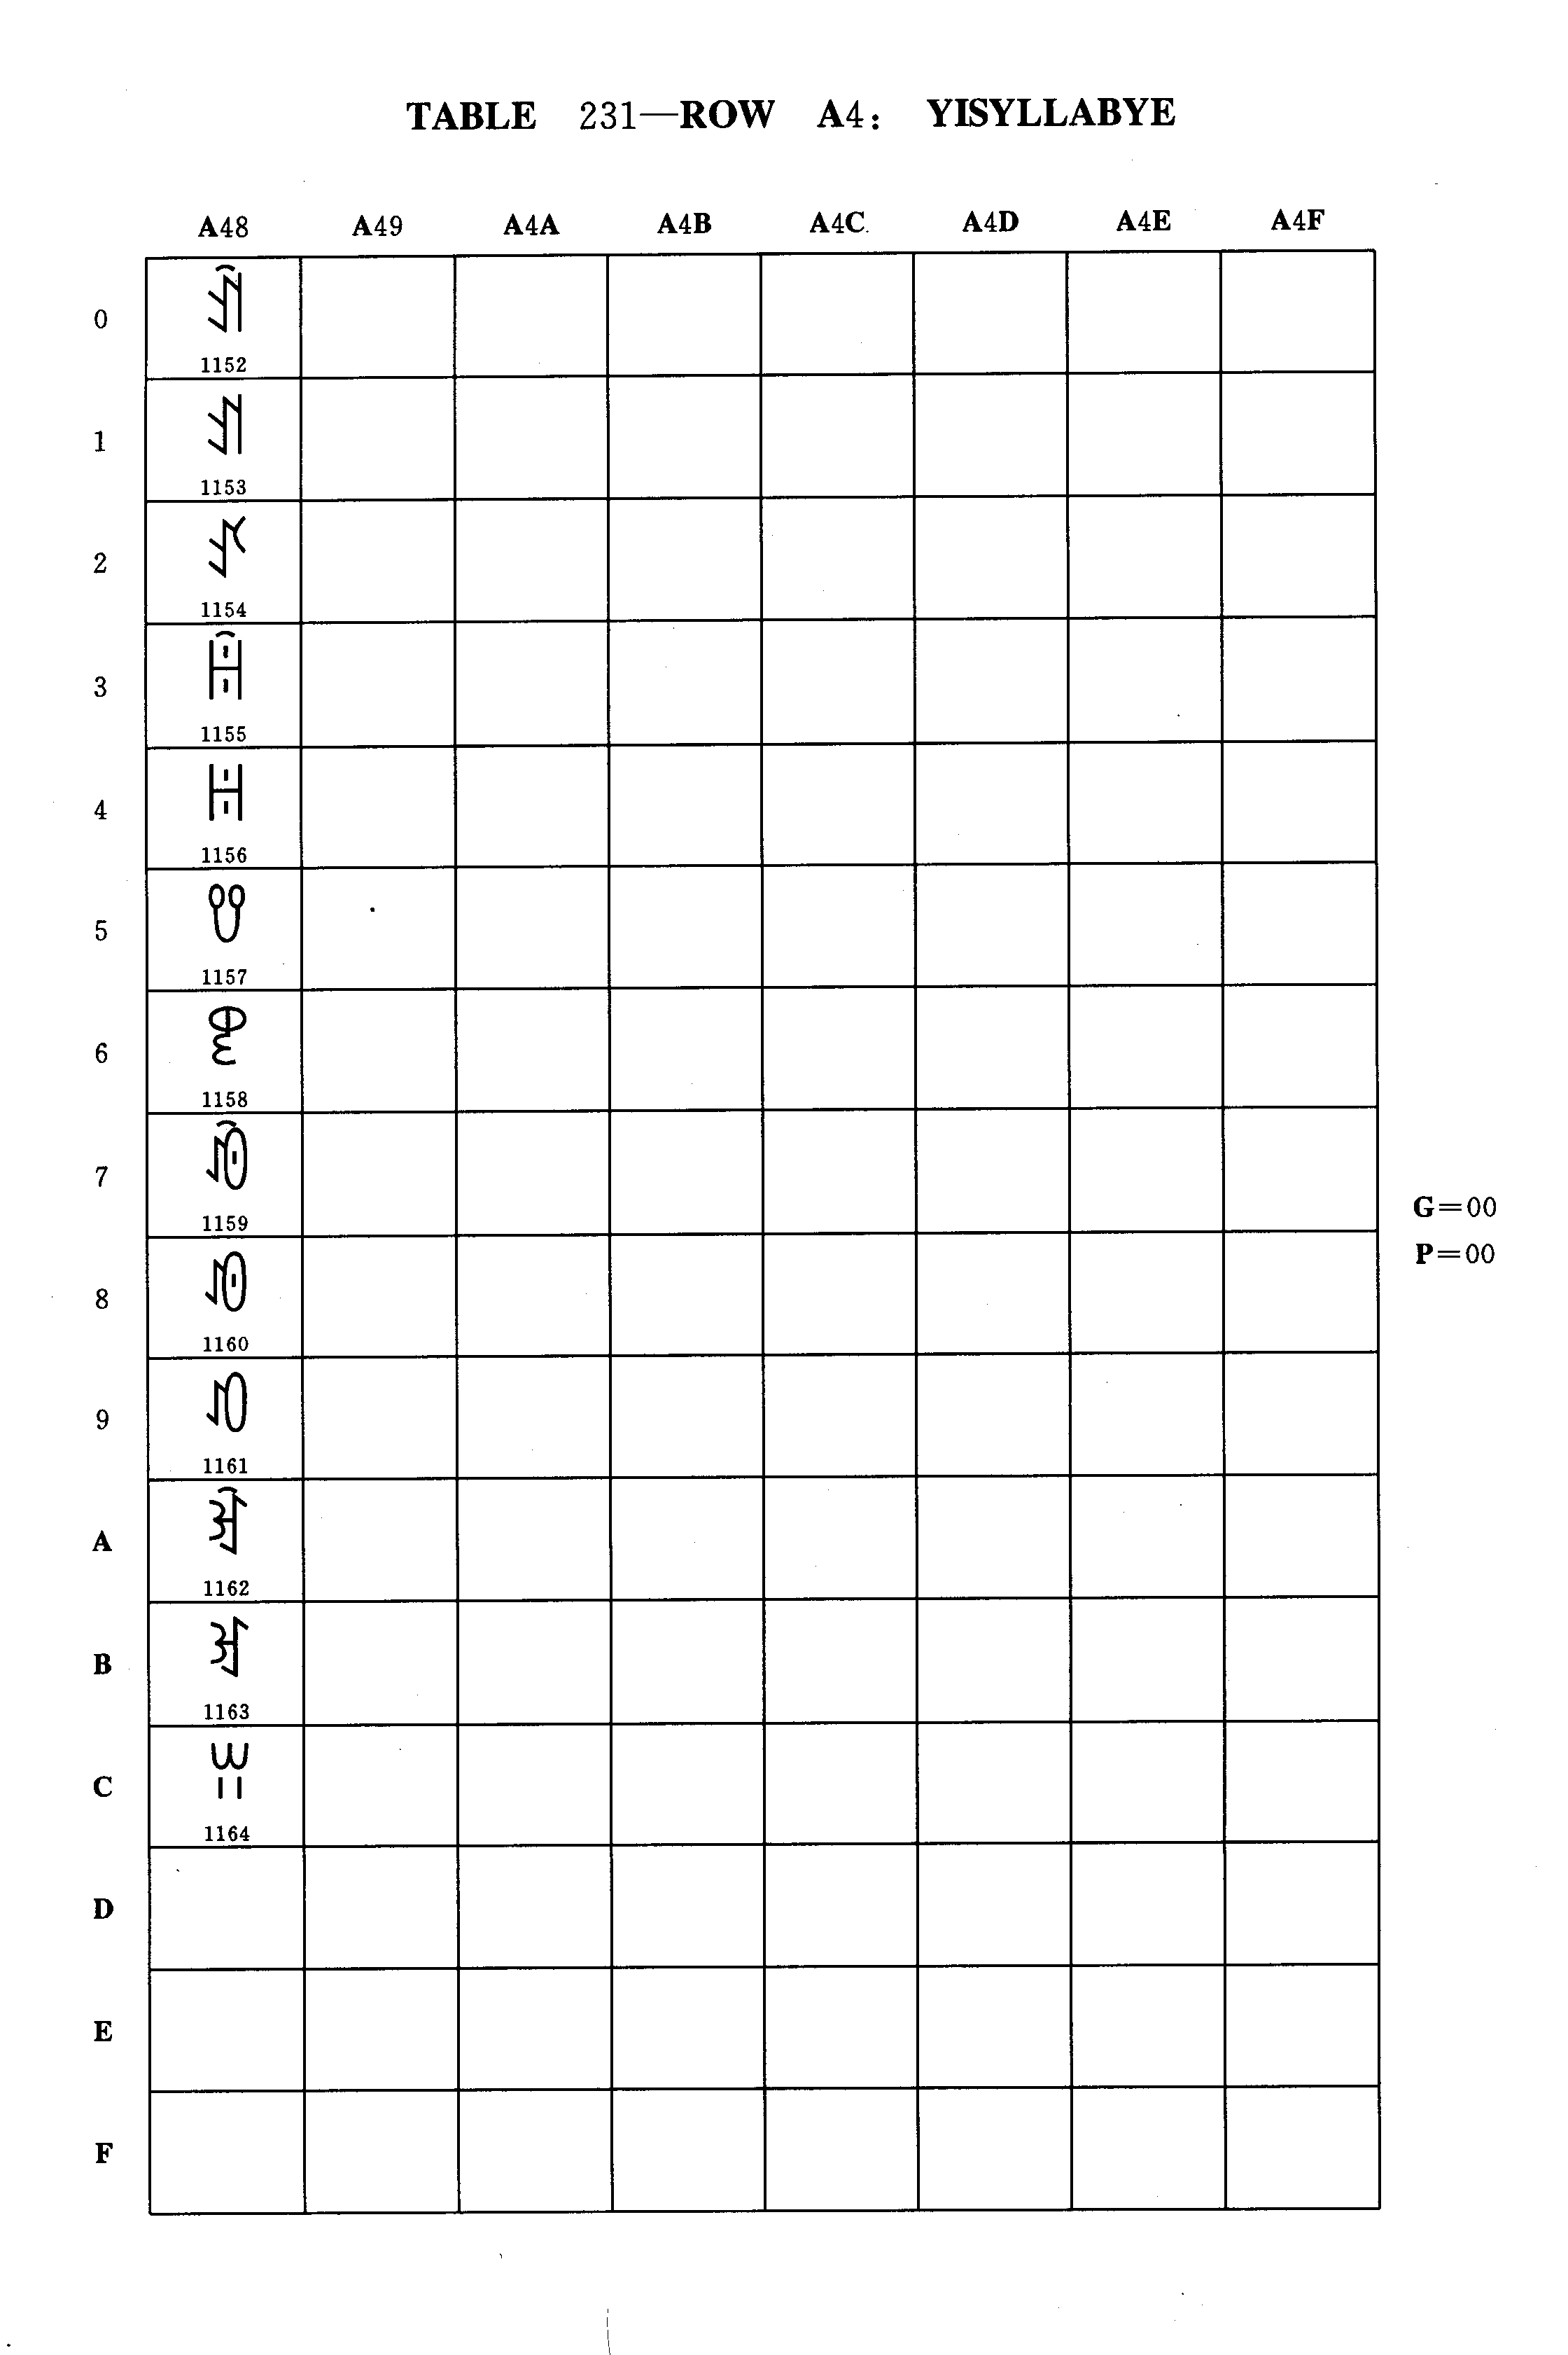
Table 231 - Row A4: YI SYLLABLES

G = 00
P = 00

TABLE 231 - Row A4: YI SYLLABLES

dec | hex | Name
128  129  130  131  132  133  134  135  136  137  138  139  140  141  142  143 | 80  81  82  83  84  85  86  87  88  89  8A  8B  8C  8D  8E  8F | YI SYLLABLE AX  YI SYLLABLE A  YI SYLLABLE AP  YI SYLLABLE UOX  YI SYLLABLE UO  YI SYLLABLE UOP  YI SYLLABLE OT  YI SYLLABLE OX  YI SYLLABLE O  YI SYLLABLE OP  YI SYLLABLE EX  YI SYLLABLE E  YI SYLLABLE W  (This position shall not be used)  (This position shall not be used)  (This position shall not be used)

dec | hex | Name

Group 00 Plane 00 Row A4

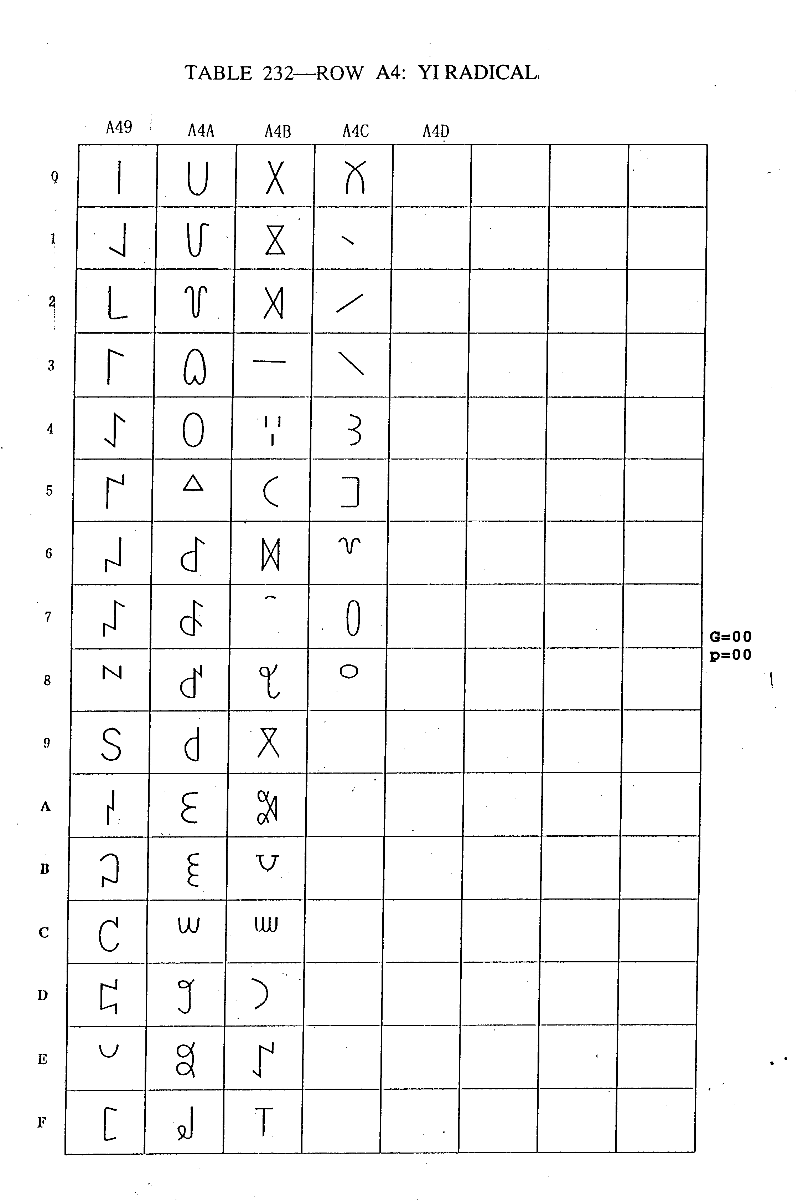
Table 232 - Row A4: YI RADICALS

G = 00
P = 00

TABLE 232 - Row A4: YI RADICALS

dec | hex | Name
144  145  146  147  148  149  150  151  152  153  154  155  156  157  158  159  160  161  162  163  164  165  166  167  168  169  170  171  172  173  174  175  176  177  178  179  180  181  182  183  184  185  186  187  188  189  190  191  192  193  194  195  196  197  198  199  200  201  202  203  204  205  206  207 | 90  91  92  93  94  95  96  97  98  99  9A  9B  9C  9D  9E  9F  A0  A1  A2  A3  A4  A5  A6  A7  A8  A9  AA  AB  AC  AD  AE  AF  B0  B1  B2  B3  B4  B5  B6  B7  B8  B9  BA  BB  BC  BD  BE  BF  C0  C1  C2  C3  C4  C5  C6  C7  C8  C9  CA  CB  CC  CD  CD  CF | YI RADICAL QOT  YI RADICAL LI  YI RADICAL KIT  YI RADICAL NYIP  YI RADICAL CYP  YI RADICAL SSI  YI RADICAL GGOP  YI RADICAL GEP  YI RADICAL HXIT  YI RADICAL LYR  YI RADICAL BBUT  YI RADICAL MOP  YI RADICAL YO  YI RADICAL PUT  YI RADICAL GA  YI RADICAL JYP  YI RADICAL DDUR  YI RADICAL BUR  YI RADICAL GGUO  YI RADICAL NYOP  YI RADICAL TU  YI RADICAL ZOT  YI RADICAL PYR  YI RADICAL HMO  YI RADICAL YIT  YI RADICAL VUR  YI RADICAL SHY  YI RADICAL ZA  YI RADICAL JO  YI RADICAL WO  YI RADICAL SHUR  YI RADICAL LIE  YI RADICAL XI  YI RADICAL CIP  YI RADICAL SHAT  YI RADICAL LAVT  YI RADICAL KE  YI RADICAL HXUO  YI RADICAL HXOP  YI RADICAL FUZZ  YI RADICAL DU  YI RADICAL CHE  YI RADICAL SHOP  YI RADICAL JJY  YI RADICAL GOT  YI RADICAL NGOT  YI RADICAL MI  YI RADICAL ZZIT  YI RADICAL CUOP  YI RADICAL CISS  YI RADICAL VRRT  YI RADICAL YRRT  YI RADICAL VE  YI RADICAL TAT  YI RADICAL JJIE  YI RADICAL OB  YI RADICAL JJUT  (This position shall not be used)  (This position shall not be used)  (This position shall not be used)  (This position shall not be used)  (This position shall not be used)  (This position shall not be used)  (This position shall not be used)

dec | hex | Name

Group 00 Plane 00 Row A4

