JTC 1 / SC 2 / WG 2 N 1979

Chinese comments on ISO/IEC 10646-1/PDAM 31: Tibetan Extension

Date: 1999-01-27

China is in favor of the CD registration on Tibetan Extension with the following comments. (These comments are also the response to WG2 N 1880, Clarifications and corrections in response to the concerns of China expressed in their submission: WG2 N1864 “Comments on WG2 N 1756 (Tibetan Extension)”.)

- We insist that the glyphs of the three characters at position AD, B1 and B2 should be kept as what they are in AMD 6. The glyphs of these three characters in AMD 6 are frequently used for the transliteration from Sanskrit to Tibetan and are independent on the typeface of Tibetan. The glyphs of current three characters in PDAM 31 are used frequently in the common-use Tibetan. The changing of using frequency of these glyphs in AMD 6 and PDAM 31 relies on the scope of use only and these characters change their glyphs in form only but not essentially. We believe that the original encoding scheme is capable of representing all the forms come from these characters. For easily implementing, we agree to add characters at position BA, BB and BC, but we do not think their glyphs should be interchanged with those at AD, B1 and B2. What we are concerned about is if adding these three characters will result in ambiguity.

- 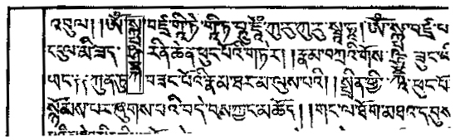In accordance with the definition of combining character specified in ISO/IEC 10646.1: 1993, we believe that characters at 3C, 3D, 88, 89 and 8B should not have a dotted circle with their glyphs respectively. Characters at 88, 89 and 8B are combined with some specific Tibetan consonants only, and appear in front of the combining sequences. Characters at 88, 89 and 8B will appear at position of headline only when they are combined with consonants below. The author of WG2 N1880 may very well misunderstand the example given in his paper. As shown in that example, the characters in the pane should be regarded as one character.

- For character at position 0C, we understand the purpose of the use of it and we agree that changing its glyph as shown in PDAM 31 is necessary.

New question:

We noticed that the glyph of character at 0F6A is same as that at 0F62. We request that the meaning and function of the character at 0F6A should be provided.

Note:

Five characters added at 0F96, 0FAE, 0FAF, 0FB0 and 0FB8 in PDAM 31 are used in form of replace-combine writing for Tibetan encryption. It is not encouraged to add these characters because this form of writing breaks the grammar and the total number of combining forms is unlimited, moreover, it is rarely used now. We agree to add them because there are only five characters to be added.

