ISO/IEC JTC1/SC2/WG2
N2184
2000-03-14

Title: Additional information for the proposal to add three symbols
Status: Personal contribution in response to action item from meeting M35
Source: Asmus Freytag
Action: For information
Distribution: Members of SC2/WG2

Related documents: N1887

Additional information on the proposal to add three symbols:

- An example of the use of the square foot symbol
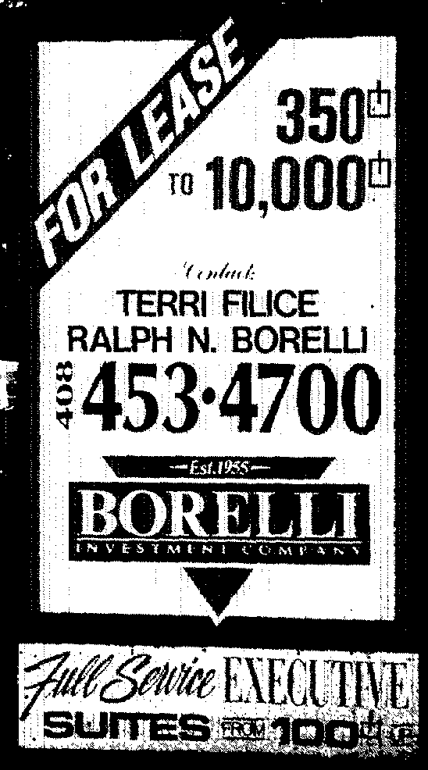

This sign was located conveniently 100ft away from the location of the 13th and 15th Unicode Conference in San Jose, CA.

As you can see this example shows the use of the symbol in advertising, but informal surveys of professionals in the field indicate that its use is not limited in that way.

- No examples of the square inch symbol have been found. It's a unit that would be in use in a different industry from the source of the other two symbols. It's possible that it is a wrong analogy to the proposed SQUARE FOOT symbol, but it is also possible that it exists, but is used in an unexamined area.

- Instances of the proposed PROPERTY LINE symbol have been located on maps of real property. Their use is fully analogous to the use of the existing CENTER LINE symbol. The example is from a manually created document in the author's possession, but it clearly shows the usage of the symbol.

