ISO/IEC JTC1/SC2/WG2 N2195
2000-03-15

ISO/IEC JTC1/SC2/WG2
Universal Multiple-Octet Coded Character Set (UCS)
Secretariat: ANSI

Title: Rationale for non-Kanji characters proposed by JCS committee
Doc. Type: national body contribution
Source: Japan
Project:
Status: To be discussed at the WG2 meeting in Beijing
Date: 2000-03-15
Distribution: ISO/IEC JTC1/SC2/WG2
Reference:

As mentioned in the IRG N690, UTC commented on the Japanese requirements to add characters of JIS X0213. This document shows some evidences and explains usages.

1. Rationale and Evidence of usage

(1) DOUBLE PLUS 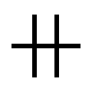, TRIPLE PLUS 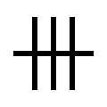
These symbols are used, to represent some "strength" or "levels," in discipline including clinical medicine. They represent twice and treble levels, respectively, of the level the PLUS SIGN does.

(2) Dentist’s symbols
These symbols are used in dentistry when drawing XXX together with some BOX DRAWING characters. The proposal includes two types of characters; those used in single-line drawing and those in triple-line drawing.

Symbols to be used in single-line drawing: | 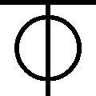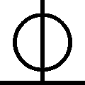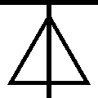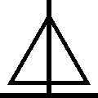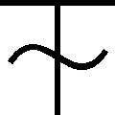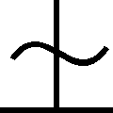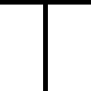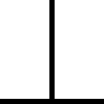
Symbols to be used in triple-line drawing: | 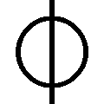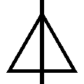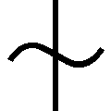

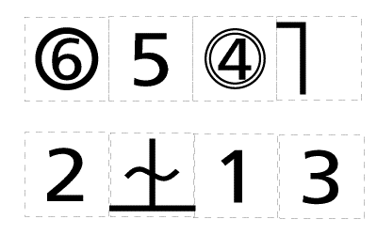 | 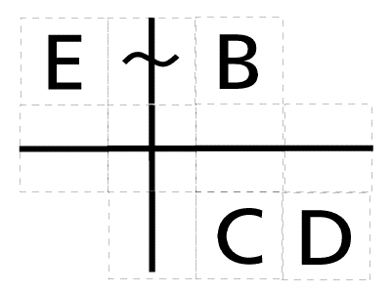
Example single line drawing | Example triple-line drawing

(3) DOUBLE HYPHEN
Recommended in KOUSEI-HIKKEI and Japan Book Publishers Association. Historically, this symbol was derived from duplex form of two HYPHENs or EN DASHes. It is used in katakana-written foreign names to indicate a break between surname and given name, to preserve a hyphen in alphabet-written form of a compound surname, etc. It has a totally different semantics than EQUALS SIGN (U+003D.) | 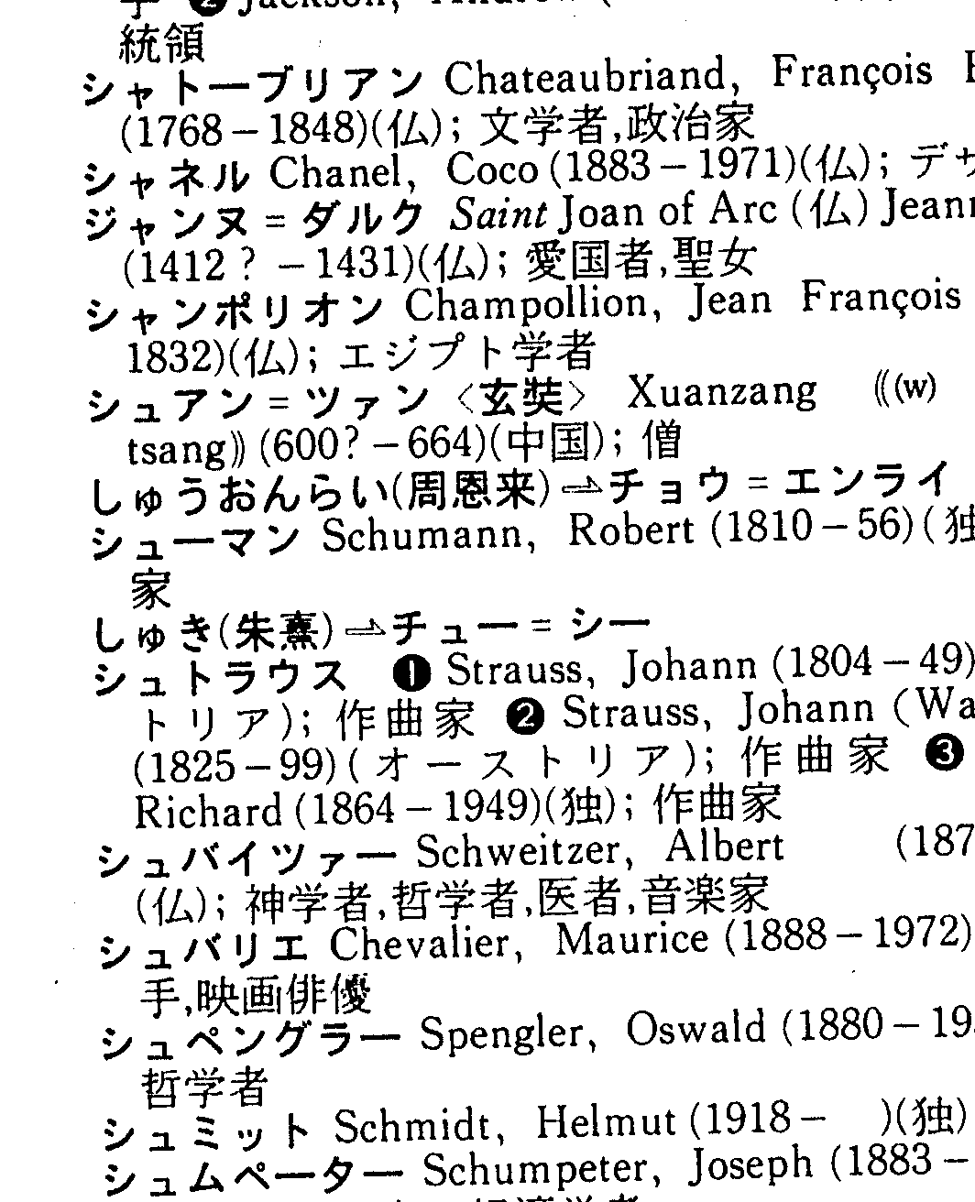

(4) LEFT WHITE PARENTHESIS 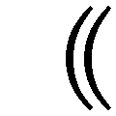 , RIGHT WHITE PARENTHESIS 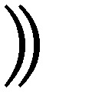

Recommended in KOUSEI-HIKKEI and Japan Book Publishers Association. | 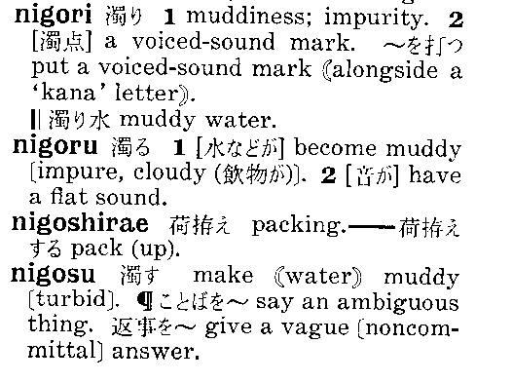

(5) CIRCLED BULLET 
Recommended in KOUSEI-HIKKEI and Japan Book Publishers Association.
In the example shown rightward, FISHEYE (U+25C9) is used in the upper column and CIRCLED BULLET is used lower column. It can be seen that these characters are used distinguished. | 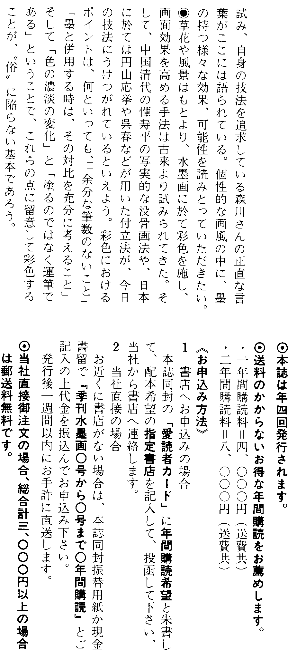

(6) DOUBLE ASTERISK 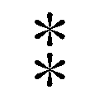
Recommended in KOUSEI-HIKKEI and Japan Book Publishers Association.

(7) ITERATION MARK 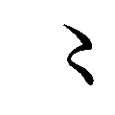
ITERATION MARK is used to indicate to repeat one character.

This character is recommended in KOUSEI-HIKKEI and Japan Book Publishers Association.

(8) MASU MARK 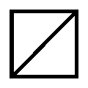
This symbols is derived from a pictogram for a 桝 (pronounced as "MASU"; a traditional square measure-cup made with woods.) It is used [in informal contexts] as an abbreviation for a Japanese word "MASU" [which frequently appears at the end of a sentence.]

(9) KATAKANA DIGRAPH KOTO 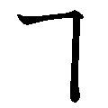
This is a digraph of KATAKANA KO followed vertically by KATAKANA TO. It is actually used in several used law texts.

(10) HIRAGANA DIGRAPH YORI 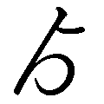
This is a digraph of HIRAGANA YO followed vertically by HIRAGANA RI. It is used in newspapers.

(11) PART-ALTERNATION MARK 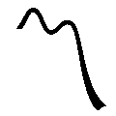

(12) WHITE SESAME DOT 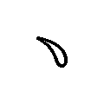, SESAME DOT 
These characters are adopted in the ISO/IEC 1541-1 DAM.3 and IOS/IEC 9541-2 DAM.1. See the documents for explanation about these characters.

2. Sources
Some characters shown above are recommended in KOUSEI-HIKKEI and HENSYUU-HIKKEI. These are widely referenced in Japan. Hence, proposed characters taken from them are regarded as actually being used in information interchange.

Kyodo News Services' K-JIS: Kyodo News Services' proprietary character codeset for news delivery. It is used when news or other information is delivered to news publishers in Japan. Based on JIS X 0208, it includes additional symbols as proprietary extension.

3. Pre-Composed characters
3.1 Enclosed numbers
As UTC has never proposed concrete composition methods for additional circled numerals, we considered that we cannot represent those characters by composition in UCS/Unicode. So, we keep proposing to assign independent code points for those proposed characters.

3.2 KANA extensions
Kana extension for Ainu is an integral part of the writing system used by aborigines in Japan. Such an extension has already been done for many other scripts in UCS, so the proposed addition must be reasonable.

Also, characters in this group represent independent sounds from their _base_ characters, so it is inappropriate to implement using combining methods for accented Latin characters.

3.3 RISING SYMBOL, FALLING SYMBOL
divLの審議の過程で、豊島先生から以下のコメントが寄せられている。
「Unicode 2.0 book の該当部分は、誤解に基づく記述だと思います。IPA の意図は、pitch + contour で high + rising -> high-rising 等を表記しようというものなのに、Unicode(2.0) は、low + high == rising だと誤解しています。これでは、high-rising と low-rising を区別する事が出来ず、こうした区別を持つ言語(e.g. 広東語)の声調表記が不可能になります。」

In Unicode book 2.0, these characters can be produced with another two characters such as
low

But according to linguist’s comment in Japan, it is misunderstanding. IPA aims
(pitch) + (pitch) => (rising)

--- end of document ---

