ISO/IEC JTC/1 SC/2 WG/2 N2221
2000-04-20

ISO/IEC JTC/1 SC/2 WG/2
Universal Multiple-Octet Coded Character Set (UCS)
Secretariat: ANSI

Title: JIS COMPATIBILITY IDEOGRAPHS (draft for ammendment-1)
Doc. Type: national body contribution
Source: Japan -SY/tks
Project: 02:18.01
Status: To be considered at #39 WG2 meeting in Greece (SEP2000)
Date: 2000-04-20
Distribution: ISO/IEC JTC/1 SC/2 WG2
Reference: WG2 N2197, Resolution M38.11
Medium:

The resolution M38.11 instructs project editor for ISO/IEC 10646-1 to include JIS X 0213 COMPATIBILITY IDEOGRAPHS into a list of characters accepted for processing beyond the 2nd edition of ISO/IEC 10646-1.
This document describes necessary information and proposal for the project editor to accommodate the instruction defined in the resolution M38.11.
Japan requests the editor to include this requirements into the first amendment of the 2nd edition of ISO/IEC 10646-1 which is also instructed to the project editor per resolution M38.14.

Note for both part-1 and part-2 editors (Bruce Paterson and Michel Suignard): To make part-1 and part-2 consistent for the COMPATIBILITY IDEOGRAPH, please open a discussion about accommodation of this requirement.

- Code table, character name table and associated changes.
  - Collection name: Japan requests an independent collection name for these ideographs. The recommended collection name is JIS COMPATIBILITY IDEOGRAPHS.

Remark: Japan believes that it is not necessary to state “compatibility with which JIS”. Those information should be described in the annex P along with other necessary information.

  - Code table: Add following code table as table xxx (xxx to be defined by editor).

TABLE xxx – Row FA: JIS COMPATIBILITY IDEOGRAPHS
 |  |  | FA3 | FA4 | FA5 | FA6
 |  | 0 | 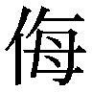  FA30 |   FA40 | 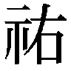  FA50 | 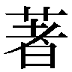  FA60
 |  | 1 |   FA31 | 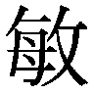  FA41 | 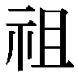  FA51 |   FA61
 |  | 2 | 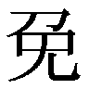  FA32 | 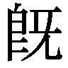  FA42 | 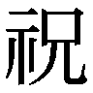  FA52 |   FA62
 |  | 3 | 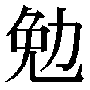  FA33 | 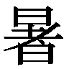  FA43 | 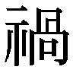  FA53 |   FA63
 |  | 4 | 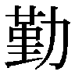  FA34 | 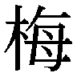  FA44 |   FA54 | 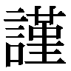  FA64
 |  | 5 | 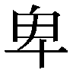  FA35 |   FA45 |   FA55 | 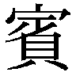  FA65
 |  | 6 |   FA36 | 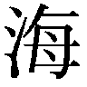  FA46 | 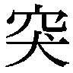  FA56 | 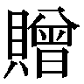  FA66
 |  | 7 |   FA37 | 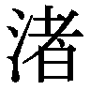  FA47 | 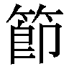  FA57 | 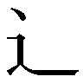  FA67
 |  | 8 | 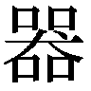  FA38 | 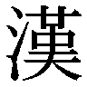  FA48 | 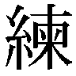  FA58 |   FA68
 |  | 9 | 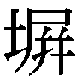  FA39 | 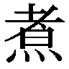  FA49 | 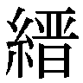  FA59 |   FA69
 |  | A | 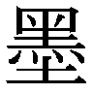  FA3A |   FA4A | 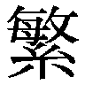  FA5A |   FA6A
 |  | B | 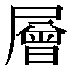  FA3B | 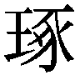  FA4B | 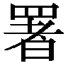  FA5B | 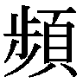  FA6B
 |  | C | 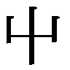  FA3C | FA4C | 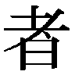  FA5C
 |  | D | 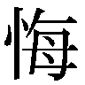  FA3D | 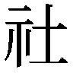  FA4D | 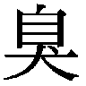  FA5D
 |  | E | 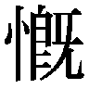  FA3E | 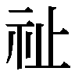  FA4E | 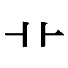  FA5E
 |  | F |   FA3F | 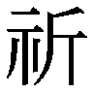  FA4F | 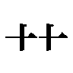  FA5F

Remark: number of the characters is 60 while the n2197 requested 61. This is per final agreement
with the JIS development committee. As a result, the code range is FA30-FA6B.

  - Character name: Japan proposes to use the same principle as CJK UNIFIED IDEOGRAPHS/CJK COMPATIBILITY IDEOGRAPHS for naming of the ANY COMPATIBILITY IDEOGRAPH (use UCS code position for the naming). The resultant character name is JIS COMPATIBILITY IDEOGRAPH-FA30 for example (for code point FA30).
Since Japan requests additional information at annex P for those characters, an ASTERISK to be added to indicate the information at the annex P.

Table xxx – Row FA: JIS COMPATIBILITY IDEOGRAPHS
HEX | NAME |  | HEX | NAME
FA30  FA31  FA32  FA33  FA34  FA35  FA36  FA37  FA38  FA39  FA3A  FA3B  FA3C  FA3D  FA3E  FA3F  FA40  FA41  FA42  FA43  FA44  FA45  FA46  FA47  FA48  FA49  FA4A  FA4B  FA4C  FA4D  FA4E  FA4F  FA50  FA51  FA52  FA53  FA54  FA55  FA56  FA57  FA58  FA59  FA5A  FA5B  FA5C  FA5D  FA5E  FA5F  FA60  FA61  FA62  FA63  FA64  FA65  FA66  FA67  FA68  FA69  FA6A  FA6B | JIS COMPATIBILITY IDEOGRAPH-FA30 *  JIS COMPATIBILITY IDEOGRAPH-FA31 *  JIS COMPATIBILITY IDEOGRAPH-FA32 *  JIS COMPATIBILITY IDEOGRAPH-FA33 *  JIS COMPATIBILITY IDEOGRAPH-FA34 *  JIS COMPATIBILITY IDEOGRAPH-FA35 *  JIS COMPATIBILITY IDEOGRAPH-FA36 *  JIS COMPATIBILITY IDEOGRAPH-FA37 *  JIS COMPATIBILITY IDEOGRAPH-FA38 *  JIS COMPATIBILITY IDEOGRAPH-FA39 *  JIS COMPATIBILITY IDEOGRAPH-FA3A *  JIS COMPATIBILITY IDEOGRAPH-FA3B *  JIS COMPATIBILITY IDEOGRAPH-FA3C *  JIS COMPATIBILITY IDEOGRAPH-FA3D *  JIS COMPATIBILITY IDEOGRAPH-FA3E *  JIS COMPATIBILITY IDEOGRAPH-FA3F *  JIS COMPATIBILITY IDEOGRAPH-FA40 *  JIS COMPATIBILITY IDEOGRAPH-FA41 *  JIS COMPATIBILITY IDEOGRAPH-FA42 *  JIS COMPATIBILITY IDEOGRAPH-FA43 *  JIS COMPATIBILITY IDEOGRAPH-FA44 *  JIS COMPATIBILITY IDEOGRAPH-FA45 *  JIS COMPATIBILITY IDEOGRAPH-FA46 *  JIS COMPATIBILITY IDEOGRAPH-FA47 *  JIS COMPATIBILITY IDEOGRAPH-FA48 *  JIS COMPATIBILITY IDEOGRAPH-FA49 *  JIS COMPATIBILITY IDEOGRAPH-FA4A *  JIS COMPATIBILITY IDEOGRAPH-FA4B *  JIS COMPATIBILITY IDEOGRAPH-FA4C *  JIS COMPATIBILITY IDEOGRAPH-FA4D *  JIS COMPATIBILITY IDEOGRAPH-FA4E *  JIS COMPATIBILITY IDEOGRAPH-FA4F *  JIS COMPATIBILITY IDEOGRAPH-FA50 *  JIS COMPATIBILITY IDEOGRAPH-FA51 *  JIS COMPATIBILITY IDEOGRAPH-FA52 *  JIS COMPATIBILITY IDEOGRAPH-FA53 *  JIS COMPATIBILITY IDEOGRAPH-FA54 *  JIS COMPATIBILITY IDEOGRAPH-FA55 *  JIS COMPATIBILITY IDEOGRAPH-FA56 *  JIS COMPATIBILITY IDEOGRAPH-FA57 *  JIS COMPATIBILITY IDEOGRAPH-FA58 *  JIS COMPATIBILITY IDEOGRAPH-FA59 *  JIS COMPATIBILITY IDEOGRAPH-FA5A *  JIS COMPATIBILITY IDEOGRAPH-FA5B *  JIS COMPATIBILITY IDEOGRAPH-FA5C *  JIS COMPATIBILITY IDEOGRAPH-FA5D *  JIS COMPATIBILITY IDEOGRAPH-FA5E *  JIS COMPATIBILITY IDEOGRAPH-FA5F *  JIS COMPATIBILITY IDEOGRAPH-FA60 *  JIS COMPATIBILITY IDEOGRAPH-FA61 *  JIS COMPATIBILITY IDEOGRAPH-FA62 *  JIS COMPATIBILITY IDEOGRAPH-FA63 *  JIS COMPATIBILITY IDEOGRAPH-FA64 *  JIS COMPATIBILITY IDEOGRAPH-FA65 *  JIS COMPATIBILITY IDEOGRAPH-FA66 *  JIS COMPATIBILITY IDEOGRAPH-FA67 *  JIS COMPATIBILITY IDEOGRAPH-FA68 *  JIS COMPATIBILITY IDEOGRAPH-FA69 *  JIS COMPATIBILITY IDEOGRAPH-FA6A *  JIS COMPATIBILITY IDEOGRAPH-FA6B *
Group 00 Plane 00 Row FA

  - Block name and table 3 and 4: It is up to editor, whether if new block name is necessary for those or not. Also, up date of the table 3 and/or 4 or not is up to the editor.
Japan does not have any preference on this issue. JIS COMPATIBILITY IDEOGRAPHS (collection) may (and may not) be a part of the CJK COMPATIBILITY IDEOGRAPHS (block)
  - Annex A clause A.1: Add collection JIS COMPATIBILITY IDEOGRAPHS in clause A.1.
  - Annex L and clause 27: Try to add a text to explain the rule 13 of the annex L is applicable to the COMPATIBILITY IDEOGRAPH. (May be rule 13 itself is Okay as it is, However, clause 27 is mentioning CJK UNIFIED IDEOGRAPHS only)).
  - Annex M: Add JIS X 0213: 2000 7-bit and 8-bit double byte coded extended KANJI sets for information interchange.

Remark: Since ISO/IEC 10646-1 does not use JIS X 0213 as a character naming reference, there is no way to add the JIS into the clause 27. Therefore, the annex M is the best place to add the JIS as a reference standard. (Besides, the part-2 is referring the JIS. Thus, it is necessary to add JIS X 0213: 2000 at clause 10.2.x of the part-2).

- Compatibility information.
Both N2142 (IRG report regarding COMPATIBILITY IDEOGRAPHS) and N2196 (Japanese contribution about the COMPATIBILITY IDEOGRAPHS) are requested to include following information for the COMPATIBILITY IDEOGRAPHS.
- Corresponding CJK UNIFIED IDEOGRAPH (code point at least)
- Source standard (and code point)
Japan recommends including that information within annex P.

  - Issue: The annex P is an informative annex, however, Japan believes that that information regarding the COMPATIBILITY IDEOGRAPHS should be a normative. Japan likes to leave this issue with the editor to resolve.
  - Annex P: Add following text to annex P

FA30-FA6A JIS COMPATIBILITY IDEOGRAPH FA30-FA6B Those characters are compatibility ideographs with JIS X 0213: 2000.

Note: a mapping information form the JIS X 0213 to this international standard is available within the JIS X 0213: 2000.

The corresponding CJK UNIFIED IDEOGRAPH are as follow:

Code point: JIS COMPATIBILITY IDEOGRAPH CJK UNIFIED IDEOGRAPH (incl. Extensions)
FA30 4FAE
FA31 50E7
FA32 514D
FA33 52C9
FA34 52E4
FA35 5351
FA36 559D
FA37 5606
FA38 5668
FA39 5840
FA3A 58A8
FA3B 5C64
FA3C 5C6E
FA3D 6094
FA3E 6168
FA3F 618E
FA40 61F2
FA41 654F
FA42 65E2
FA43 6691
FA44 6885
FA45 6982
FA46 6D77
FA47 6E1A
FA48 6F22
FA49 716E
FA4A 722B
FA4B 7422
FA4C 7891
FA4D 793E
FA4E 7949
FA4F 7948
FA50 7950
FA51 7956
FA52 795D
FA53 798D
FA54 798E
FA55 7A40
FA56 7A81
FA57 7BC0
FA58 7DF4
FA59 7E09
FA5A 7E41
FA5B 7F72
FA5C 8005
FA5D 81ED
FA5E FA5F, 8279, 4491
FA5F FA5E, 8279, 4491
FA60 8457
FA61 8910
FA62 8996
FA63 8B01
FA64 8B39
FA65 8CD3
FA66 8D08
FA67 8FB6
FA68 9038
FA69 96E3
FA6A 97FF
FA6B 983B

Remark: Japan does not want to add the code point information onto this international standard. It
should be a part of the source standard. Reasons are.
- The source standard should have the information and has to keep the right to manage the information (such as up-dating).
- If this international standard also has the information, it may have a danger of the inconsist referring. The reference should be one direction and never be a bi-directional.

- Other concerns: Besides the above, Japan does believe that following to be considered.
  - Adding a definition of the COMPATIBILITY IDEOGRAPHS. For better understanding of the relation between CJK UNIFIED IDEOGRAPHS and CJK COMPATIBILITY IDEOGRAPHS, it might be better to include a explanatory text like in N21 96 as a part of the ISO/IEC 10646.
  - The text might be a part of the definition clause, an independent clause in main text or independent annex which might include other information such as information described in para-2 of this draft (as a part of annex P).
  - There is a possibility to move the corresponding CJK UNIFIED IDEOGRAPH information from annex P (as proposed in pare-2) to the parenthesized information along with the character name. This may (may not) soften the normative/informative discussion of the annex P.
  - By the way, some of the information in the annex P might have a nature of normative also (such as Glyph table for FA1F and FA23).

---end----

