ISO/IEC JTC 1/SC 2/WG 2 N2774
IRG N1064

2004-05-25

Title:  Source:  Distribution:  Action:  Reference: | Proposal to add 6 KP source references to existing CJK Unified Ideographs  Committee for Standardization of the D P R of Korea (CSK)  IRG Members  For IRG reivew  IRG N 1046

The following 6 KP source references to existing CJK Unified Ideographs should be added to ISO/IEC 10646.

UCS | KP | Glyph
U+03E14 | KP1-5DC7 | 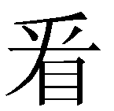
U+056D8 | KP1-3749 | 
U+07AD0 | KP1-636D | 
U+20617 | KP1-49E2 | 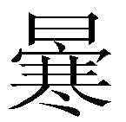
U+20F96 | KP1-3AA3 | 
U+2258D | KP1-7352 | 

