 | ISO/IEC JTC 1/SC 2/WG 2 N2975R
DATE: 2006-04-19

ISO/IEC JTC 1/SC 2/WG 2
Universal Multiple-Octet Coded Character Set (UCS) - ISO/IEC 10646
Secretariat: ANSI

TITLE: | Proposal to add Mahjong symbols to ISO/IEC 10646
SOURCE: | TCA
STATUS: | Contribution from Liaison Member
ACTION: | For consideration by JTC1/SC2/WG2
DISTRIBUTION: | ISO/IEC JTC1/SC2/WG2

A. Administrative
1. Title: Mahjong Symbols
2. Requester's name: TCA
3. Requester type (Member body/Liaison/Individual contribution): Liaison
4. Submission date: 2006/4/19
5. Requester's reference (if applicable): No
6. Choose one of the following:
This is a complete proposal: Yes
or, More information will be provided later: No

B. Technical - General
1. Choose one of the following:
a. This proposal is for a new script (set of characters): Yes
Proposed name of script: Mahjong Symbols
b. The proposal is for addition of character(s) to existing block: No
Name of existing block:
2. Number of characters in proposal: 43
3. Proposed category (select one from below - see section 2.2 of P&P document):
A-Contemporary X
B.1-Specialized (small collection) _____ B.2-Specialized (large collection) _____
C-Major extinct _____ D-Attested extinct _____ E-Minor extinct _____
F-Archaic Hieroglyphic or Ideographic _____
G-Obscure or questionable usage symbols _____
4. Proposed Level of Implementation (1, 2 or 3) (see Annex K in P&P document): 1
Is a rationale provided for the choice? No
If Yes, reference:
5. Is a repertoire including character names provided? Yes
a. If YES, are the names in accordance with the “character naming guidelines” in Annex L of P&P document? Yes
b. Are the character shapes attached in a legible form suitable for review? Yes
6. Who will provide the appropriate computerized font (ordered preference: True Type, or PostScript format) for publishing the standard? jpg files were provided by the Chinese Foundation for Digitization Technology (CMEX)
If available now, identify source(s) for the font (include address, e-mail, ftp-site, etc.) and indicate the tools used: selena@cmex.org.tw
7. References:
a. Are references (to other character sets, dictionaries, descriptive texts etc.) provided?
No
b. Are published examples of use (such as samples from newspapers, magazines, or other sources) of proposed characters attached? No
8. Special encoding issues:
Does the proposal address other aspects of character data processing (if applicable) such as input, presentation, sorting, searching, indexing, transliteration etc. (if yes please enclose information)? No
9. Additional Information:
Submitters are invited to provide any additional information about Properties of the proposed Character(s) or Script that will assist in correct understanding of and correct linguistic processing of the proposed character(s) or script. Examples of such properties are: Casing information, Numeric information, Currency information, Display behaviour information such as line breaks, widths etc., Combining behaviour, Spacing behaviour, Directional behaviour, Default Collation behaviour, relevance in Mark Up contexts, Compatibility equivalence and other Unicode normalization related information. See the Unicode standard at http://www.unicode.org for such information on other scripts. Also see http://www.unicode.org/Public/UNIDATA/UCD.html and associated Unicode Technical Reports for information needed for consideration by the Unicode Technical Committee for inclusion in the Unicode Standard.

C. Technical – Justification
1. Has this proposal for addition of character(s) been submitted before? No
If YES explain
2. Has contact been made to members of the user community (for example: National Body, user groups of the script or characters, other experts, etc.)? Yes
If YES, with whom? Bureau of Standard, Metrology and Inspection (BSMI)
If YES, available relevant documents: The contract between BSMI and CMEX
3. Information on the user community for the proposed characters (for example: size, demographics, information technology use, or publishing use) is included? More than millions people play manual Mahjong game, and more than ten thousand people play computer or online Mahjong game.
Reference: for example, http://www.mj-king.com/modules.php?name=Sections&op=listarticles&secid=1
http://www.acergame.com.tw/document/mj.shtml
http://kosti.tripod.com/mahjongbasic-big5.htm
or to find a lot of relevant information by using the google to search the keyword “mahjong”
4. The context of use for the proposed characters (type of use; common or rare): Play Mahjong with computer (i.e., computer game) or with another people through Internet (i.e., online game).
Reference: for example, http://www.mjonline.com.tw/
5. Are the proposed characters in current use by the user community? Yes
If YES, where? Reference: for example, http://www.mjonline.com.tw/
6. After giving due considerations to the principles in the P&P document must the proposed characters be entirely in the BMP? No
If YES, is a rationale provided?
If YES, reference:
7. Should the proposed characters be kept together in a contiguous range (rather than being scattered)? Yes
8. Can any of the proposed characters be considered a presentation form of an existing character or character sequence? No
If YES, is a rationale for its inclusion provided?
If YES, reference:
9. Can any of the proposed characters be encoded using a composed character sequence of either existing characters or other proposed characters? No
If YES, is a rationale for its inclusion provided?
If YES, reference:
10. Can any of the proposed character(s) be considered to be similar (in appearance or function) to an existing character? No
If YES, is a rationale for its inclusion provided?
If YES, reference:
11. Does the proposal include use of combining characters and/or use of composite sequences?
No
If YES, is a rationale for its inclusion provided?
If YES, reference:
Is a list of composite sequences and their corresponding glyph images (graphic symbols) provided? No
If YES, reference:
12. Does the proposal contain characters with any special properties such as control function or similar semantics? No
If YES, describe in detail (include attachment if necessary):
13. Does the proposal contain any Ideographic compatibility character(s)? No
If YES, is the equivalent corresponding unified ideographic character(s) identified?
If YES, reference:

D. Proposal
User Community
Mahjong (Mahjongg, Mah Jong) solitaire is a free puzzle game based on a classic Chinese game for four players to play at a square table. It includes 136 tiles and each player is dealt 13 tiles for 13-tile variations or 144 tiles for each player to deal 16 tiles for 16-tile variations. The object of the game is to build complete suits for either 13 or 16 tiles. The first player to achieve this goal is the winner of the game.
Mahjong is still a very popular game in Taiwan. Most adults in Taiwan have the experience of playing Mahjong during Chinese New Year holidays. With the development of computer technology and Internet, there are two new types of Mahjong appeared. The first one is a computer game which allows a person to play against computer opponents on a PC. The second one is an online game for which 4 people playing by means of Internet. Certainly the printing industry also needs Mahjong to be encoded.
Invention of Mahjong
The true origin of Mahjong is still a mystery and many legends relating to its development are made up to attract potential customers and players. Mahjong which commonly known as “Sparrow” is said to be originated from Ningpo in Chunchu and Warring Period (B.C. 770 -221) of China. Originally, characters and icons were engraved onto the wooden tiles, yet products in various fashions are now available and there are paper cards convenient for outdoor use. It is also said that Mahjong has been played on Noah’s Ark; if so, the game then has a history of more than four thousand years. Nowadays, it is generally believed to start since mid of 19th century because there is no evidence related to it. However, the precise time of its birth is still unknown.
Although the game of card stacking was seen in China since AD 1120, Mahjong is more similar to many ancient card games. One of the games is called “Mahdiao” (“horse-hoisting” literally), which has 40 cards in total and divided into 4 doors; each door has numbers from 1 to 9 together with remaining 4 cards as flowers. The most popular statement is that Mahjong was transformed from this game in Ningpo around AD 1850, where two brothers engraved the card surface onto small tiles made with ivory and bamboos for invention of Mahjong.
Spread of Mahjong
Mahjong spread over the world very quickly. It spread to Japan in 1907 and to USA after 1920. Since there are no formal rules and people playing Mahjong increased, the way to play it also has many changes. Two major changes were made in Japanese rules of Mahjong. Firstly, there was no more scoring according to type of tile arrangement and it was replaced by “hu” competition; secondly, the second winning player had no more score and only the player obtained “hu” may receive money from other 3 players.
When Mahjong was introduced to USA, the introducer simplified the rules and got rid of many details. The game became popular very fast, but many people still thought that the game needed improvement; thus some new rules and special hands of “hu” were added. The new addition created large confusions in USA and for this, the National Mahjong Union published the official American rules. During the period, there are many new changes on Mahjong and everyone looked it as a whole new game.
Type of Mahjong
Mahjong started in mainland China and became popular in Taiwan, Hong Kong, Japan and various places in Europe and USA. It can be divided into two types: (1) 16-tile Mahjong: this is also known as Taiwanese Mahjong, which has 144 tiles inclusive of 8 flower tiles; (2) 13-tile Mahjong: this has 8 flower tiles less than the Taiwanese Mahjong and comes to a total of 136 tiles. Except for Taiwan, the 13-tile Mahjong is most popular in mainland China, Hong Kong, Japan, Europe and USA.
Classification of Mahjong Tiles
Mahjong has total of 144 tiles divided into 7 categories: thousands (4 sets each having 9 tiles), bars (4 sets each having 9 tiles), pies (4 sets each having 9 tiles), dasanyuan (4 sets each having 3 tiles), winds (4 sets each having 4 tiles), seasons (4 tiles) and flowers (4 tiles). An additional tile, named “back” tile was included for indicating the symbol of that tile was face down and only the back of it was visible. The glyphs and names of those different Mahjong tiles are as follows:
1. THOUSANDS
Glyph | Name | Glyph | Name
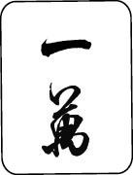 | TEN-THOUSAND | 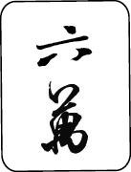 | SIXTY-THOUSAND
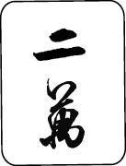 | TWENTY-THOUSAND | 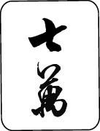 | SEVENTY-THOUSAND
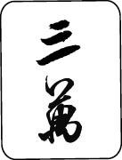 | THIRTY-THOUSAND | 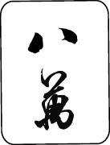 | EIGHTY-THOUSAND
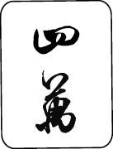 | FOURTY-THOUSAND | 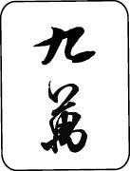 | NINETY-THOUSAND
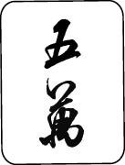 | FIFTY-THOUSAND

2. BARS
Glyph | Name | Glyph | Name
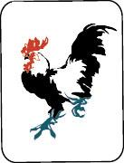 | ONE-BAR | 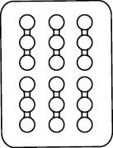 | SIX-BAR
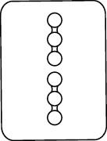 | TWO-BAR | 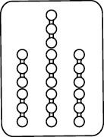 | SEVEN-BAR
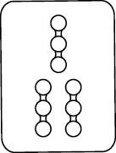 | THREE-BAR | 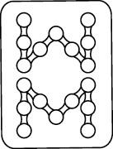 | EIGHT-BAR
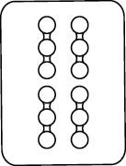 | FOUR-BAR | 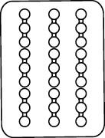 | NINE-BAR
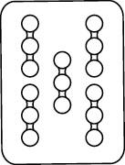 | FIVE-BAR

3. PIES
Glyph | Name | Glyph | Name
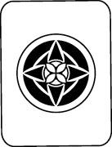 | ONE-PIE | 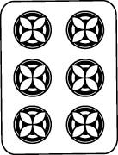 | SIX-PIE
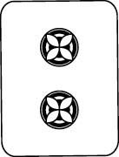 | TWO-PIE | 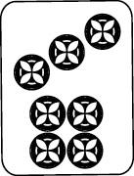 | SEVEN-PIE
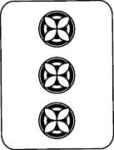 | THREE-PIE | 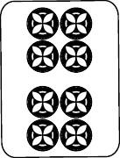 | EIGHT-PIE
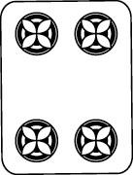 | FOUR-PIE | 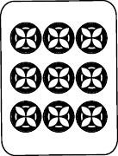 | NINE-PIE
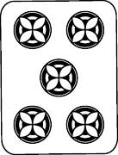 | FIVE-PIE

4. DASANYUNGS
Glyph | Name | Glyph | Name
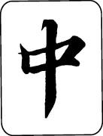 | RED-ZHONG | 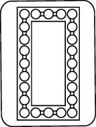 | BAI-PLATE
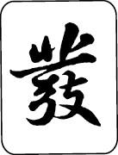 | BLUE-FA

5. WINDS
Glyph | Name | Glyph | Name
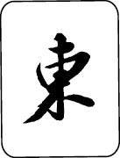 | EASTERN-WIND | 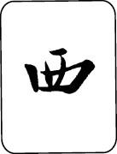 | WESTERN-WIND
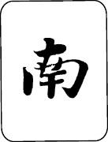 | SOUTHERN-WIND | 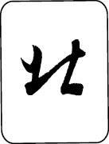 | NORTHERN-WIND
6. SEASONS
Glyph | Name | Glyph | Name
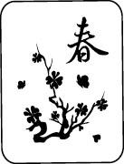 | SPRING | 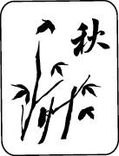 | AUTUMN
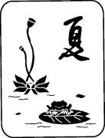 | SUMMER | 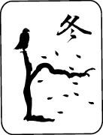 | WINTER
7. FLOWERS
Glyph | Name | Glyph | Name
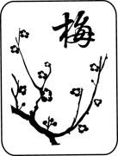 | PLUM | 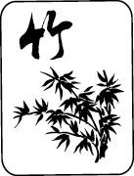 | BAMBOO
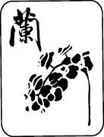 | ORCHID | 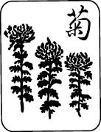 | CHRYSANTHEMUM
8. Other
Glyph | Name | Glyph | Name
 | BACK

How to Play
There are many methods to play Mahjong, but most of the rules are the same, before the game start, players will declare the rules. What I am going to introduce is Taiwanese Mahjong.
At the beginning of the game, each of the four players sits at one of the points of the compass (North, South, East, and West). The tiles are placed face down and shuffled around. Each player then draws out 36 tiles and arranges them in 18 stacks of two all pushed together to form a wall. The four walls are pushed together to form a square.
East is the first dealer and it is his job to throw the dice to determine who breaks the wall. Counting himself as '1' and proceeding in a counter clockwise manner, the dealer counts around the players up to the sum of the spots shown on the dice. The selected player throws the dice again and counts the total of the first and second throws along the tiles comprising his section of the tile wall starting from his right most to the left. The two stacks following the counted tiles are taken by the dealer, the next two by the player to his right, and so on. After each player takes 3 double stacks (12 tiles total), players take one more tile (for a total of 13) in turn. After each player has 13, the dealer takes one more to give him the first discard to start the game. When a flower tile is drawn, it is placed face up next to the player's hand and another tile is drawn from the end of the wall. The last 8 stacks that were counted over from the second dice throw are separated from the rest of the wall. These will not be used within play of the game.
Players take turns (going around counter clockwise) drawing a tile starting from the break and working around to the separated tiles. After a tile is drawn, a tile must be discarded (keeping 16 in your hand) face up in the center of the walls on the table. It is customary to announce the name of the tile that is being discarded.
Tiles that are discarded may be picked up instead of drawing from the wall. To do this, you announce what you intend to use the tile for (“Pong,” “Kong,” “Chow,” or “Mahjong”).This retrieved discard must be the tile that completes your set (e.g., you must have a pair of Red-zhongs to “Pong” a discarded Red-zhong). Any player may “Pong,” “Kong” of “Mahjong” from any other player (with “Mahjong” taking precedence over “Pong” and “Kong” no matter who called it first). However, you can only “Chow” the person sitting on your left. After the player that picked up the discard has discarded a tile, the player to his right draws and discards next.
When a discard is taken, the set is placed face up next to the player to prove that the tile was drawn correctly. In the case of a “Kong,” the player draws another tile from the stack at the end of the wall that is removed from the rest of the wall. Then a discard is made. In the case of drawing an in-hand “Kong” from the wall, the tiles involved are placed face-up, with the middle two face-down to show that this “Kong” is still in-hand (called a closed “Kong”), and a tile is drawn from the end of the wall before discarding a tile.
The object of the game is to get triples (“Pong”), quadruples (“Kong”), or sequences of three in the same suit (“Chow”). When you have 4 of the above and a pair in your hand (16 tiles) you have “Mahjong” and have won the hand.
After each game is completed, if the dealer won, he remains the dealer for the next game. Otherwise, the deal rotates to the right. A full game is completed after each player has been dealer 4 times (at least 16 hands).
Taiwan
Online Mahjong game website
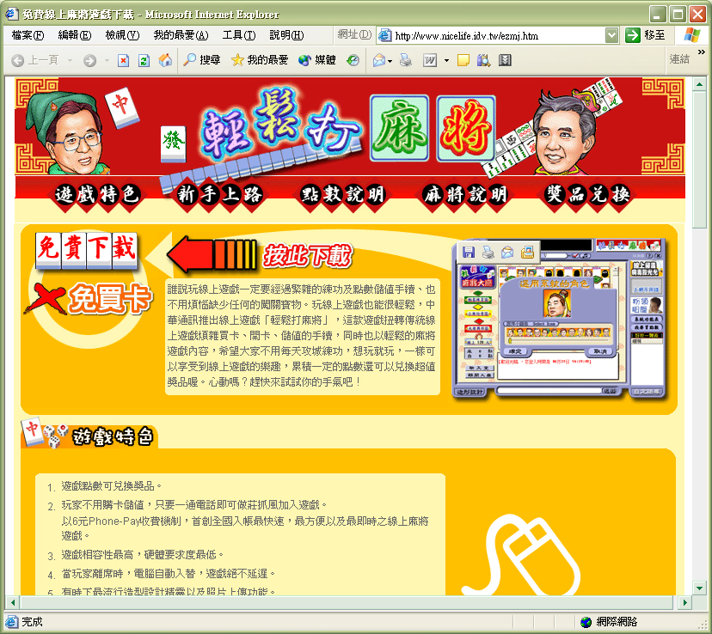

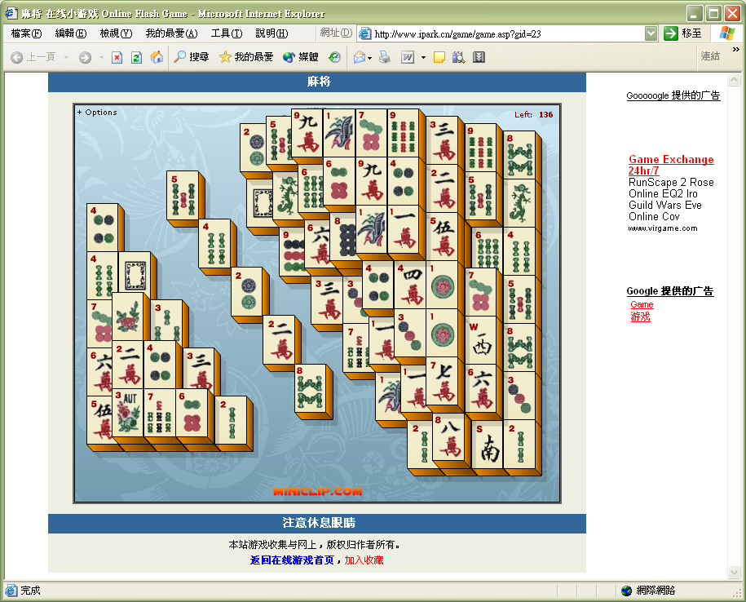
China
Online Mahjong game website
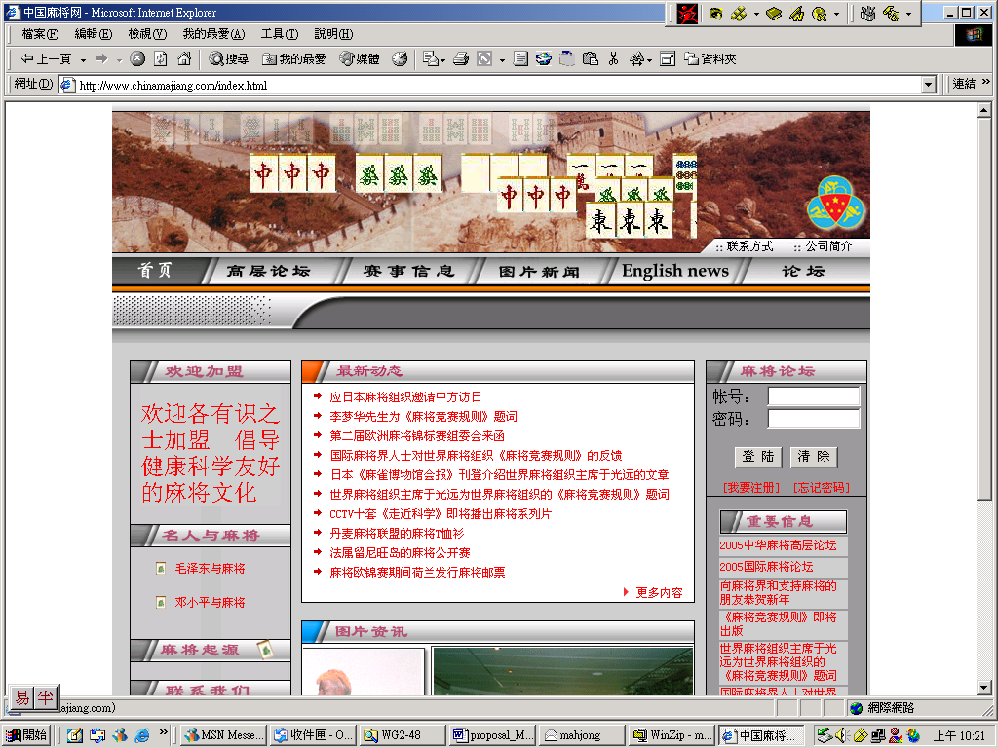

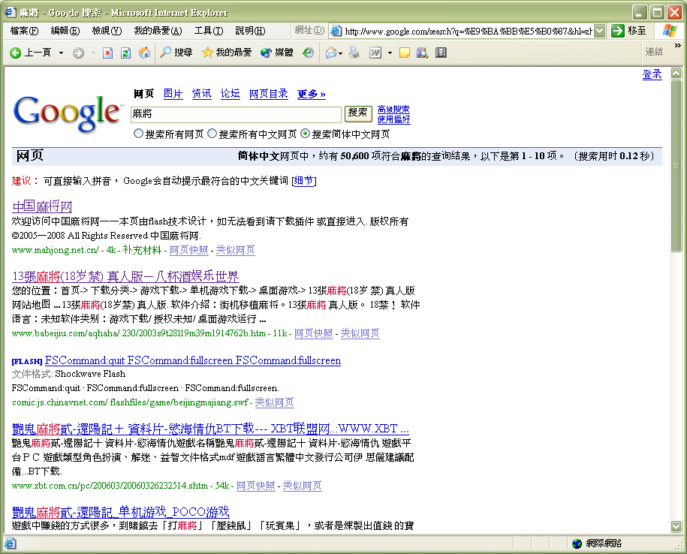

Japan
Online Mahjong game website
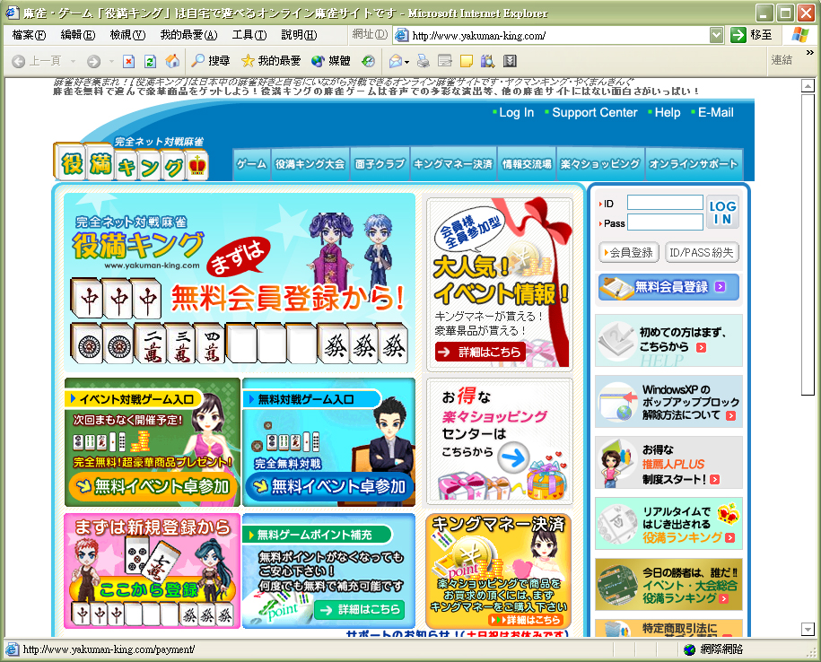

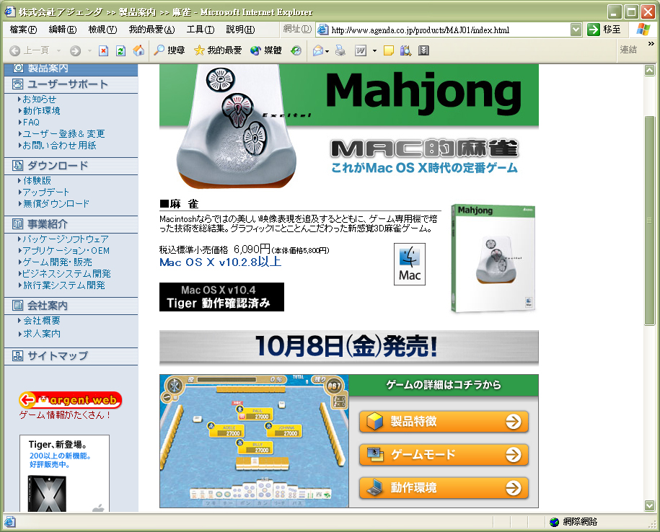

Others Mahjong Games Website
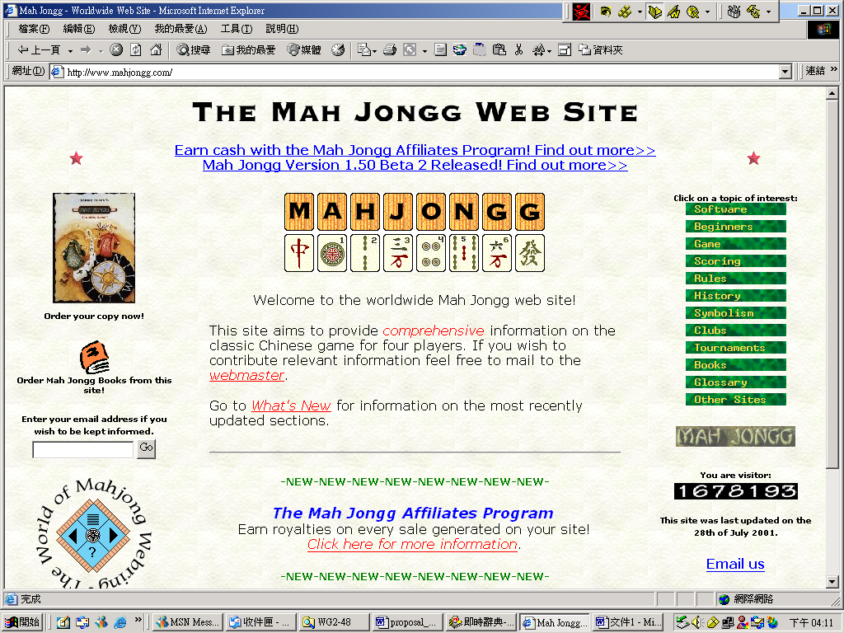

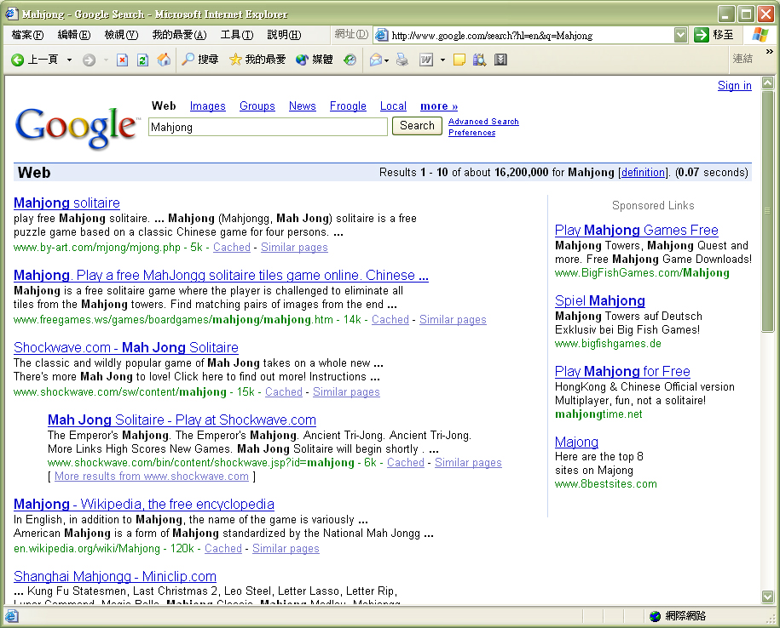

English Sites
Mah Jong Museum © copyright, all rights reserved-- Excellent Website with rules, history, and merchandise.
Mahjong Medley - Miniclip.com--Free Online Games
Mah Jong History and Useful Information-- Includes a history and introduction to the game, rules.
Mah Jong - Modern Japanese Rules, v1.54 -- Japanese rules and terminology
Mah Jong Collection by Peter Chan.
MacGameStore: Mah Jong Medley
http://mahjongtime.com/

Japanese Sites (in Japanese)
MahjongWalker-麻雀プロ団体公認オフィシャル麻雀 ...
http://www.yakuman-king.com/
http://www.agenda.co.jp/
当店ルール

Software
Berrie Bloem's Mah Jongg for Windows -- Game of the Four Winds.
Green Dragon Mahjongg -- On-line, interactive Mahjongg game written in Java.
Arcanium Productions -- The Isle of Four Winds: Rune War (commercial).
PARABEN SOFTWARE - MAH-JONG
Download Paraben's Mah-jong
http://mjcity.homeip.net/
http://www.nicelife.idv.tw/ezmj.htm
戲谷麻將館
贏了再上！- 中華麻將館Online

Books
Click on one of the categories below for list of MahJong books and publications.
Books in Print
Magazines and Periodicals
http://www.kingstone.com.tw/
Miscellaneous Books
The following books are recently published or are not currently being published, some you may find them in a second hand book store or in a local library.
Lo, Ginnie, Mahjong All Day Long Publisher：Walker & Company ISBN：0802789412 Pub. Date：March 2005
Ai, Weiwei Mahjong: Contemporary Chinese Art from the Sigg Collection Publisher：Hatje Cantz Verlag GmbH & Co KG ISBN：3775716130 Pub. Date：September 2003
Lo, Amy, TheBook of Mahjong: An Illustrated Guide Publisher：Tuttle Publishing ISBN：0804833028 Pub. Date：May 2001
Gelbman, Alain, Mahjong: One step at a time. Ishi Press, 1991. 50 p. : ill.
Hammer, Marcia, Learn to play Mahjongg : from beginner to winner. New York : D. McKay Co., c1979. xii, 143 p.
Bray, Jean, How to play Mahjong, 2d ed. New York & London, G. P. Putnam's sons, 1923. x, 162 p. illus. 18 cm.
Bray, Jean, How to play Mahjong, New York & London, G. P. Putnam's sons, 1923. ix, 112 p.
Campbell, Winifred W., comp., Mahjongg scoring combinations and conventions, Forsyth, Mont., Times-journal printing co., 1924.
Thompson, Patricia A., The game of Mahjong, illustrated. Ishi Press, 1990. 64 p.
Chue, John Alfred, The mastering of Mahjongg. Hongkong, Yew Kee, printers, c1925. 2 p.l., iv, 58 p. illus. 20 cm.
Lim, Willie, Mahjong made easy : standard Chinese rules simplified / 1st ed. Smithtown, N.Y. : Exposition Press, c1982. ix, 30 p.
Lim, Yang-Chow, The original rules of the ancient Chinese game, Seattle, Y.C. Lim, c1923. 3 p.l., 9-50 p. incl. front..
Mah-jongg league, limited, London, The official standardised rules of the Mah-jongg league limited ... London, Heath, Cranton, limited [1924] 52 p. incl. front.
Millington, A. D., The complete book of Mah-Jongg. London : A. Barker, c1977. 200 p.
Morgan, Casey Bruce, Ma jong scoring made easy, and notes on playing; the scoring table analysed and discussed, thereby permanently fixing it in the player's memory, New York, Brentano's [c1924] 41 p.
Morris, William C., The game of mahjuck; Chinese dominos Los Angeles, Morris & Lelevier, c1922. 40 p.
Boulon, F. George, Standard rules and instructions for the Chinese game of ma chiang (sparrow) with notes on the American and one suit games, New York, A. J. Brandt sons, c1924. 32 p. illus. 19 cm.
Cecil, Viola L, Maajh, the American version of an ancient Chinese game, New York, Printed by Hallco, inc., c1938. 53 p., 1 l. illus. 19 cm.
Wang, Su-hsin, Tu kuo ch'un ch'iu. Orien China [1972] 3, 220 p. Call Number: HV6710 .W36
Wu, Ch'ung, Ma ch'ueh kai lun. Orien China [1965] 9, 60 p.
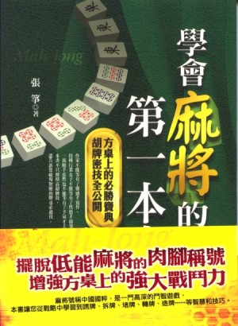

Movies Featuring MahJong
Snake Fist Fighter (Jackie Chan)
Drunken Master II (Jackie Chan, Hong Kong)
Ranma Nibunnoichi (Japanese anime)
God of Gamblers (Hong Kong)
Wagging School (Hong Kong)
Project A (Jackie Chan, Hong Kong)
Raise the Red Lantern
Driving Miss Daisy
Sweet Lorraine
Boys Are Easy (Hong Kong)
Once Upon A Time in China Part III (Hong Kong)
The Wedding Banquet
Double Impact
Temptress Moon
Used People
Stow Away (Shirley Temple, Robert Young)

TV Shows Featuring Mahjong
Highlander
Happy Days
Ranma 1/2 (Japanese anime series; Mahjong mentioned in theme)
MASH ("They'll be playing Mahjong with our fingernails.")

