WG2/N2988
Proposal to correct the Character Names for Tai Xuan Jing（太玄経）(U+13D00 ~ U+13D05)

KAWABATA, Taichi

- Introduction.

“Tai Xuan Jing” Symbols has been assigned to the UCS (U+13D00 to U+13DFF) by the proposal document N2416 “Proposal to add monogram, digram and tetragram characters to the UCS” and Resolution M42.16 (N2454r.pdf). However, I have noticed that several symbols have been given incorrect names. I would like to clarify this problem and propose to discuss on this issue.

- What’s wrong with the current Tai Xuan Jing character names?

UCS character names for Tai Xuan Jing assumes that three monograms, namely “”, “” and “”, designate Heaven（天）, Human（人） and Earth（地）respectively (Fig. 1 N2416.pdf, page 9). This assumption is incorrect. Each monograms represents Heaven, Earth and Human （天・地・人） respectively in this order. (Earth and Human are swapped). This may confuse the users of Tai Xuan Jing symbols.

- Proposed Solutions

I propose the following two solutions for this problem

- Add the statement that alerts this swapping to the standard.
The statement should tell that the character names for Tai Xuan Jing mistook “Earth” for “Human” and vice versa.

- Revise some glyphs and names of Tai Xuan Jing characters in the UCS. I would like to propose to revise the glyphs and character names for Tai Xuan Jing as follows (this reflects the glyph change of Amendment 1:2005).

UCS |  | Amd.1:2005 NAME |  | PROPOSED NAME
U+1D300 | 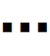 | MONOGRAM FOR EARTH |  | MONOGRAM FOR HUMAN
U+1D301 | 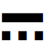 | DIGRAM FOR HEAVENLY EARTH |  | DIGRAM FOR HEAVENLY HUMAN
U+1D302 | 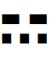 | DIGRAM FOR HUMAN EARTH |  | DIGRAM FOR EARTHLY HUMAN
U+1D303 |  | DIGRAM FOR EARTHLY HEAVEN |  | DIGRAM FOR HUMAN HEAVEN
U+1D304 | 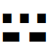 | DIGRAM FOR EARTHLY HUMAN |  | DIGRAM FOR HUMAN EARTH
U+1D305 | 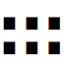 | DIGRAM FOR EARTH |  | DIGRAM FOR HUMAN

(Note that this problem can not be fixed by merely swapping the glyphs, since the correct glyphs for “Digram for Earth”, for example, is already encoded in U+268F, “DIGRAM FOR GREATER YIN”.)

- Background

. Repeated earlie

This “Earth” and “Human” swapping comes from N2416 document (Fig. 1).
)In N2416,

this incorrect correspondence of symbols (“” and “”) and their names (Earth and Human) comes from the document [Walter, 1986], which is referred at the page 17 of N2416 (Figure 3). However, N2416 also refers [Nylan, 1994], at page 14, which correctly assigns “” to Human and “” to Earth (Figure 4).

(Note that N2416 mistakingly swaps the glyphs for U+1D301, U+1D302 and U+1D303 in page 21 (Fig. 2 N2416.pdf p.20), but this has been corrected in Amendment 1.)

Fig. 1 N2416.pdf, page 9
Fig. 2 N2416.pdf p.20
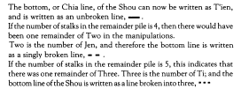
Fig. 3 N2416.pdf, p.17
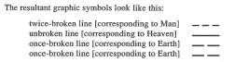
Fig. 4 N2416.pdf, p.19

4. Document for Evidence
The 10th page of Xuan-Ku (玄告) of Tai-Xuan-Jing (太玄経) document has the following statements.

「玄一 (first) 摸而得乎天、故謂之有天 (heaven)、再 (second) 摸而得乎地 (earth)、故謂之有地、三 (third) 摸而得乎人 (human) 、故謂之有人」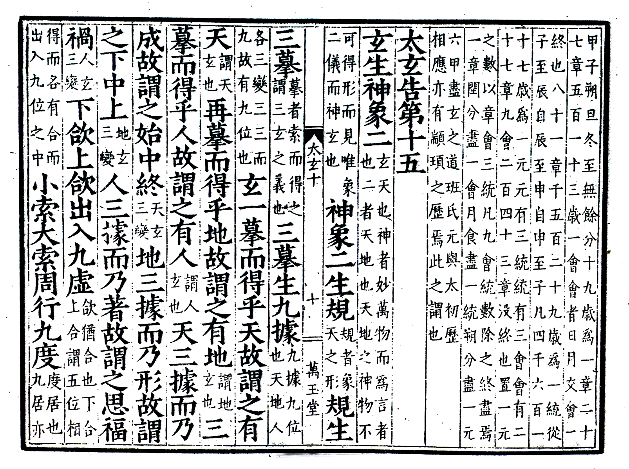
Fig. 5 Tai-Xuan-Jing, page 10.
References
1. N2416.pdf
2. 『太玄經』玄告（立命館大学蔵）(I really thank Dr. Akiyama Yoichiro and Dr. Nikaido Yoshihiro for obtaining and checking this document.)

