JTC1/SC2/WG2 N2992
Title: Supporting references for N2931: Proposal to Encode Additional Latin Characters for Uighur and Kazak Latin Alphabet
Requester name: China
Requester type: Public contribution
Distribution: ISO/IEC JTC 1/SC 2/WG 2

This document presents some references supporting the distributed documents N2931.

Proposed Characters in N2931
There have a code chart and character names listed in N2931 to Encode Additional Latin Characters for Uighur and Kazak Latin alphabet:
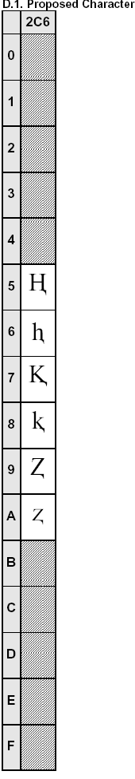
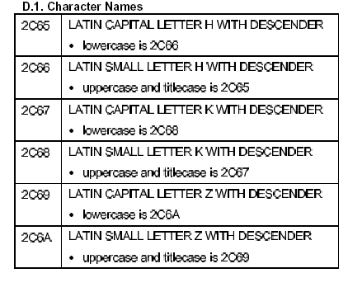
D.1. Character Names
2C65 LATIN CAPITAL LETTER H WITH DESCENDER
. lowercase is 2C66
2C66 LATIN SMALL LETTER H WITH DESCENDER
. uppercase and titlecase is 2C65
2C67 LATIN CAPITAL LETTER K WITH DESCENDER
. lowercase is 2C68
2C68 LATIN SMALL LETTER K WITH DESCENDER
. uppercase and titlecase is 2C67
2C69 LATIN CAPITAL LETTER Z WITH DESCENDER
. lowercase is 2C6A
2C6A LATIN SMALL LETTER Z WITH DESCENDER
. uppercase and titlecase is 2C69

D.2. Unicode Character Properties
2C66, 2C68, and 2C6A should have a general category of Ll. Other properties for these characters should match those of similar characters, such as U+0061 LATIN SMALL LETTER A.
Other characters should have a general category of Lu. Other properties for these remaining characters should match those of similar characters, such as U+0041 LATIN CAPITAL LETTER A.

D.3 Other Information
Latin Extended
1. New characters (the Latin alphabet) regarded as official languages and generally used in our government, organ, education publishing , communication , broadcasting and TV from 1964 to 1984, and also used in various kinds of files , teaching material , newspapers and periodicals , books ,etc.
2. Within 20 years, more than 1,500,000 students in middle and primary schools and universities used these characters to train out.
3. There are some dictionaries, documents, materials at present, especially some foreign websites still use the new characters.
4. Cancelled the new characters in 1984 resumed the old characters (Uighur of the Arabic characters), this is an official file stipulates but the new characters (the Latin alphabet) can continue using in some scientific and technological fields and documents and materials.

