ISO/IEC JTC 1/SC 2/WG 2 N3031
ISO/IEC JTC 1/SC 2/WG 2
PROPOSAL SUMMARY FORM TO ACCOMPANY SUBMISSIONS
FOR ADDITIONS TO THE REPERTOIRE OF ISO/IEC 10646TPPT
Please fill all the sections A, B and C below.
Please read Principles and Procedures Document (P & P) from HTUhttp://www.dkuug.dk/JTC1/SC2/WG2/docs/principles.html UTH for guidelines and details before filling this form.
Please ensure you are using the latest Form from HTUhttp://www.dkuug.dk/JTC1/SC2/WG2/docs/summaryform.htmlUTH.
See also HTUhttp://www.dkuug.dk/JTC1/SC2/WG2/docs/roadmaps.html UTH for latest Roadmaps.
A. Administrative
1. Title: |  | Proposal to encode characters for Ordbok över Finlands svenska folkmål in the UCS
2. Requester's name: |  |  | Therese Leinonen, Klaas Ruppel, Erkki I. Kolehmainen, Caroline Sandström
3. Requester type (Member body/Liaison/Individual contribution): |  |  |  |  | Member Body
4. Submission date: |  |  |  |  | 2006-01-26
5. Requester's reference (if applicable):
6. Choose one of the following:
 | This is a complete proposal: |  |  |  |  | YES
 | (or) More information will be provided later: |  |  |  |  | NO
B. Technical – General
1. Choose one of the following:
 |  | a. This proposal is for a new script (set of characters): |  |  |  |  |  |  |  |  |  |  |  |  |  |  |  |  | NO
 |  |  |  | Proposed name of script:
 |  | b. The proposal is for addition of character(s) to an existing block: |  |  |  |  |  |  |  |  |  |  |  |  |  |  |  |  | YES
 |  |  |  | Name of the existing block: |  |  |  |  |  |  | Phonetic Extensions Supplement
2. Number of characters in proposal: |  |  |  |  |  |  |  |  |  |  |  |  |  |  |  |  |  |  | 3
3. Proposed category (select one from below - see section 2.2 of P&P document):
 | A-Contemporary |  |  |  |  |  |  | B.1-Specialized (small collection) |  |  |  |  |  |  |  |  | B.2-Specialized (large collection) |  |  |  | X
 | C-Major extinct |  |  |  |  |  |  | D-Attested extinct |  |  |  |  |  |  |  |  | E-Minor extinct
 | F-Archaic Hieroglyphic or Ideographic |  |  |  |  |  |  |  |  |  |  |  |  |  | G-Obscure or questionable usage symbols
4. Proposed Level of Implementation (1, 2 or 3) (see Annex K in P&P document): |  |  |  |  |  |  |  |  |  |  |  |  |  |  |  |  |  |  | 3
 |  | Is a rationale provided for the choice? |  |  |  |  |  |  |  |  |  |  |  |  |  |  |  |  | YES
 |  |  |  | If Yes, reference: |  |  |  |  | see the proposal for use of diacritics
5. Is a repertoire including character names provided? |  |  |  |  |  |  |  |  |  |  |  |  |  |  |  |  |  |  | YES
 |  | a. If YES, are the names in accordance with the “character naming guidelines”
 |  |  |  | in Annex L of P&P document? |  |  |  |  |  |  |  |  |  |  |  |  |  |  | YES
 |  | b. Are the character shapes attached in a legible form suitable for review? |  |  |  |  |  |  |  |  |  |  |  |  |  |  |  |  | YES
6. Who will provide the appropriate computerized font (ordered preference: True Type, or PostScript format) for
 |  | publishing the standard? |  |  |  |  |  |  | available now
 |  | If available now, identify source(s) for the font (include address, e-mail, ftp-site, etc.) and indicate the tools
 |  | used: |  |  | see choice of fonts in the proposal
7. References:
 |  | a. Are references (to other character sets, dictionaries, descriptive texts etc.) provided? |  |  |  |  |  |  |  |  |  |  |  |  |  |  |  | YES
 |  | b. Are published examples of use (such as samples from newspapers, magazines, or other sources)
 |  | of proposed characters attached? |  |  |  |  |  |  |  |  |  | YES
8. Special encoding issues:
 |  |  | Does the proposal address other aspects of character data processing (if applicable) such as input,
 |  | presentation, sorting, searching, indexing, transliteration etc. (if yes please enclose information)? |  |  |  |  |  |  |  |  |  |  |  |  |  |  |  |  |  | NO
9. Additional Information:
Submitters are invited to provide any additional information about Properties of the proposed Character(s) or Script that will assist in correct understanding of and correct linguistic processing of the proposed character(s) or script. Examples of such properties are: Casing information, Numeric information, Currency information, Display behaviour information such as line breaks, widths etc., Combining behaviour, Spacing behaviour, Directional behaviour, Default Collation behaviour, relevance in Mark Up contexts, Compatibility equivalence and other Unicode normalization related information. See the Unicode standard at HTUhttp://www.unicode.orgUTH for such information on other scripts. Also see HTUhttp://www.unicode.org/Public/UNIDATA/UCD.htmlUTH and associated Unicode Technical Reports for information needed for consideration by the Unicode Technical Committee for inclusion in the Unicode Standard.

C. Technical - Justification
1. Has this proposal for addition of character(s) been submitted before? |  |  |  |  |  |  |  |  |  |  | NO
 |  | If YES explain
2. Has contact been made to members of the user community (for example: National Body,
 |  | user groups of the script or characters, other experts, etc.)? |  |  |  |  |  |  |  |  | YES
 |  |  | If YES, with whom? |  |  |  |  | NB represented by RILF, and the Swedish expert Stig Isaksson
 |  |  | If YES, available relevant documents:
3. Information on the user community for the proposed characters (for example:
 |  | size, demographics, information technology use, or publishing use) is included? |  |  |  |  |  |  |  |  | YES
 |  | Reference: |  |  |  |  | see proposal for use in research and dictionaries
4. The context of use for the proposed characters (type of use; common or rare) |  |  |  |  |  |  |  |  |  |  | rare
 |  | Reference: |  |  |  |  | see proposal
5. Are the proposed characters in current use by the user community? |  |  |  |  |  |  |  |  |  |  | YES
 |  | If YES, where? Reference: |  |  |  |  |  |  | in research and dictionaries
6. After giving due considerations to the principles in the P&P document must the proposed characters be entirely
 |  | in the BMP? |  |  |  |  |  |  |  |  | YES
 |  |  |  | If YES, is a rationale provided? |  |  |  |  |  |  | YES
 |  |  |  |  |  | If YES, reference: |  |  | immediate need with present application problems
7. Should the proposed characters be kept together in a contiguous range (rather than being scattered)? |  |  |  |  |  |  |  |  |  |  |  |  | NO
8. Can any of the proposed characters be considered a presentation form of an existing
 |  | character or character sequence? |  |  |  |  |  |  |  |  | NO
 |  |  |  | If YES, is a rationale for its inclusion provided?
 |  |  |  |  |  | If YES, reference:
9. Can any of the proposed characters be encoded using a composed character sequence of either
 |  | existing characters or other proposed characters? |  |  |  |  |  |  |  |  | NO
 |  |  |  | If YES, is a rationale for its inclusion provided?
 |  |  |  |  |  | If YES, reference:
10. Can any of the proposed character(s) be considered to be similar (in appearance or function)
 |  | to an existing character? |  |  |  |  |  |  |  |  | NO
 |  |  |  | If YES, is a rationale for its inclusion provided?
 |  |  |  |  |  | If YES, reference:
11. Does the proposal include use of combining characters and/or use of composite sequences? |  |  |  |  |  |  |  |  |  |  | YES
 |  | If YES, is a rationale for such use provided? |  |  |  |  |  |  |  |  | YES
 |  |  |  |  | If YES, reference: |  |  |  | use common in phonetic alphabets
 |  | Is a list of composite sequences and their corresponding glyph images (graphic symbols) provided? |  |  |  |  |  |  |  |  |  |  |  | NO
 |  |  |  |  |  | If YES, reference:
12. Does the proposal contain characters with any special properties such as
 |  | control function or similar semantics? |  |  |  |  |  |  |  |  | NO
 |  |  |  | If YES, describe in detail (include attachment if necessary)
13. Does the proposal contain any Ideographic compatibility character(s)? |  |  |  |  |  |  |  |  |  |  | NO
 |  | If YES, is the equivalent corresponding unified ideographic character(s) identified?
 |  |  |  | If YES, reference:

Proposal
The practical situation that has raised the issue of adding 3 characters to UCS is the editing of the dictionary Ordbok över Finlands svenska folkmål (dictionary of Swedish dialects in Finland, Ahlbäck et al. 1976–). The dictionary has been published since 1976, and so far 3 volumes have been published. The fourth volume will be published in 2006. After that 3 volumes remain. The 3 remaining volumes will be edited in XML with the use of Unicode standard. So far the dictionary has been published as printed volumes. However, in the future the work will also be made available electronically.
Ordbok över Finlands svenska folkmål uses a phonetic transcription that has been developed especially for the dictionary in question. Most of the characters in this phonetic transcription already exist in Unicode (IPA). However 3 characters are missing. These 3 characters are imported from landsmålsalfabetet, a phonetic transcription for Swedish dialects that has not yet been included in the Unicode standard.
Landsmålsalfabetet was developed in 1879 by J.A. Lundell for describing Swedish dialects (Lundell 1879). The first version of landsmålsalfabetet included 89 characters. Later the number of characters has grown to over 200. In landsmålsalfabetet each speech sound is represented by one character. Diacritics are merely used for prosodic features. Since landsmålsalfabetet was developed it has been widely used for scientific purposes in fields like dialectology, onomastics, ethnology and folkloristics, mostly in Sweden and Finland. An example of a comprehensive dictionary which uses landsmålsalfabetet as the phonetic transcription is Ordbok över folkmålen i övre Dalarna (dictionary of the dialects in the upper Dalarna in Sweden, Levander et al. 1961–), the editing of which has now reach the 37th part. Also other works than Ordbok över Finlands svenska folkmål has used some characters from landsmålsalfabetet without using the whole script; an example of this is Ordbok över Sveriges dialekter (dictionary of the dialects of Sweden, Reinhammar et al. 1991–). In general landsmålsalfabetet is written with italic glyphs.
The full landsmålsalfabetet will eventually be encoded. At this stage however these particular characters are immediately needed for publication.

Characters
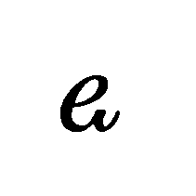
latin small letter e with tail (Figs. 2, 3, 4, 5, 7, 8)
- unrounded front vowel more open than IPA [e] but not as open as [ɛ]

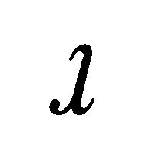
latin small letter turned r with tail (Figs. 1, 3, 4, 6, 8)
- voiceless [l]

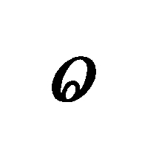
latin small letter o with ring inside down (Figs. 2, 3, 5, 7, 8)
- rounded back vowel more open than IPA [o] but not as open as [ɔ]

Figure 1. Noreen 1903:496.
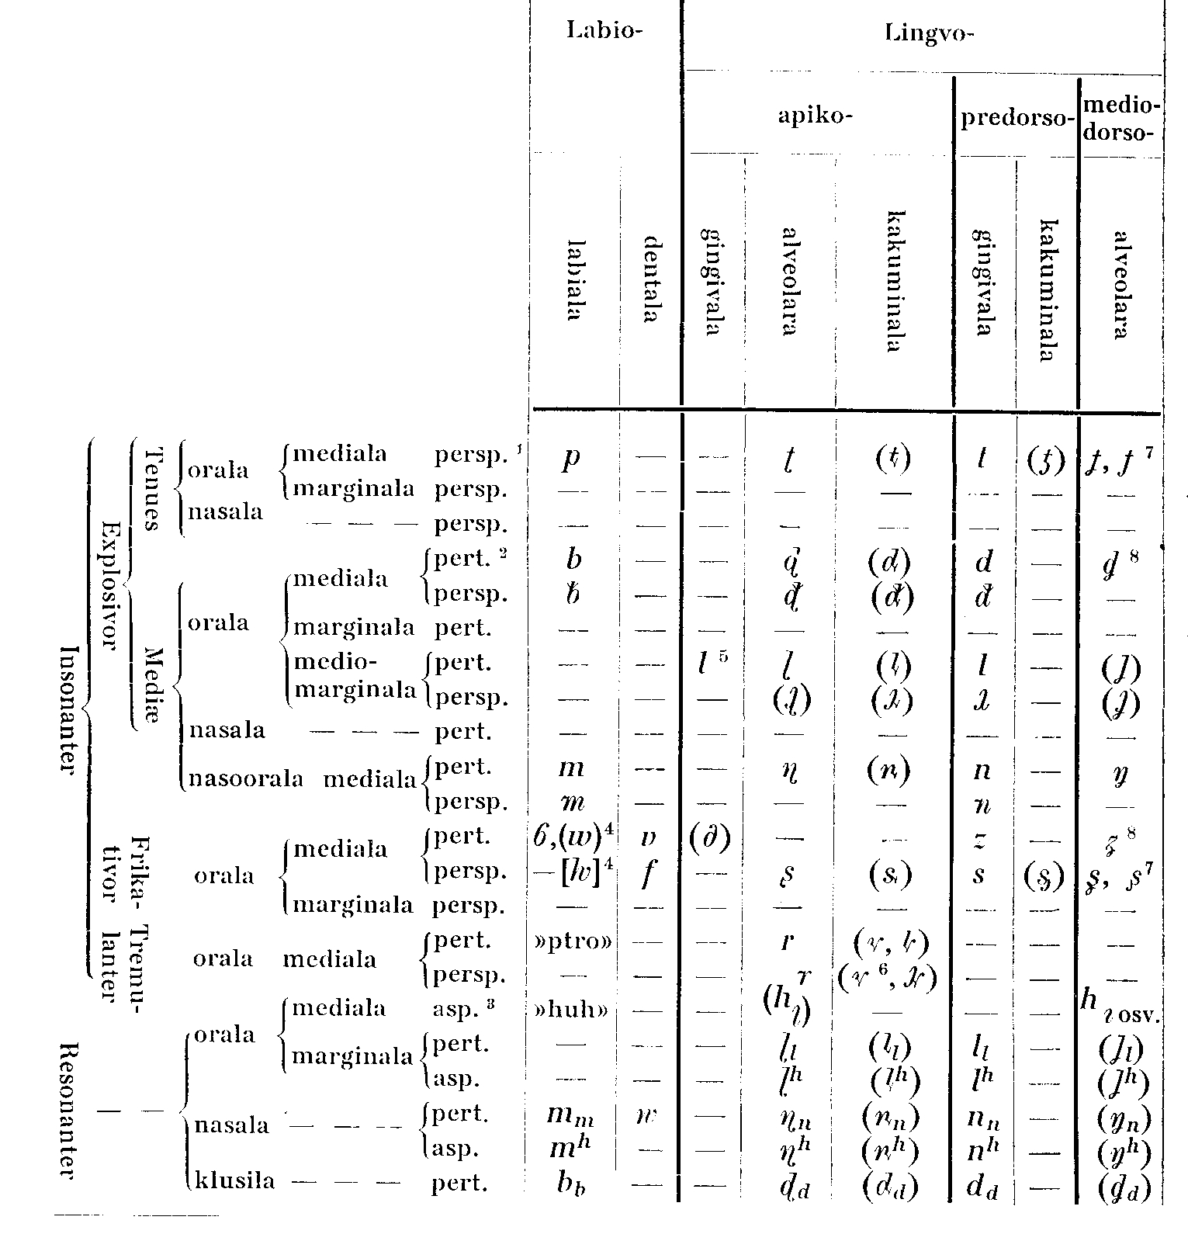

Figure 2. Noreen 1903:538.
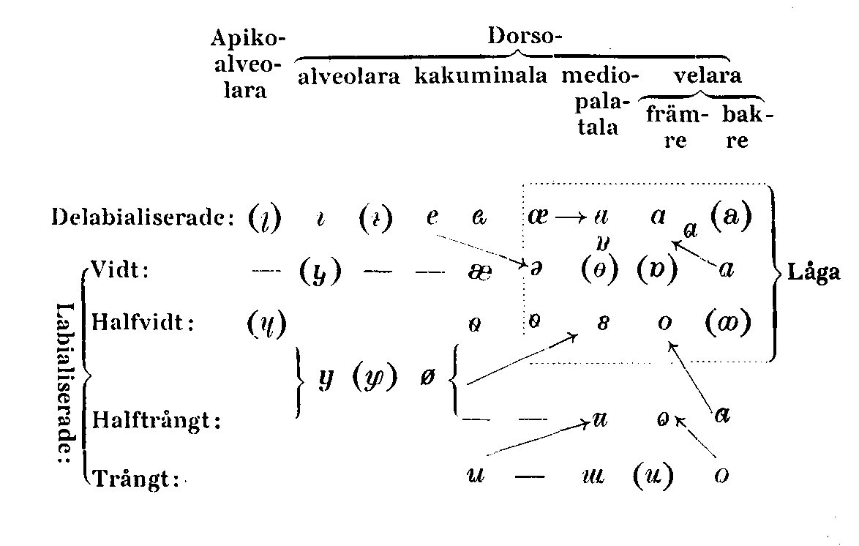

Figure 3. Slotte et al. 2000:14a.
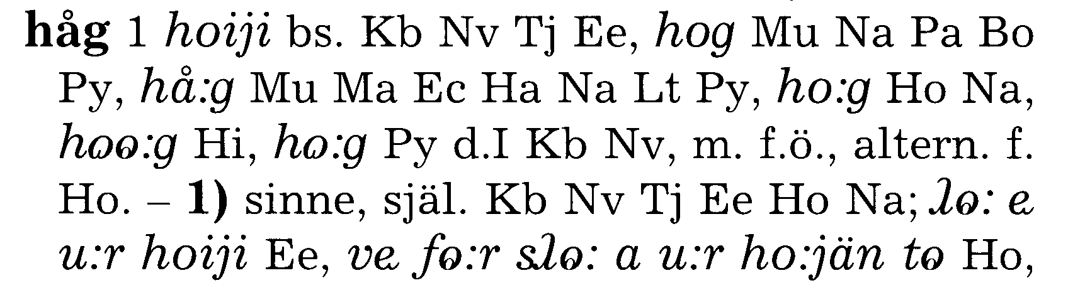

Figure 4. Wessman 1930–1932: 238b
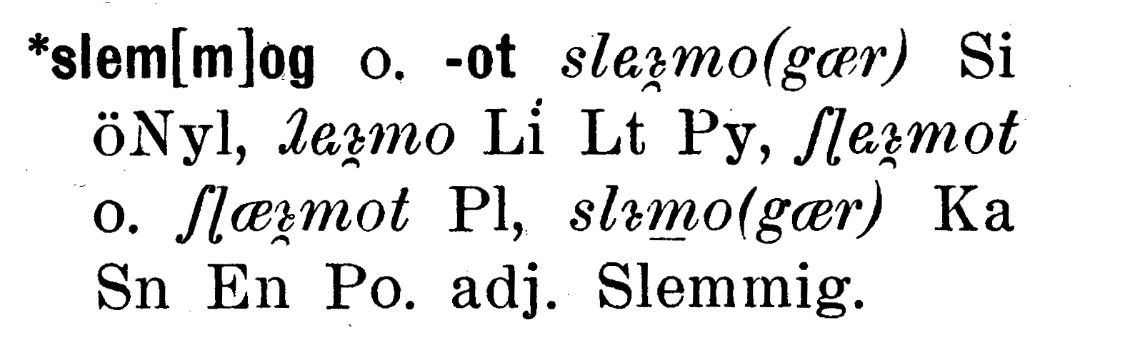

Figure 5. Zilliacus 1968:38.
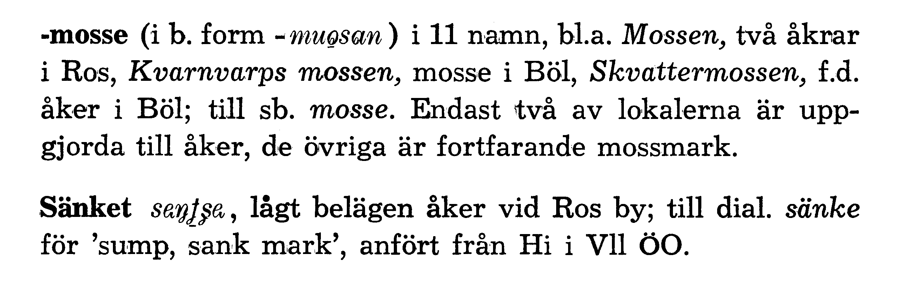

Figure 6. Reinhammar et al. 1991:62a.
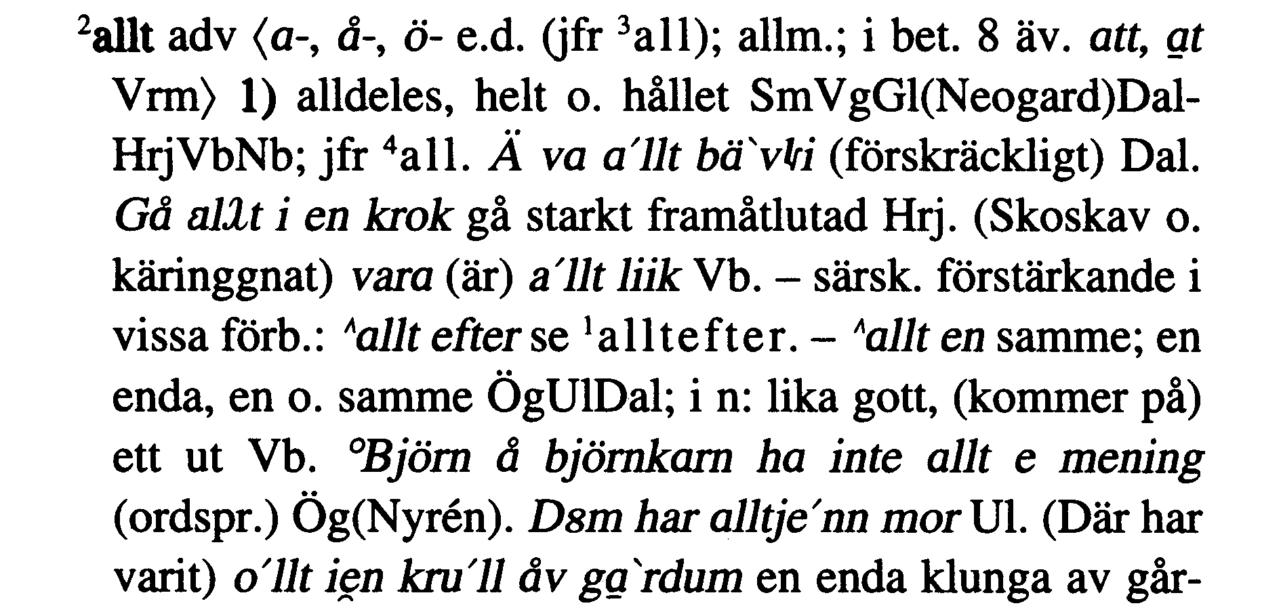

Figure 7. Fridell 1992:152.
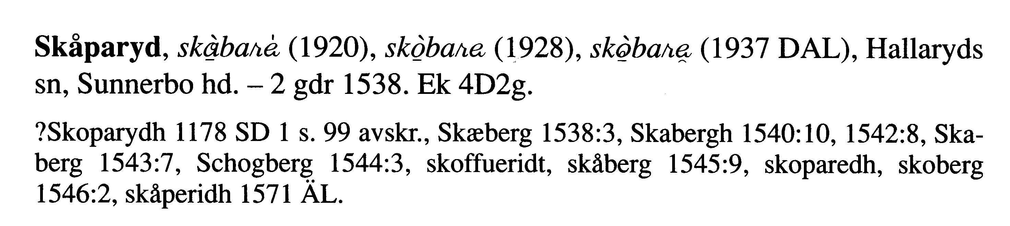

Figure 8. Harling-Kranck 1998:73.
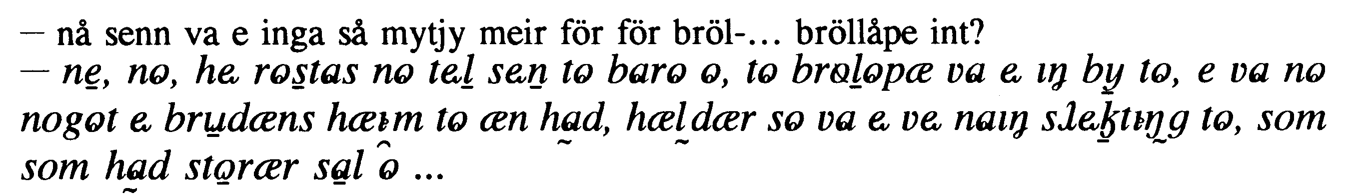

Fonts
http://www.dal.lu.se/~si/lmapage.html
- permission required (and obtained for this proposal and eventual publications)

http://www.thesauruslex.com/typo/engfont.htm
- free availability

References
Ahlbäck, Olav et al. 1976–. Ordbok över Finlands svenska folkmål. Helsinki: Research Institute for the Languages of Finland.
Fridell, Staffan. 1992. Ortnamn på -ryd i Småland. (Acta academiae regiae Gustavi Adolphi LX.) Stockholm: Almqvist & Wiksell.
Harling-Kranck, Gunilla. 1998. Från Pyttis till Nedervetil: tjugonio prov på dialekter i Nyland, Åboland, Åland och Österbotten. Helsinki: Svenska litteratursällskapet i Finland.
Levander, Lars et al. 1961–. Ordbok över folkmålen i övre Dalarna. Uppsala : Dialekt- och folkminnesarkivet.
Lundell, J.A. 1879. Det svenska landsmålsalfabetet. (Nyare bidrag till kännedom om de svenska landsmålen ock svenskt folkliv 1:2.) Stockholm: Norstedt.
Noreen, Adolf. 1903. Vårt språk 1. Lund: Gleerup.
Reinhammar, Vidar et al. 1991–. Ordbok över Sveriges dialekter. Uppsala: Arkivet för ordbok över Sveriges dialekter.
Reinhammar, Vidar et al. 1991. Ordbok över Sveriges dialekter. 1. A-Andtäppt. Uppsala: Arkivet för ordbok över Sveriges dialekter.
Slotte, Peter et al. 2000. Ordbok över Finlands svenska folkmål. 3. Hy–Kyss. Helsinki: Research Institute for the Languages of Finland.
Wessman, V.E.V. 1930–1932. Samling av ord ur östsvenska folkmål. 2. O–Ö. Helsinki: Svenska litteratursällskapet i Finland.
Zilliacus, Kurt. 1968: ”Sydfinländska skärgårdsnamn I”. In Studier i nordisk filologi 56:2. Helsinki: Svenska litteratursällskapet i Finland.

TP?PT Form number: N3002-F (Original 1994-10-14; Revised 1995-01, 1995-04, 1996-04, 1996-08, 1999-03, 2001-05, 2001-09, 2003-11, 2005-01, 2005-09, 2005-10)

