ISO/IEC JTC1/SC2/WG2 N3537

2008-10-14
Universal Multiple-Octet Coded Character Set
International Organization for Standardization

............. ........... .. ..............

Doc Type: Working Group Document
Title: Proposal to add India specific annotation to Right facing Svasti
Source: Swaran Lata
Status: BIS Contribution
Action: Addition of India Specific Annotation for consideration by JTC1/SC2/WG2
Addendum to N3516:Technical Comments on T.2. Tibetan: Symbols used in Buddhism

Background
In the Indian tradition Swastik is considered to be a very auspicious symbol. Swastik is normally believed to be an amalgam of the words Su and Asati. Su means 'good' and ‘Asati’ meant 'to exist'. As per Sanskrit grammar the words Su and Asati when amalgamated into one word become Svasti. Thus, the literal meaning of the term Svasti would be 'let good prevail'. It is considered that it not only brings positive energy but also brings Good Luck to the person as well as removes all obstacles in all undertaking.

In almost all religious / social publication this symbol is very frequently used. With the objective of ease in printing this symbol, it was proposed to encode this symbol in the Unicode Standard.

Tibetan community also uses this symbol in four different forms in their tradition.

Supporting Pictures:

Indian Homes use this symbol for Well-being

In the Puja Place
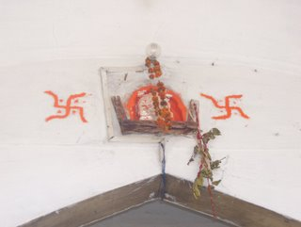
At the Door-Step
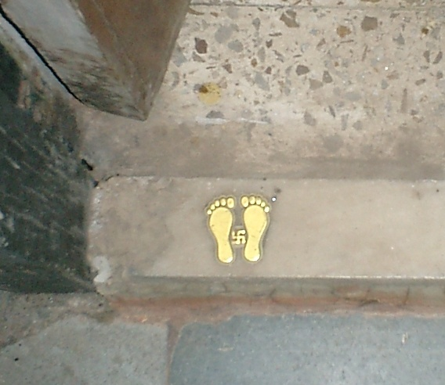

Svasti Vastu Symbol for Well Being


The Indus Seals from Ancient India
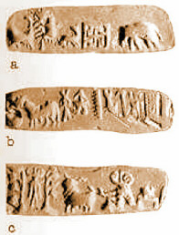
Proposal:

Extra Annotation to the Right Facing Svasti Sign proposed to take care of India-specific requirements:
for example:
Symbol of good Luck and well-being in India

