Universal Multiple-Octet Coded Character Set

UCS
ISO/IEC JTC1/SC2/WG2 N3787
ISO/IEC JTC1/SC2/WG2 IRG N 1666

Date: 2010-3-25
Doc. Type: | Member body contribution
Title: | Request for disunifying U+2F89F from U+5FF9
Source: | TCA and China
Status: | Input to WG2 and IRG
Action: | For discussion on the meeting
Distribution: | WG2 members and IRG members
No. of pages: | 6
Appendixes | None
Medium: | Electronic

1 Background
The character U+2F89F was encoded as a compatibility ideograph because it had been unified to the character U+5FF9, please refer to the figure shown below and the entry “U+2F89F” in the electronic insertion file “CJKC_SR.txt” of ISO/IEC 10646:2003. TCA and China found that both of the glyphs shown in the G-column and T-column of the code point U+5FF9 are wrong and the characters U+5FF9 and U+2F89F are non-cognate, as mentioned below.
(see p.477 in ISO/IEC 10646:2003) | (see p.1310 in ISO/IEC 10646:2003)
1.1 The glyph, pronunciations and meanings of the character T3-2623
The CNS Character Database (http://www.cns11643.gov.tw) provides attributes of characters encoded in CNS 11643, and the Dictionary of Chinese Character Variants (http://140.111.1.40/main.htm) provides glyphs, pronunciations and meanings of 106,230 ideographs and the variantal relationships among them. Both of the websites are build and maintained by Taiwan’s government. It means that all information provided by those websites are offically.
By means of the CNS Character Database, the pronunciation of the character T3-2623 can be found as either “ren ()” or “nin ()”, as shown following:
(see http://www.cns11643.gov.tw/AIDB/query_general_view.do?page=3&code=2623)
Most of Chinese characters are consisted of a radical part and a phonetic part. For a Chinese charcter having radical-phonetical structure, the radical part (namely radical) determines its class of meaning and the phonetic part (namely phontical) determines its pronunciation and sometime more specific meaning. It’s a common rule for a radical-phonetical structured Chinese character that the pronunciation of the character always simlar to the pronunciation (or accient pronunciation) of its phonetical.
In the CNS 11643:1992, the character T3-2623 () is consisted of the radical “” and the phonetical “” with pronunciation “wang”. Because an inconsistency exists between pronunciations of the character T3-2623 (i.e., “ren” in offical record from CNS Character Database) and its phonetical (i.e., “wang”), the phonetical shall be wrong. That’s the reason why Taiwan’s MOE modified the glyph of T3-2623 to be the compositon of the radical “” and the phonetical “” with pronunciation “ren” in the CNS 11643:2007.
By means of the Dictionary of Chinese Character Variants, the meaning of the character T3-2623 with pronunciation “ren” is relative to “think about”, and the meaning with pronunciation “nin” is “you (in good manners)”, as shown below.
(see http://140.111.1.40/yitib/frb/frb01102.htm)
1.2 The glyph, pronunciations and meanings of the character T5-2438
By means of the CNS Character Database, the pronunciation of the character T5-2438 can be found as either “wang()” or “kuang ()”. In both of the CNS 11643:1992 and CNS 11643:2007, the character T5-2438 is consisted of the radical “” and the phonetical “” with pronunciation “wang”, as shown following:
(see http://www.cns11643.gov.tw/AIDB/query_general_view.do?page=5&code=2438)
By means of the Dictionary of Chinese Character Variants, the meaning of the character T5-2438 with pronunciation “wang” is relative to “wicked”, and the meaning with pronunciation “kuang” is relative to “undisciplined” or “crazy”, as shown below.
(see http://140.111.1.40/yitic/frc/frc03617.htm)
1.3 The glyph, pronunciations and meanings of G3-5137
The image below shows the glyph of U+5FF9 in G3 (GB 7589-87)
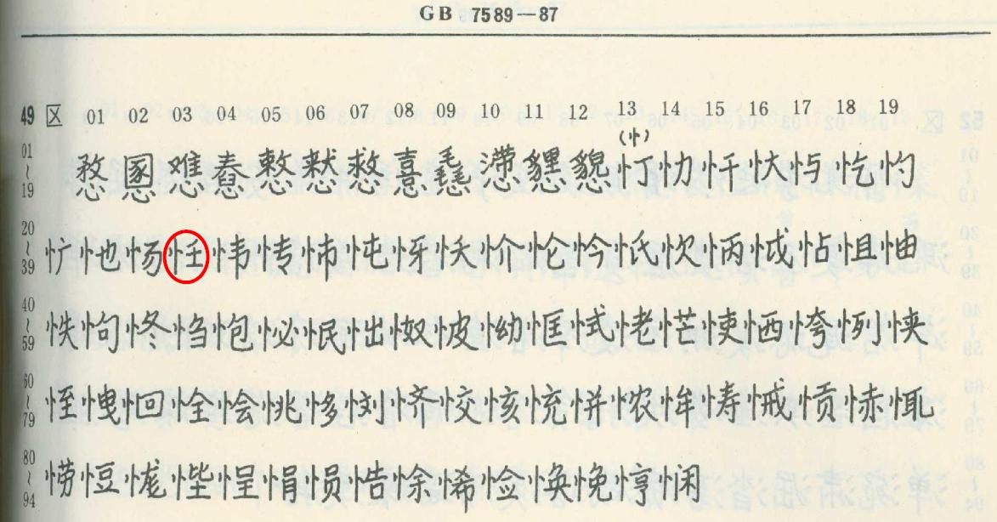
The character was selected from Page 2277 of Hanyu Da Zidian ( 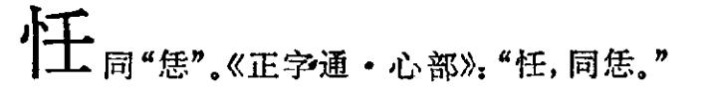
It is considered as a variant of (U+6041) which is pronounced “ren” (meaning “thinking about”). See page 2291 of Hanyu Da Zidian ():
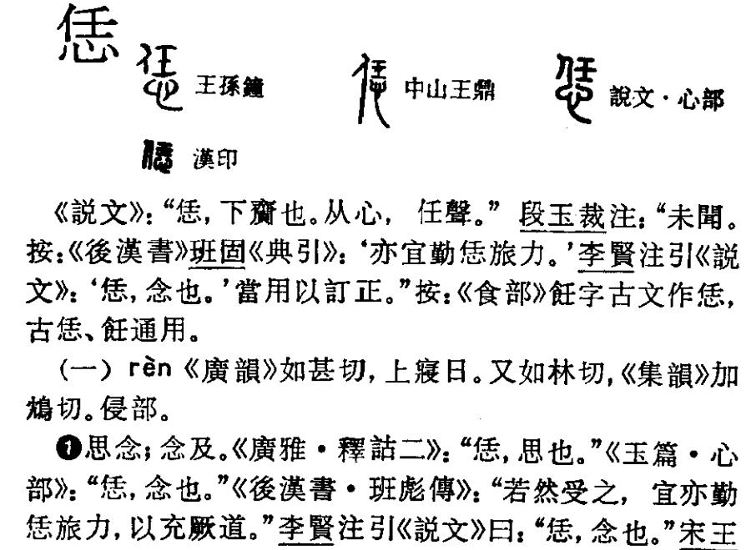
While the character (currently coded in U+5FF9) is pronounced “kuang” (meaning “crazy”) or “wang” (meaning “evil, irregular”), see page 2275 of Hanyu Da Zidian ():
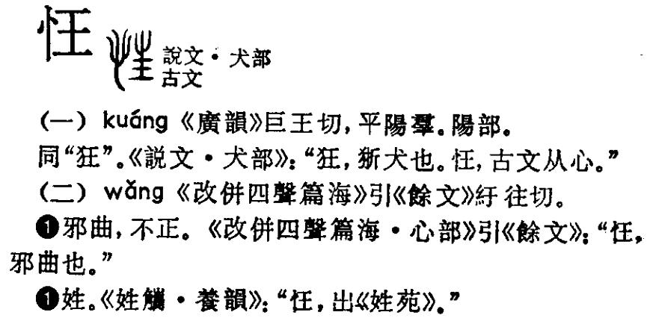
2 Proposed Solution
2.1 Change the glyphs in G-column and T-column of U+5FF9:
In order to replce the wrong glyphs (both ) in the code point U+5FF9 with the correct glyphs, TCA and China will submit the correct glyphs of G3-5137 and T3-2623 (both )to IRG and WG2.
2.2 Remove the glyph from U+2F89F and remove the entry “U+2F89F” from the electronic insertion file “CJKC_SR.txt” of ISO/IEC 10646:2003.
2.3 A new code point U+XXXX is assigned for encoding the character T5-2438 (), and insert a corresponding entry into the electronic insertion file “CJKU_SR.txt” of ISO/IEC 10646:2003.

