JTC1/SC2/WG2 N4594

ISO/IEC JTC 1/SC 2/WG 2
PROPOSAL SUMMARY FORM TO ACCOMPANY SUBMISSIONS
FOR ADDITIONS TO THE REPERTOIRE OF ISO/IEC 10646TPPT
Please fill all the sections A, B and C below.
Please read Principles and Procedures Document (P & P) from HTUhttp://www.dkuug.dk/JTC1/SC2/WG2/docs/principles.html UTH for guidelines and details before filling this form.
Please ensure you are using the latest Form from HTUhttp://www.dkuug.dk/JTC1/SC2/WG2/docs/summaryform.htmlUTH.
See also HTUhttp://www.dkuug.dk/JTC1/SC2/WG2/docs/roadmaps.html UTH for latest Roadmaps.
A. Administrative
1. Title: |  | Proposal to encode NOMISMA SIGN : 
2. Requester's name: |  |  | Dumbarton Oaks
3. Requester type (Member body/Liaison/Individual contribution): |  |  |  |  | individual contribution
4. Submission date: |  |  |  |  | 2014-07-18
5. Requester's reference (if applicable):
6. Choose one of the following:
 | This is a complete proposal: |  |  |  |  | yes
 | (or) More information will be provided later:
B. Technical – General
1. Choose one of the following:
 |  | a. This proposal is for a new script (set of characters):
 |  |  |  | Proposed name of script:
 |  | b. The proposal is for addition of character(s) to an existing block: |  |  |  |  |  |  |  |  |  |  |  |  |  |  | yes
 |  |  |  | Name of the existing block: |  |  |  |  | Ancient Greek Numbers
2. Number of characters in proposal: |  |  |  |  |  |  |  |  |  |  |  |  |  |  |  |  | 1
3. Proposed category (select one from below - see section 2.2 of P&P document):
 | A-Contemporary |  |  |  |  |  | B.1-Specialized (small collection) |  |  |  |  |  |  |  | B.2-Specialized (large collection)
 | C-Major extinct |  |  |  |  |  | D-Attested extinct |  |  |  |  |  |  |  | E-Minor extinct |  |  |  | yes
 | F-Archaic Hieroglyphic or Ideographic |  |  |  |  |  |  |  |  |  |  |  | G-Obscure or questionable usage symbols
4. Is a repertoire including character names provided? |  |  |  |  |  |  |  |  |  |  |  |  |  |  |  |  | yes
 |  | a. If YES, are the names in accordance with the “character naming guidelines”
 |  |  |  | in Annex L of P&P document? |  |  |  |  |  |  |  |  |  |  |  |  | yes
 |  | b. Are the character shapes attached in a legible form suitable for review?
5. Fonts related:
 |  | a. Who will provide the appropriate computerized font to the Project Editor of 10646 for publishing the standard?
 |  |  | Dumbarton Oaks
 |  | b. Identify the party granting a license for use of the font by the editors (include address, e-mail, ftp-site, etc.):
 |  |  | Trustees for Harvard University, Dumbarton Oaks, 1703 32nd St. NW, Washington, DC 20007, kalvesmaki.com/athenaruby
6. References:
 |  | a. Are references (to other character sets, dictionaries, descriptive texts etc.) provided? |  |  |  |  |  |  |  |  |  |  |  |  |  | yes
 |  | b. Are published examples of use (such as samples from newspapers, magazines, or other sources)
 |  | of proposed characters attached? |  |  |  |  |  |  |  | yes
7. Special encoding issues:
 |  |  | Does the proposal address other aspects of character data processing (if applicable) such as input,
 |  | presentation, sorting, searching, indexing, transliteration etc. (if yes please enclose information)? |  |  |  |  |  |  |  |  |  |  |  |  |  |  |  | no
8. Additional Information:
Submitters are invited to provide any additional information about Properties of the proposed Character(s) or Script that will assist in correct understanding of and correct linguistic processing of the proposed character(s) or script. Examples of such properties are: Casing information, Numeric information, Currency information, Display behaviour information such as line breaks, widths etc., Combining behaviour, Spacing behaviour, Directional behaviour, Default Collation behaviour, relevance in Mark Up contexts, Compatibility equivalence and other Unicode normalization related information. See the Unicode standard at HTUhttp://www.unicode.orgUTH for such information on other scripts. Also see HTUhttp://www.unicode.org/Public/UNIDATA/UCD.htmlUTH and associated Unicode Technical Reports for information needed for consideration by the Unicode Technical Committee for inclusion in the Unicode Standard.

C. Technical - Justification
1. Has this proposal for addition of character(s) been submitted before? |  |  |  |  |  |  |  |  |  |  | no
 |  | If YES explain
2. Has contact been made to members of the user community (for example: National Body,
 |  | user groups of the script or characters, other experts, etc.)? |  |  |  |  |  |  |  |  | yes
 |  |  | If YES, with whom? |  |  |  |  | members of the scholarly community
 |  |  | If YES, available relevant documents:
3. Information on the user community for the proposed characters (for example:
 |  | size, demographics, information technology use, or publishing use) is included? |  |  |  |  |  |  |  |  | yes
 |  | Reference: |  |  |  |  | scholars of Byzantine inscriptions and papyri
4. The context of use for the proposed characters (type of use; common or rare) |  |  |  |  |  |  |  |  |  |  | rare
 |  | Reference: |  |  |  |  | common in antiquity; rare in modern typography
5. Are the proposed characters in current use by the user community? |  |  |  |  |  |  |  |  |  |  | yes
 |  | If YES, where? Reference: |  |  |  |  |  |  | see attached
6. After giving due considerations to the principles in the P&P document must the proposed characters be entirely
 |  | in the BMP? |  |  |  |  |  |  |  |  | no
 |  |  |  | If YES, is a rationale provided?
 |  |  |  |  |  | If YES, reference:
7. Should the proposed characters be kept together in a contiguous range (rather than being scattered)? |  |  |  |  |  |  |  |  |  |  |  |  | yes
8. Can any of the proposed characters be considered a presentation form of an existing
 |  | character or character sequence? |  |  |  |  |  |  |  |  | no
 |  |  |  | If YES, is a rationale for its inclusion provided?
 |  |  |  |  |  | If YES, reference:
9. Can any of the proposed characters be encoded using a composed character sequence of either
 |  | existing characters or other proposed characters? |  |  |  |  |  |  |  |  | no
 |  |  |  | If YES, is a rationale for its inclusion provided?
 |  |  |  |  |  | If YES, reference:
10. Can any of the proposed character(s) be considered to be similar (in appearance or function)
 |  | to an existing character? |  |  |  |  |  |  |  |  | no
 |  |  |  | If YES, is a rationale for its inclusion provided? |  |  |  |  |  |  | no
 |  |  |  |  |  | If YES, reference:
11. Does the proposal include use of combining characters and/or use of composite sequences? |  |  |  |  |  |  |  |  |  |  | no
 |  | If YES, is a rationale for such use provided?
 |  |  |  |  | If YES, reference:
 |  | Is a list of composite sequences and their corresponding glyph images (graphic symbols) provided?
 |  |  |  |  |  | If YES, reference:
12. Does the proposal contain characters with any special properties such as
 |  | control function or similar semantics? |  |  |  |  |  |  |  |  | no
 |  |  |  | If YES, describe in detail (include attachment if necessary)
13. Does the proposal contain any Ideographic compatibility character(s)? |  |  |  |  |  |  |  |  |  |  | no
 |  | If YES, is the equivalent corresponding unified ideographic character(s) identified?
 |  |  |  | If YES, reference:

Proposal to encode U+1018E NOMISMA SIGN
On Byzantine Greek weights there remain a number of inscriptions for the nomisma, the standard gold coin that formed the backbone of the late Roman and Byzantine empire’s currency system. The symbol would have been universally recognized as a single glyph as much as any currency symbol used today.

NOMISMA SIGN

Greek capital letter nu with Greek capital letter omicron, the latter normally suspended over middle crossbar of the former:

We propose that this symbol be included in the Ancient Greek Numbers block under the subhead Ancient Greek Papyrological Numbers. The nomisma is a sign of currency and a marker of weight, like U+10184, GREEK OUNKIA SIGN.

The nomisma sign comes in a variety of forms in antiquity. The default form depicted below, alongside variants. We expect these varieties to be handled at the glyph level.

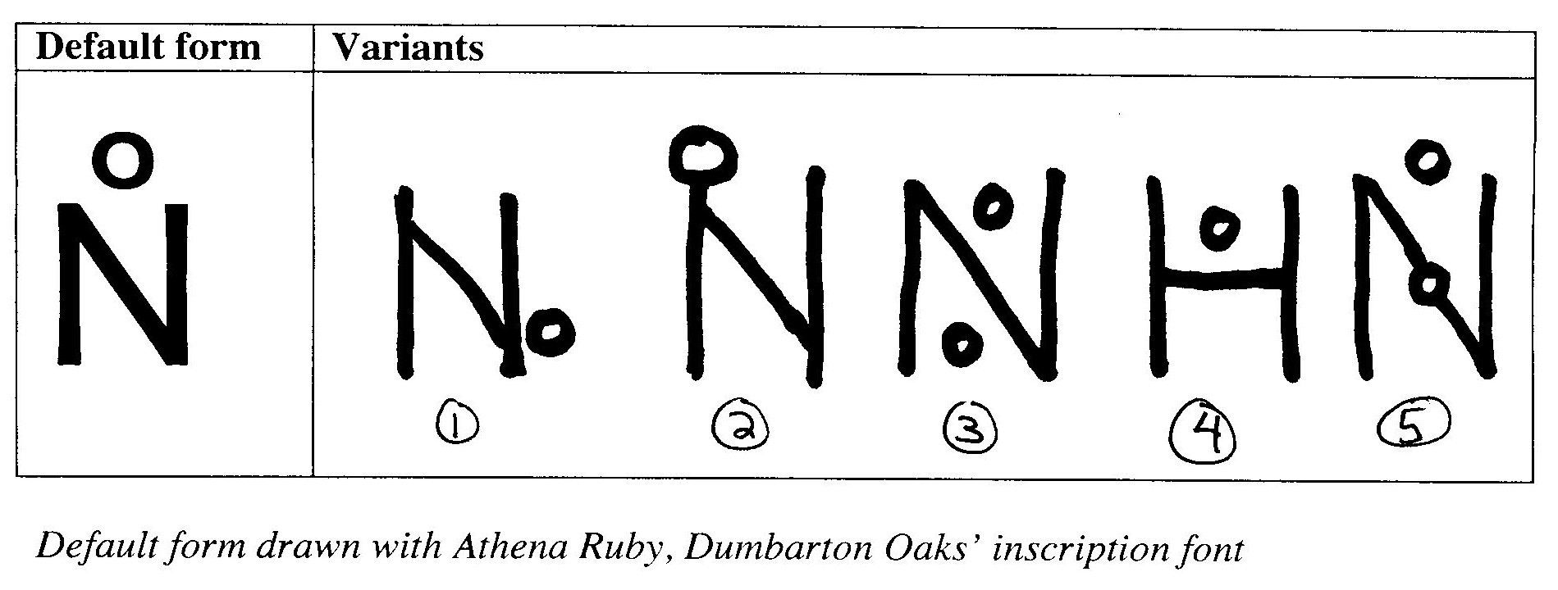
The default form is exhibited below to varying degrees in example nos. 104, 105, 110, 136, 138, 141, 144
Variant 1: see example 42
Variant 2: see examples 43, 44, 145
Variant 3: see example 103
Variant 4: see example 101
Variant 5: see example 149

Character properties

Code Point: 1018E
Name: NOMISMA SIGN
General category: So
Line breaks: permitted before and after character
Casing information: none
Numeric information: nt (none)
Combining behaviour: combining allowed
Directional behaviour: ON
Unicode normalization: none

Bibliography

Bendall, Simon. Byzantine Weights: An Introduction. London: Lennox Gallery, 1996.

Examples
Typography

Bendall, p. 6
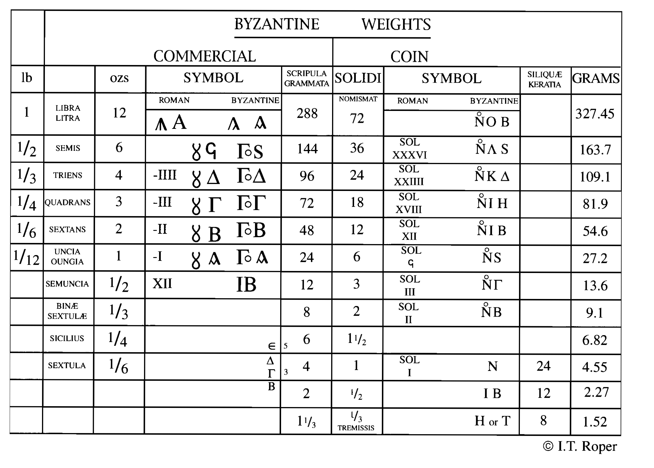

Bendall, pp. 29–30
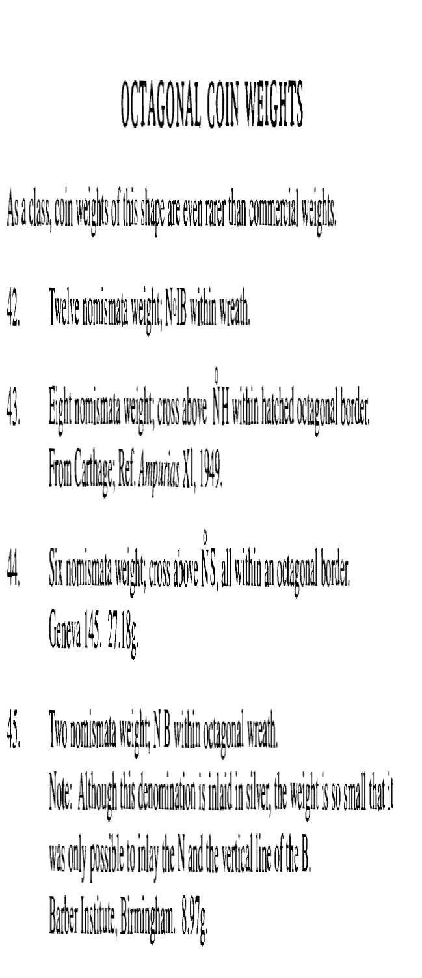

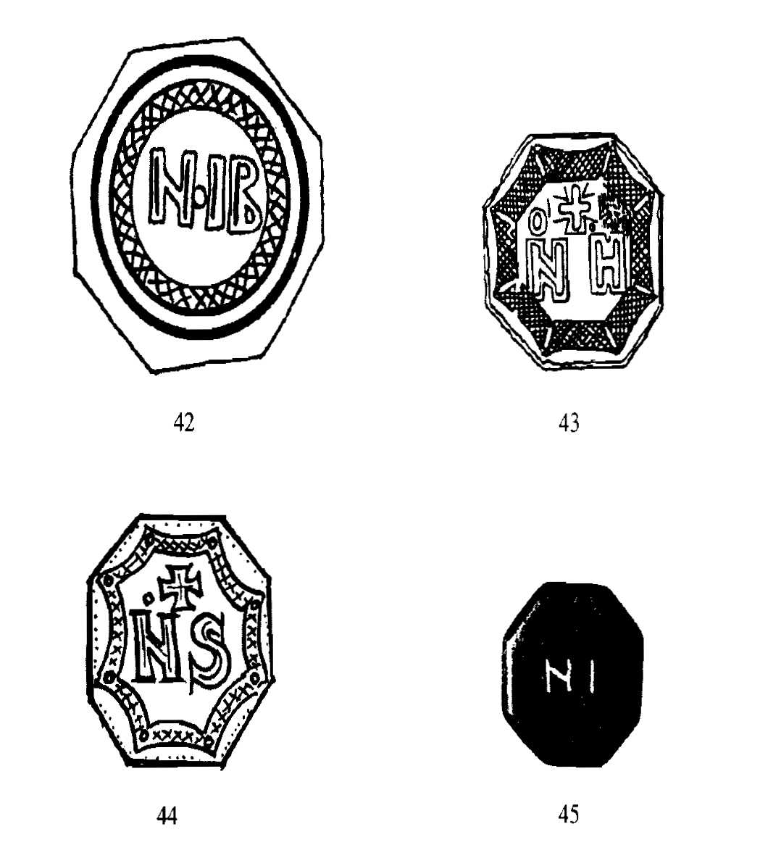

Bendall, p. 43. Relevant examples: 101, 103, 104, 105, 110. Note stylistic variants in nos. 103, 104.

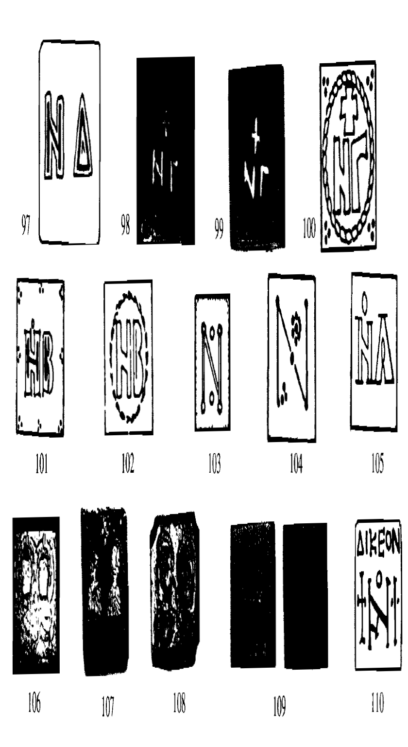

Bendall, p. 53. Relevant examples: 136, 138, 141, 144, 145, 147, 149. Note the stylistic variant in 149 (omicron doubled, one in suspension and the other as a feature of the crossbar)

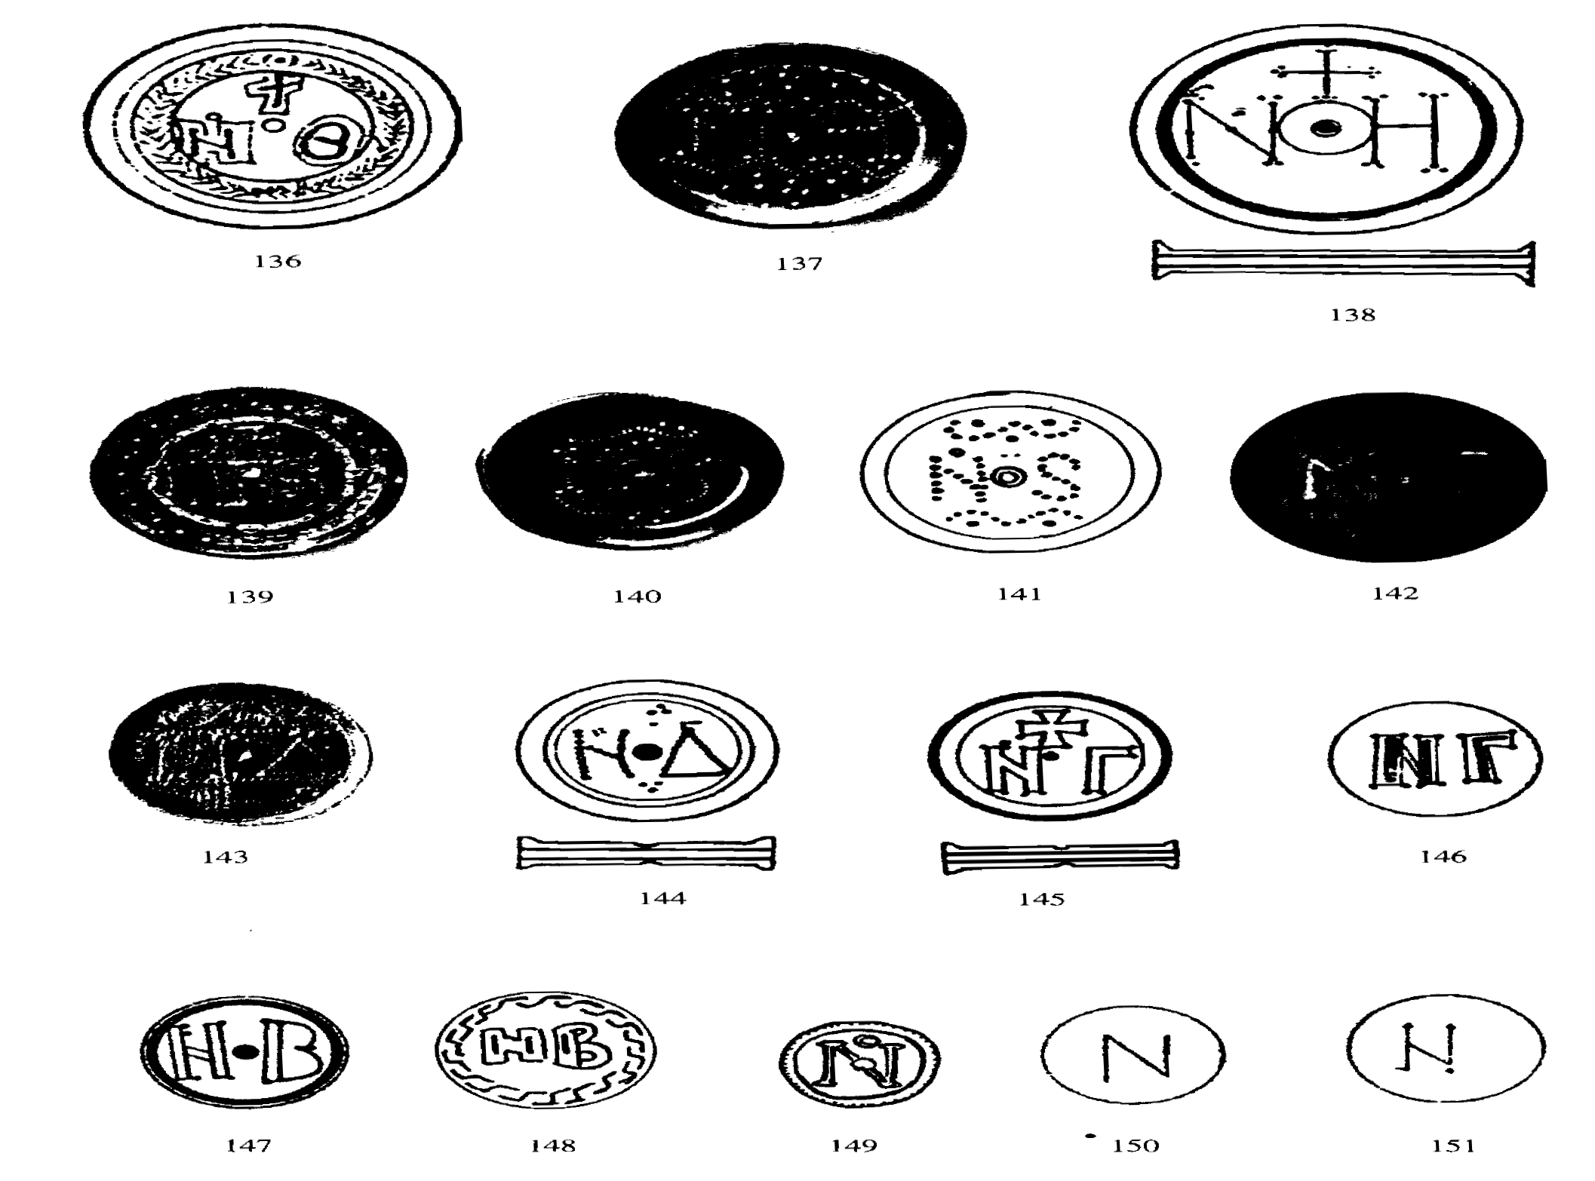

TP?PT Form number: N3702-F (Original 1994-10-14; Revised 1995-01, 1995-04, 1996-04, 1996-08, 1999-03, 2001-05, 2001-09, 2003-11, 2005-01, 2005-09, 2005-10, 2007-03, 2008-05, 2009-11)

